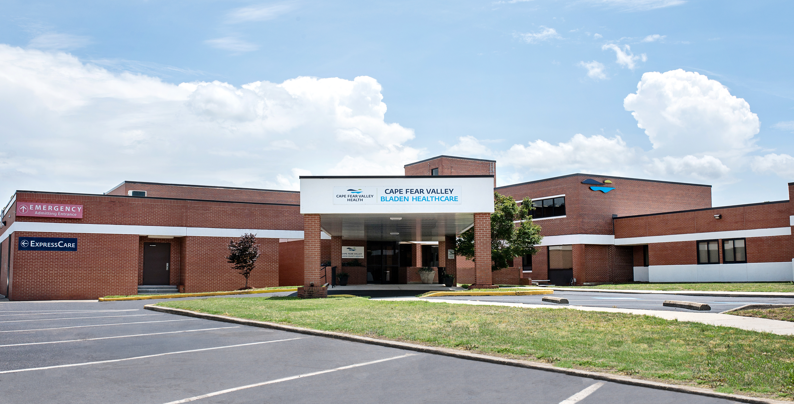

BLADEN COUNTY
2025 Community Health Needs Assessment

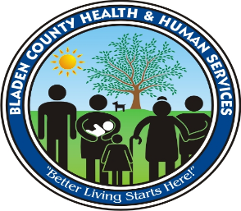

ACKNOWLEDGEMENTS

This Community Health Needs Assessment (CHNA) represents the culmination of work completed by multiple individuals and groups. Health ENC – a group of stakeholders who help find ways to collaborate and share resources to improve the health of the population in eastern North Carolina – served an integral role in making this comprehensive assessment possible. To provide focused guidance throughout the assessment process, Health ENC convened a smaller decision-making group, which will be referred to as the Steering Committee throughout this CHNA. The Steering Committee would like to extend its gratitude to all the focus groups participants, health leaders, and community members who provided information used in the development of this assessment.

The Health ENC CHNA Steering Committee

Name | Title | Organization
Lorrie Basnight | Executive Director | Eastern Area Health Education Center (AHEC)
Amanda Betts | Public Health Education Coordinator | Albemarle Regional Health Services (ARHS)
April Culver | Vice President, External Affairs | UNC Health Johnston
Caroline Doherty | Community Health Consultant | Roanoke Chowan Community Health Center (RCCHC)
Laura Ellis | Health Education | Halifax County Health Department
Sandra McMasters | Community Benefit Project Manager | Sentara Health
Claire Mills | Director | Eastern AHEC
Emmanuelle Quenum | Health Education Director | Greene County Department of Public Health (DPH)
Rose Ann Simmons | Administrator, Community Health Improvement | ECU Health
Michelle Wagner | Public Health Educator | Dare County Department of Health & Human Services (DHHS)

Bladen County CHNA Leadership

In addition to the Steering Committee, the Bladen County 2024 CHNA was developed in partnership with the following individuals:

Name | Title | Organization
Spencer Cummings | President | Bladen County Hospital
Faith Rivera | Intern | University of North Carolina at Pembroke
Lizbeth Rivera Rosa | Intern | Fayetteville State University
Emma Cobb | Intern | NC State University
 | Marketing and Communications Department | Cape Fear Valley Health System

Bladen County CHNA Stakeholders

The Bladen County 2024 CHNA was also developed with input from the following individuals and organizations who participated in the prioritization process:

Name | Title | Organization
Taylor Spell | Senior Finance and Strategic Planning Analyst | Cape Fear Valley Health System
Carl DeAndre | Bladen Health and Human Services Advisory Committee Member | Bladen Health and Human Services Committee
Dr. Teresa Duncan | Bladen County Health and Human Services Director | Healthy Bladen
Terri Dennison | Director- Elizabethtown Chamber of Commerce | Healthy Bladen
Isabella Faison | Bladen County Health Department Safe Kids/Substance Misuse Resource Coordinator | Healthy Bladen
Vicky Graham | Bladen County Health Department Health Educator/Accreditation | Healthy Bladen
Dean Hamilton | Community Outreach- Trillium | Healthy Bladen
Jesse Jones | Bladen County Extension Family and Consumer Sciences Agent | Healthy Bladen
Sheila Nance | Bladen County Library Director | Healthy Bladen
Toni Newby | Bladen county Extension 4-H/Youth Development Agent | Healthy Bladen
Quessie Peterson | Community Member | Healthy Bladen
Susie Gooden Prevette | Community Member | Healthy Bladen
Susan Phelps | Cape Fear Valley-Bladen-Director of Nursing | Healthy Bladen
Jill Sampson | Bladen County DSS Social Work Program | Healthy Bladen
Morgan Yow | Bladen County Division of Aging- Nutrition Coordinator | Healthy Bladen
Ernest Watts | Region 8 Tobacco Prevention Specialist | Healthy Bladen

In addition, the Health ENC Steering Committee and Bladen County CHNA Leadership would like to thank Kathryn Dail, Director of Community Health Assessment at the NCDHHS Division of Public Health, for her valuable guidance throughout the development of this assessment, as well as Ascendient Healthcare Advisors for directing the CHNA process and producing this report.

TABLE OF CONTENTS

ACKNOWLEDGEMENTS ii
TABLE OF CONTENTS iv
REPORT TABLE AND FIGURES vii
EXECUTIVE SUMMARY 1
INTRODUCTION 4
Background 4
Timeline 6
Process Overview 6
Report Structure 8
Evaluation of Prior CHNA Implementation Strategies 9
Summary Findings: Bladen County 2024 Priority Health Need Areas 13
CHAPTER 1 | METHODOLOGY 15
Study Design 15
New (Primary) Data 15
Existing (Secondary) Data 15
Comparisons 16
Population Health Framework 16
Prioritization Process Overview and Results 19
Study Limitations 21
CHAPTER 2 | COUNTY PROFILE 23
Geography 23
Population 23
Age and Sex Distribution 24
Race and Ethnicity 24
Disability Status 26
Veteran Status 26
Economic Indicators 26
Social Determinants of Health 29
CHAPTER 3 | PRIORITY NEED AREAS 38
Priority Need: Behavioral Health 38
Context and National Perspective 38
Secondary Data Findings 41
Primary Data Findings – Community Member Web Survey 42
Primary Data Findings – Focus Groups 47
Priority Need: Healthcare Access & Quality 48
Context and National Perspective 48
Secondary Data Findings 49
Primary Data Findings – Community Member Web Survey 51
Primary Data Findings – Focus Groups 54
Priority Need: Nutrition & Physical Activity 54
Context and National Perspective 54
Secondary Data Findings 56
Primary Data Findings – Community Member Web Survey 57
Primary Data Findings – Focus Groups 58
CHAPTER 4 | HEALTH RESOURCE INVENTORY 60
CHAPTER 5 | NEXT STEPS 62
APPENDIX 1 | STATE OF THE COUNTY HEALTH REPORT 63
Results-Based Accountability Framework 63
State of the County Health Report 64
APPENDIX 2 | SECONDARY DATA METHODOLOGY AND SOURCES 68
Methodology 68
Data Sources 69
APPENDIX 3 | SECONDARY DATA COMPARISONS 90
Description of Focus Area Comparisons 90
Detailed Focus Area Benchmarks 91
APPENDIX 4 | PRIMARY DATA METHODOLOGY AND SOURCES 98
Focus Groups 98
Community Member Web Survey 98
APPENDIX 5 | DETAILED PRIMARY DATA FINDINGS 108
Focus Groups 108
Community Member Web Survey 109
APPENDIX 6 | SUMMARY OF DATA FINDINGS ACROSS SOURCES 128

REPORT TABLE AND FIGURES

Figure 1: The 10 Essential Public Health Services 5
Figure 2: Health ENC 2024 CHNA Milestones 6
Figure 3: The Community Health Assessment Process 8
Figure 4: Bladen County 2021 Priority Need Areas 9
Figure 5: Bladen County 2024 Priority Health Needs 14
Figure 6: Population Health Framework 17
Figure 7: Social Determinants of Health 18
Figure 8: SDoH and Health Disparities 18
Figure 9: Bladen County 2024 Priority Health Needs 20
Figure 10: Bladen County Map: Population Density 23
Figure 11: Bladen County Map: Population Growth 24
Figure 12: Social Determinants of Health 29
Figure 13: Residential Segregation 30
Figure 14: Income Inequality Ratio 31
Figure 15: Percent of Population with Limited English Proficiency 31
Figure 16: SVI Variables 32
Figure 17: United States SVI by County, 2022 33
Figure 18: Bladen County SVI by Census Tract, 2022 33
Figure 19: EJI Variables 34
Figure 20: United States EJI by Census Tract, 2022 35
Figure 21: Bladen County EJI, 2022 35
Figure 22: State Health Outcomes Rating Map 36
Figure 23: State Health Factors Rating Map 37
Figure 24: Crude Rate of Deaths of Despair by Gender 41
Figure 25: What are the three most important health problems that affect the health of your community? Please select up to three. 43
Figure 26: What are the three most important health problems that affect the health of your community? Please select up to three. (by age) 44
Figure 27: What are the three most important health problems that affect the health of your community? Please select up to three. (by race) 44
Figure 28: What are the three most important health problems that affect the health of your community? Please select up to three. (by ethnicity) 45
Figure 29: What are the three most important health problems that affect the health of your community? Please select up to three. (by gender) 45
Figure 30: Now thinking about your MENTAL health, which includes stress, depression, and problems with emotions, for how many days during the past 30 days was your mental health NOT good? 46
Figure 31: Was there a time in the past 12 months when you needed mental health care or counseling, but did not get it at that time? 46
Figure 32: What was the MAIN reason you did not get mental health care or counseling? 47
Figure 33: Preventable Hospital Stays by Race/Ethnicity 50
Figure 34: Health Insurance Status by Age Group 51
Figure 35: What are the three most important reasons people in your community do not get health care when they need it? Please select up to three. 51
Figure 36: What are the three most important reasons people in your community do not get health care when they need it? Please select up to three. (by race) 52
Figure 37: What are the three most important social or environmental problems that affect the health of your community? Please select up to three. 53
Figure 38:During the past 12 months, was there any time when you needed any of the following, but didn't get it because you couldn't afford it? 54
Figure 39: What are the three most important health problems that affect the health of your community? Please select up to three. 57
Figure 40: What are the three most important health problems that affect the health of your community? Please select up to three. (by ethnicity) 58

Table 1: Total Population, 2023 23
Table 2: Age Distribution, 2023 24
Table 3: Sex Distribution, 2023 24
Table 4: Racial Distribution, 2023 25
Table 5: Ethnic Distribution, 2023 25
Table 6: Foreign Born Population, 2022 25
Table 7: Language Spoken at Home, 2022 26
Table 8: Disability Status, 2022 26
Table 9: Veteran Status, 2022 26
Table 10: Median Household Income, 2023 27
Table 11: Percent of Households Below the FPL, 2023 27
Table 12: Households Receiving Food Stamps/SNAP, 2022, 27
Table 13: Educational Attainment, 2020, 28
Table 14: Unemployment, 2022, 28
Table 15: Health Insurance Status, 2022 29
Table 16: Mental Health Indicators 41
Table 17: Substance Use Disorder Indicators 42
Table 18: Healthcare Provider Rates Per 100,000 Population 49
Table 19: Transportation Access Indicators 50
Table 20: Physical Activity Indicators 56
Table 21: Food Security and Food Environment Indicators 56

EXECUTIVE SUMMARY

A Community Health Needs Assessment (CHNA) helps health leaders evaluate the health and wellness of the community they serve and identify gaps and challenges that should be addressed through new programs, services and policy changes. This report was developed as part of the Health ENC coalition's collaborative, regional 2024 CHNA process. Health ENC -- a group of stakeholders who help find ways to collaborate and share resources to improve the health of the population in eastern North Carolina -- served an integral role in making this comprehensive assessment possible. The report adheres to North Carolina Local Health Department Accreditation standards, as well as Internal Revenue Service requirements for not-for-profit hospitals.
Vision Statement
Through collaboration between the Health ENC Steering Committee, Bladen County Health Department and Cape Fear Valley Bladen County Hospital, the 2024 CHNA process aspires to create a healthier eastern North Carolina where collaborative action, shared resources, and community engagement converge to eliminate health disparities and build resilient, connected communities that support wellbeing for generations to come.
Bladen County CHNA Leadership

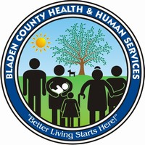
Bladen County opted for a bi-sectoral approach to the leadership of the 2024 CHNA process, which included representatives from Bladen County Health Department (BCHD) and Cape Fear Valley Bladen County Hospital.
Name | Title | Organization
Spencer Cummings | President | Bladen County Hospital
Faith Rivera | Intern | University of North Carolina at Pembroke
Lizbeth Rivera Rosa | Intern | Fayetteville State University
Emma Cobb | Intern | NC State University
 | Marketing and Communications Department | Cape Fear Valley Health System

Bladen County CHNA Partnerships

The 2024 CHNA process for Bladen County included a variety of different stakeholders who assisted with community engagement activities, provided feedback, and participated in the prioritization process. A summary of the partner organizations who participated in the process is below.

Type of Partner Organization | Number of Partners
Public Health Agency | 3
Hospital/Health Care System(s) | 1
Healthcare Provider(s) | 2
Behavioral Healthcare Provider(s) | 2
EMS Provider(s) | 1
Community Organization(s) | 5
Business(es) | 1
Public/Private/Charter School System(s) | 1
Government/Public Agencies | 4

The Health ENC Steering Committee and Bladen County CHNA Leadership contracted with Ascendient Healthcare Advisors to coordinate the regional CHNA process, including primary and secondary data analysis, relevant trainings for county partners and development of the contents of this report.

Bladen County CHNA Timeline and Process

The Health ENC 2024 process formally kicked off with a collaborative meeting of all participating counties on February 8th, 2024. It concluded with the delivery of final CHNA reports to all 34 counties on December 20th, 2024. A summary of key process milestones is shown below.

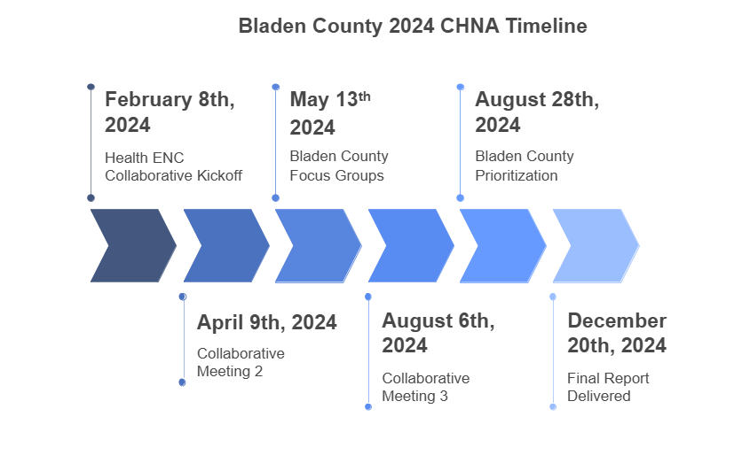
Secondary (existing) data is an important piece of the CHNA process. Key sources for secondary data included information provided by the Steering Committee and a variety of public data sources related to demographics, social and economic determinants of health, environmental health, health status and disease trends, mental/behavioral health trends, and individual health behaviors. Each data measure was also compared to state or national benchmarks to identify areas of specific concern for Bladen County. Top community needs identified through secondary data analysis included health concerns related to physical and behavioral health, and social or environmental concerns such as education, housing and homelessness, and family, community, and social support, among others.
Primary (new) data were collected through focus groups and a web-based survey for community members, and included feedback from 407 people who live, work or receive healthcare in Bladen County. A total of two in-person focus groups were conducted, with a variety of community members from different backgrounds, age groups and life experiences. Primary data identified behavioral health (specifically mental health), employment and income, healthcare access and quality, and physical health (chronic diseases, cancer, obesity) as top needs that impact the health and well-being of people living in Bladen County.
Representatives from Bladen County worked together to identify the priorities the county should focus on over the following three-year period. Leaders evaluated the primary and secondary data collected throughout the process to identify needs based on the size and scope, severity, the ability for hospitals or health departments to make an impact, associated health disparities, and importance to the community. Although it was not possible for every single area of potential need to be identified as a priority, Bladen County selected three top priority health needs (Behavioral Health, Healthcare Access and Quality, and Nutrition and Physical Activity), which are shown here in alphabetical order:
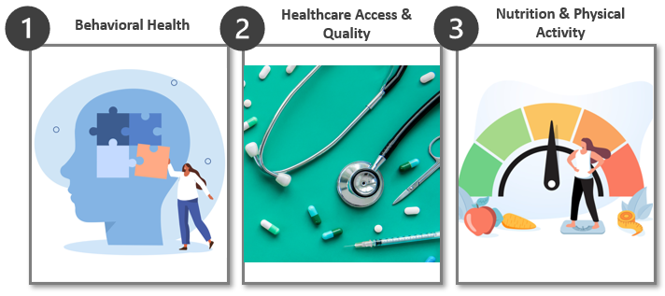
Bladen County also compiled a Health Resources Inventory, which describes a variety of resources available to help Bladen County residents meet their health and social needs.
Following completion of this report, health leaders throughout Bladen County will use its findings to collaborate with community organizations and local residents to develop effective health strategies, new implementation plans and interventions, and action plans to improve the communities they serve.

INTRODUCTION

Background
To illustrate its commitment to the health and well-being of the community, the Health ENC CHNA Steering Committee has completed this assessment to understand and document the greatest health needs currently faced by local residents. Guidance was also provided by local representatives from Bladen Health and Human Services Department and Cape Fear Valley Health System. These organizations helped gather the focus group and survey data that are detailed in this report. The CHNA process helps local leaders continuously evaluate how best to improve and promote the health of the community. It builds upon formal collaborations between the Steering Committee and other community partners to proactively identify and respond to the needs of Bladen County residents.

This report was created in compliance with the State of North Carolina’s Local Health Department Accreditation (NCLHDA) Board’s accreditation standards. The accreditation process allows local health departments to assess how they are meeting national and state-specific standards for public health practice and provides opportunities to address any identified gaps. It also ensures that local health departments have the ability to deliver the 10 essential public health services, as described in Figure 1 below. In its demonstration of data and prioritization of Bladen County’s community needs, this report aligns with all NCLHDA standards for accreditation, including the need to:

- Provide evidence of community collaboration in planning and conducting the assessment;

- Reflect the demographic profile of the population and describe socioeconomic, educational and environmental factors that affect health;

- Assemble and analyze secondary data to describe the health status of the community;

- Collect and analyze primary data to describe the health status of the community;

- Use scientific methods for collecting and analyzing data, including trend data to describe changes in community health status and in factors affecting health;

- Identify population groups at risk for health problems;

- Identify existing and needed health resources;

- Compare selected local data with data from other jurisdictions; and

- Identify leading community health problems.

Figure 1: The 10 Essential Public Health Services
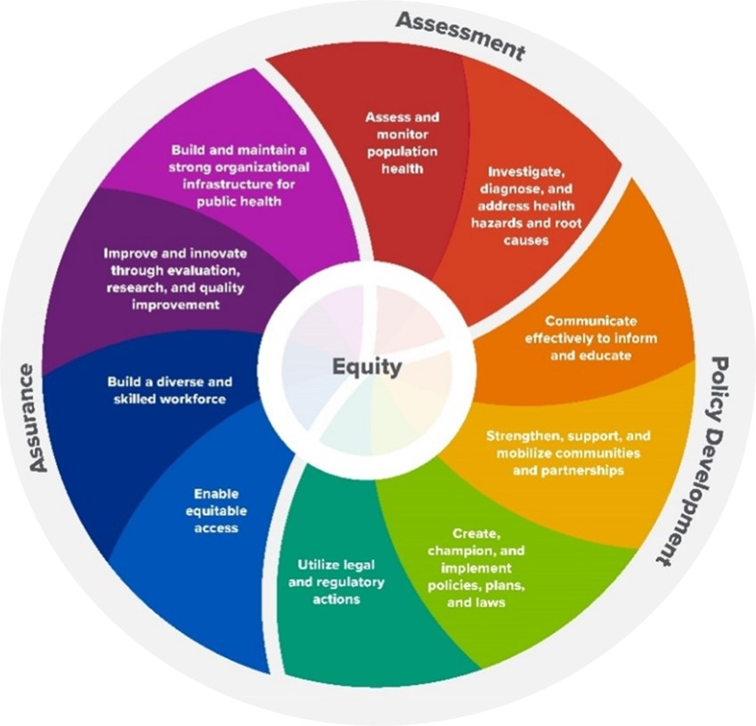

Further, this process complies with Internal Revenue Service (IRS) requirements for not-for-profit hospitals to complete a CHNA every three years to maintain their tax exemption. Specifically, the IRS requires that hospital facilities do the following:

- Define the community it serves;

- Assess the health needs of that community;

- Through the assessment process, take into account input received from people who represent the community’s broad interests, including those with special knowledge of or expertise in public health;

- Document the CHNA in a written report that is reviewed and adopted by the hospital facility’s authorizing body; and

- Make the CHNA widely available to the public.

Timeline
The Health ENC 2024 CHNA process for all participating counties, including Bladen County, began in January 2024 with the convening of the Steering Committee and continued throughout the year. The process concluded in December 2024 with the delivery of final CHNA reports. A high-level summary of activities conducted throughout the year can be found in Figure 2 below.
Figure 2: Health ENC 2024 CHNA Milestones
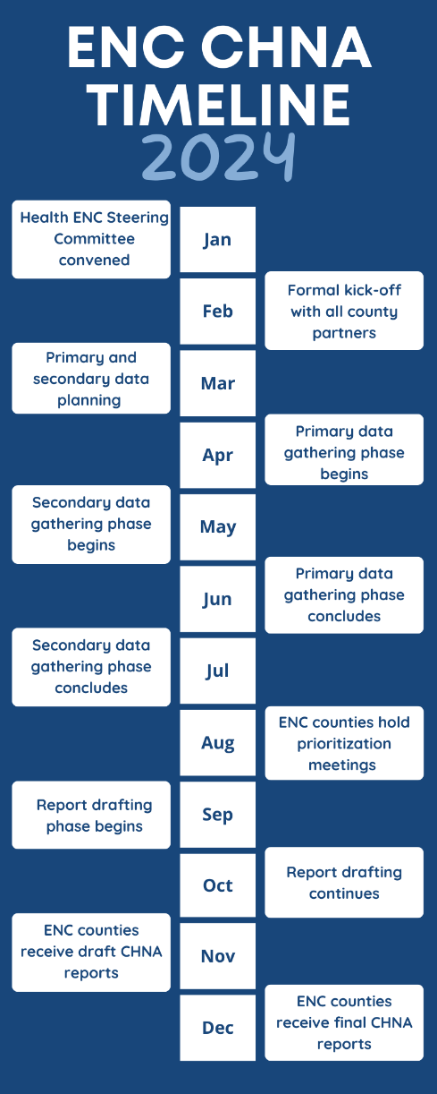

Process Overview
A significant amount of information has been reviewed during this planning process, and the Steering Committee has been careful to ensure that a variety of sources were used to deliver a truly comprehensive report. Both existing (secondary) data and new (primary) data were collected directly from the community throughout this process. It is also important to note that, although unique to Bladen County, the sources and methodologies used to develop this report comply with the current NCLHDA and IRS requirements for health departments and not-for-profit hospital organizations.

The purpose of this study is to better understand, quantify, and articulate the health needs of Bladen County residents. Key objectives of this CHNA include:

- Identify the health needs of Bladen County residents;

- Identify disparities in health status and health behaviors, as well as inequities in the factors that contribute to health challenges;

- Understand the challenges residents face when trying to maintain and/or improve their health;

- Understand where underserved populations turn for services needed to maintain and/or improve their health;

- Understand what is needed to help residents maintain and/or improve their health; and

- Prioritize the needs of the community and clarify/focus on the highest priorities.

There are twelve phases in the CHNA process, as shown in Figure 3 below, beginning with pre-planning and assessing organizational capacity and ending with an evaluation of the process. Once the CHNA process is complete, county leaders must develop community health action plans to describe the specific activities they will implement to address the health and social needs identified in the CHNA.

Figure 3: The Community Health Assessment Process
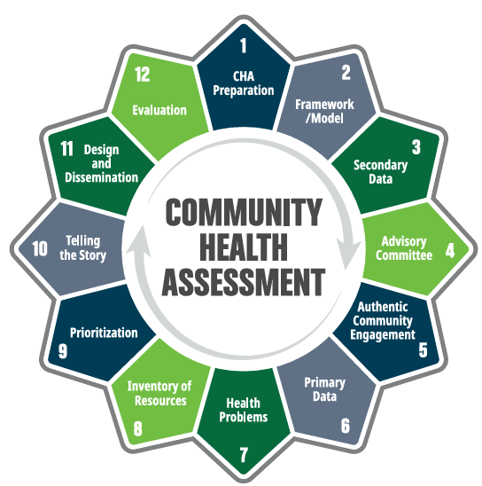

Report Structure
The outline below provides detailed information about each section of the report.

- Methodology – The methodology chapter provides an overall summary of how the priority health need areas were selected as well as how information was collected and incorporated into the development of this CHNA, including study limitations.

- County Profile – This chapter details the demographic (such as age, gender, and race) and socioeconomic data of Bladen County residents.

- Priority Health Need Areas – This chapter describes each identified priority health need area for Bladen County and summarizes the new and existing data that support these prioritizations. This chapter also describes the impact of health disparities among various sub-groups in Bladen County.

- Health Resource Inventory – This chapter documents existing health resources currently available to the Bladen County community.

- Next Steps – This chapter briefly summarizes the next steps that will occur to address the priority health need areas discussed throughout this document.

In addition, the appendices discuss all of the data used during the development of this report in detail, including:

- State of the County Health Report – Detailed information about actions taken to address the priority health needs identified in previous CHNAs are presented in Appendix 1.

- Detailed Summary of Secondary Data Measures and Findings – Existing data measures and findings used in the prioritization process are presented in Appendices 2-3.

- Detailed Summary of Primary Findings – Summaries of new data findings from community member surveys as well as focus groups are presented in Appendices 4-5.

Evaluation of Prior CHNA Implementation Strategies

A CHNA is an ongoing process that begins with an evaluation of the previous CHNA. In 2021, Bladen County completed its previous assessment. Associated implementation strategies focused on three priority areas, as listed below:

Figure 4: Bladen County 2021 Priority Need Areas
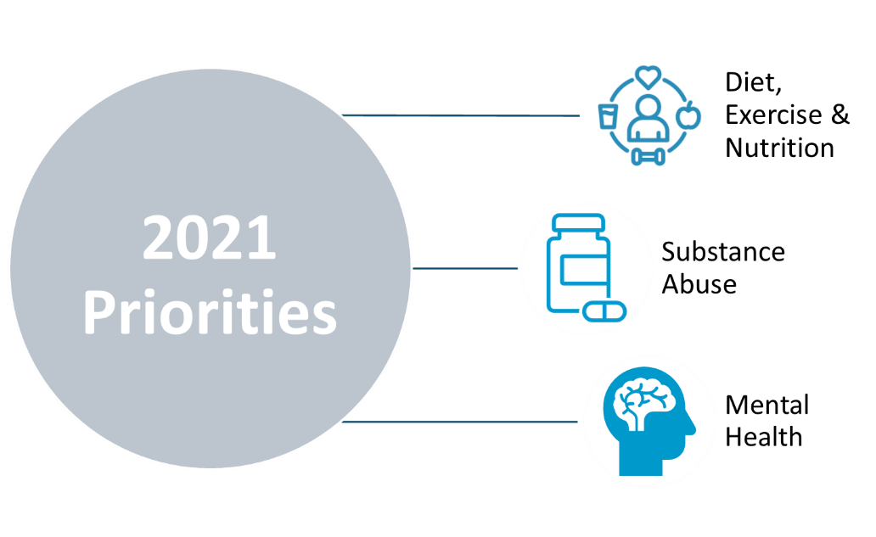

Local organizations developed goals and implementation plans to address these priority health needs. Below are brief summaries of each organization’s most recent CHNA implementation plans.

Cape Fear Valley Health System – Bladen County Hospital

At Cape Fear Valley Health System (CFVHS), the goal is to improve the quality of every life touched by providing exceptional healthcare for all patients. To achieve that, CFVHS’s doctors, surgeons and staff are committed to excellence in every aspect of the healthcare process. CFVHS’ values of patient-centeredness, integrity, innovation, teamwork, diversity, accountability, and education help create a better experience for every patient, every time. System medical facilities include Cape Fear Valley Medical Center, Highsmith-Rainey Specialty Hospital, Cape Fear Valley Rehabilitation Center, Behavioral Health Care, Bladen County Hospital, Hoke Hospital, Central Harnett Hospital, Betsy Johnson Hospital, as well as several medical offices and clinics spread throughout the Cape Fear region. The doctors at CFVHS proudly serve a seven-county region of southeastern North Carolina, including Fayetteville, Fort Liberty, Hope Mills, Raeford, Lumberton, Elizabethtown, Clinton, Lillington, Dunn, and beyond. CFVHS provides exceptional medical care, serving more than 1 million patients annually – each of whom is treated to knowledgeable, personal care.

Bladen County Hospital is a modern, up-to-date 25-bed facility with a 24-hour emergency department, a fully staffed medical-surgical unit, and an intensive care unit with specially trained physicians and nurses. As one of North Carolina’s 21 critical access facilities, Bladen County Hospital is located in a rural, often underserved community and provides limited outpatient and inpatient services to residents who otherwise would have to travel long distances for emergency care. The surgical suite and ambulatory surgical section offer the latest in laparoscopic and cataract surgery. The imaging department is equipped with the latest technology such as CT, MRI, ultrasound, and 3D digital mammography. Various cardiopulmonary tests can be performed, including EKG's, stress testing, and Holter monitoring. The hospital has a cardiac rehab program and a physical therapy department providing up-to-date treatments for patients requiring therapy. The hospital’s laboratory is open 24 hours a day to provide accurate, timely test results. In addition, outpatient clinics are available to serve the community and surrounding areas, including family practice and specialty clinics located in Elizabethtown, Bladenboro, Dublin, White Lake, Whiteville, and Clarkton.

Bladen County Health and Human Services

The mission of the Bladen County Health and Human Services (BCHHS) is to preserve, protect, and improve the health and quality of life of the community. In order to support the conditions necessary for leading healthy lives, BCHHS tracks and monitors disease outbreaks, investigates the underlying connections between inequities and poor health, and engages in research to develop science-based solutions to identified problems. Working directly in the community, BCHHS promotes wellness by encouraging healthy behaviors such as vaccinations for children and adults to prevent the spread of disease and providing education about the risks of alcohol and tobacco. Other BCHHS-led public health initiatives include setting safety standards to protect workers, developing school nutrition programs to ensure children have access to healthy food, and advocating for laws that promote smoke-free air and enforce the use of seatbelts.

Previous CHNA Priority: Diet, Exercise and Nutrition

- Making Rounds LIVE: Over 21,900 community members participated in the Making Rounds LIVE educational events and learned more about heart health, orthopedics, healthy habits (exercise and diet), the opioid crisis, chronic disease management/prevention, early detection of cancer, strokes and heart attacks, palliative care, and Alzheimer’s awareness.
- Step Up 4 Health & Wellness Expo: A partnership between Cape Fear Valley Health Foundation and Methodist University, the event was hosted for its second year on April 15, 2023 in Fayetteville, NC. Over 500 participants and 50 vendors were present. A 4k or 1 mile route was available for attendees to participate in which required a registration fee where registrants could choose the beneficiary (Friends of the Cancer Center, Children’s Services, etc.). This health-related educational festival featured informational booths for CFVHS services as well as food trucks, music, and sponsor tables. Participants learned about hands-only CPR and received free wellness checks and other health-related goodies.
- Community Paramedicine: CFVHS continues to utilize and expand its community paramedicine program which provides home visits to patients with chronic conditions to prevent readmissions and to maintain stable health outcomes. A grant was received to support the expansion of this program. This program provides patients and families with additional education and routine support in managing their conditions.

Previous CHNA Priority: Substance Abuse

- Opioid Stewardship Program: CFVHS has established a system-wide Opioid Stewardship Program which exists to reduce opioid use, decrease harm related to opioid use, and identify patients with potential opioid use disorders. These goals are met by educating patients, identifying and monitoring high risk patients, systemic screening, and providing alternative treatment options. Ordering practices of physicians are monitored regularly and alternatives for pain control are offered in the Emergency Departments. Kits are provided through the outpatient pharmacy to dispose of opioids safely. Additionally, safe drug disposals are located at CFVHS pharmacies for prescription take-back during operating hours. Narcan is available for use on EMS Transport Vehicles. CFVHS has established several community partnerships to address substance abuse issues in the area such as Fighting Addiction through Community Empowerment Teams with Southeastern Regional Area Health Education Center (SRAHEC) & Cumberland-Fayetteville Opioid Response Teams.
- Peer Support Specialists: In May of 2023, CFVHS Emergency Departments implemented Peer Support Specialists. These specialists interact with Emergency Department patients who have existing drug and/or alcohol issues to help patients identify community assets. Training modules are being developed for healthcare professionals for prescribing opioids for pain based on recent CDC guidelines.

Previous CHNA Priority: Mental Health

- Rural Access: CFVHS has continued to provide access to patients in rural counties for mental health related illnesses. The main campus at CFVMC has an inpatient adult and adolescent psychiatric unit, as well as a community mental health facility in Fayetteville, which sees patients from all surrounding counties.

Summary of Other Activities

- Outreach and Education Events: CFVHS hosted many Breast Cancer Awareness outreach events throughout the year, educating members of the community about Breast Care Education and Breast Cancer Awareness. CFVHS Friends of the Cancer Center also continued to provide funding for mammograms to catch breast cancer in earlier stages. Hands-only CPR instruction and Blood Pressure checks are offered at most outreach events, reaching over 6,166 community members across four counties (including Bladen County) in 2023. Over 3,100 community members participated in sponsored blood drives that offered education and blood donation to CFVHS hospitals. CFVHS also hosted eighteen educational events, including Making Rounds LIVE which provides education from doctors and leaders to members of the community. Stroke education events were held to educate over 220 members of the community on identifying and preventing strokes as well as caring for yourself and others after a stroke.
- NC MedAssist Over the Counter Medicine Program: CFVHS participated in the NC MedAssist Over the Counter Medicine Program. NC MedAssist tries to eliminate the barriers for homebound patients who would like to participate in a scheduled Mobile Free Pharmacy event by providing a process to select over-the-counter medicine items without physically attending the event. Over-the-counter medications available through NC MedAssist include allergy, cough, cold, pain relief, vitamins, and children’s medications.
- LifeLink Air: As of May 2023, a new LifeLink Air helicopter is stationed at Bladen County Hospital. The aircraft is an example of Cape Fear Valley Health’s investment in caring for and supporting the residents of Bladen County and its surrounding communities. Having access to a helicopter that is staffed with a nurse, a paramedic, and a pilot 24 hours a day, seven days a week, 365 days a year ensures that communities in and around Bladen County are provided with the best possible opportunity to receive medical treatment at more advanced hospitals as soon as possible in emergent situations.
- Residency Program: The provider residency program at CFVHS boasts 13 programs and over 275 residents. Program areas offered by the health system include the traditional rotating internship, internal medicine, family medicine, emergency medicine, surgery, psychiatry, OB/GYN, podiatry, pharmacy, and orthopedics. Fellows in the Cardiology and Adolescent Psychiatry Fellowship program have grown 30% since 2022. More than half of eligible residents have committed to work at CFVHS upon completion of their residency. The residency program at CFVHS fosters outreach amongst residents and raises awareness of the residency program and its expected impact. CFVHS will continue its aggressive outreach efforts to help educate patients about the various risk factors associated with all the identified needs. CFVHS continues to strengthen its relationships with local health departments, area churches and the school systems to better identify areas of future community impact.
- School of Medicine: On February 27, 2023, Methodist University and CFVHS announced their intent to establish a state-of-the-art School of Medicine on the campus of Cape Fear Valley Medical Center. The new medical school will combine the expertise and resources of both institutions to provide students with unparalleled educational and clinical experiences. The partnership will have a mission that focuses on providing better medical care for rural and underserved populations and diversifying the physician workforce. This partnership between CFVHS and Methodist University is a significant milestone in the history of medical education in Southeastern North Carolina. The new medical school will be an important contributor to the healthcare industry, addressing the shortage of healthcare professionals and improving the quality of healthcare delivery. Students will be given the opportunity to learn in a collaborative and innovative environment, with access to innovative technologies and new, state-of-the-art facilities constructed at CFVMC. Students will be given the opportunity to work alongside experienced faculty and healthcare professionals, gaining valuable real-world experience that will prepare them for their future careers. Construction on the medical school building began in early 2024. The building is scheduled for completion in late 2025. The first class (Class of 2030) will matriculate in July 2026. Recruitment of students will begin pending receipt of preliminary accreditation from the Liaison Commission on Medical Education (LCME) in the spring of 2025. The school will start with 80 students per year and grow to 120 students per year.
- Center for Medical Education & Research and Neuroscience Institute: In January 2023, CFVHS opened the Center for Medical Education & Research and Neuroscience Institute, a state-of-the-art education and research center for medical residency programs that will benefit medical students for generations to come. The Center for Medical Education & Research and Neuroscience Institute spans five floors and 120,000 square feet and includes lecture halls, classrooms, and simulation labs to provide resident medical students with hands-on, applied learning with sophisticated technology. The facility was under construction for several years and has been a wonderful addition to the community since its opening in January 2023. The new Center for Medical Education allows CFVMC to expand to its full educational capacity; thus, the residency program is poised to bring hundreds of new doctors to the region in the next decade.
- Clinical Pharmacist Practitioners: Pharmacy has continued to expand into the outpatient clinics through the integration of Clinical Pharmacist Practitioners, or CPPs, who provide services in four Cape Fear Valley outpatient clinics including Fayetteville Family, Senior Health Services, the Diabetes and Endocrine clinic, and the Medical Oncology clinic at the main campus. These advanced practice providers offer patients in-depth medication counseling to improve outcomes and help ease the burden of heavy caseloads for providers. Since the introduction of the CPP in the Diabetes and Endocrine Center, patient A1C levels were dramatically decreased in patients receiving medication counseling from the pharmacist. In 2023, six clinical pharmacist practitioners joined the health system in outpatient pharmacies and clinics.
- Vaccines: CFVHS’ outpatient pharmacies continued the mission of vaccinating the public against COVID-19 and influenza with both new vaccinations and boosters. CFVHS has provided over 183,000 vaccines to members of the community since the COVID-19 vaccine was made available. Further, CFVHS administered 17,679 influenza vaccines systemwide in 2023. The ease of online scheduling and walk-in options led to very short wait times and increased availability of these life-saving vaccines. CFVHS hosted regular clinics at its hospitals, community pharmacies, and clinics, and also hosted events at local high schools for adults and students, as well as multiple other community events.

Additional detail about previous implementation plans, as captured in the NCLHDA State of the County Health (SOTCH) report, can be found in Appendix 1.

Summary Findings: Bladen County 2024 Priority Health Need Areas
To achieve the study objectives in the 2024 assessment, both new and existing data were collected and reviewed. New data included information from web-based surveys of adults (18+ years) and focus groups; various local organizations, community members, and health service providers within Bladen County participated. Existing data included information regarding the demographics, health and healthcare resources, behavioral health, disease trends, and county rankings. The data collection and analysis process began in January 2024 and continued through July 2024.

Throughout Bladen County, significant variations in demographics and health needs exist within the county. At the same time, consistent needs are present across the whole county and serve as the basis for determining priority health needs at the county level. This document will discuss the priority health need areas for Bladen County, as well as how the severity of those needs might vary across subpopulations based on the information obtained and analyzed during this process.

Through the prioritization process, the CHNA Steering Committee identified Bladen County’s priority health need areas from a list of over 100 health indicators. Please note that the final priority needs were not ranked in any order of importance and county health leaders will engage in each of the three priority need areas. After looking at all relevant data and feedback from the CHNA Steering Committee, the Bladen focus areas identified as countywide priorities for the 2024 CHNA are Behavioral Health, Healthcare Access and Quality, and Nutrition and Physical Activity, as seen in Figure 5.

Figure 5: Bladen County 2024 Priority Health Needs
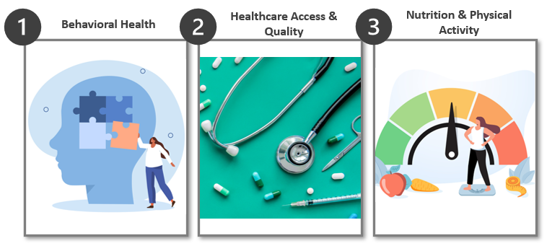

Health, healthcare and associated community needs are very much interrelated, and often impact each other. Although this CHNA process considered these areas separately, their impact on each other should be considered when planning for programs or services to address community needs.

Many health needs are also related to underlying societal and socioeconomic factors. Research has consistently shown that income, education, physical environment, and other such demographic and socioeconomic factors affect the health status of individuals and communities. This CHNA acknowledges that link and focuses on identifying and documenting the greatest health needs as they present themselves today. As plans are developed to address these needs, the Committee’s goal is to work with other community organizations to address underlying factors that could drive long-term improvements to the county population’s health.

For additional discussion of current priority needs and the data that supports those priorities, please see Chapter 3.

CHAPTER 1 | METHODOLOGY

Study Design

The process used to assess Bladen County’s community needs, challenges, and opportunities included multiple steps. Both new and existing data were used throughout the study to paint a more complete picture of Bladen County’s health needs. While the CHNA Steering Committee largely viewed the new and existing data equally, there were situations where one provided clearer evidence of community health need than the other. In these instances, the health needs identified were discussed based on the most appropriate data gathered. Data analysis, community feedback review, and stakeholder engagement were all used to identify key areas of need.

Specifically, the following data types were collected and analyzed:

New (Primary) Data

Public engagement and feedback were received through a web-based community member survey along with community focus groups and significant input and direction from the CHNA Steering Committee. The Steering Committee worked together to develop the survey questions for the web-based survey, and county leaders were provided with a set of target numbers based on their county population’s race, ethnicity and age distribution to encourage recruitment of a representative sample of the community. Community members were asked to identify the most significant health and social needs in their community, as well as asked questions about topics of interest to Bladen County, including access to care, mental health, and substance use disorders. Focus group participants were asked a standard set of questions about health and social needs, in order to identify trends across various groups and to highlight areas of concern for specific populations. In total, the input was gathered from over 420 Bladen County residents and other stakeholders. This included web survey responses from over 400 community members and two focus groups that included over 15 community members and other people who live, work or receive healthcare in Bladen County.

For more information regarding specific questions asked as part of the focus groups and surveys, please refer to Appendix 4.

Existing (Secondary) Data

The primary source for existing data on Bladen County was the North Carolina Data Portal. This website is a joint effort by NCDHHS and the University of Missouri Center for Applied Research and Engagement Systems (CARES), which includes over 120 data indicators focused on demographics, health status and social determinants of health. In addition to information from the North Carolina Data Portal, a variety of other sources were leveraged in this assessment process, including:
- County Health Rankings, developed in partnership by Robert Wood Johnson Foundation (RWJF) and University of Wisconsin Population Health Institute

- The Opportunity Atlas, developed in partnership by the U.S. Census Bureau, Harvard University, and Brown University

- Food Access Research Atlas, published by the U.S. Food and Drug Administration

- Social Vulnerability Index, developed by the CDC and the Agency for Toxic Substances and Disease Registry (ATSDR)

- Environmental Justice Index, developed by the CDC and the ATSDR

- American Community Survey, as collected and published by the U.S. Census Bureau

- Data provided by CHNA Steering Committee members and other affiliated organizations, including Community Health Assessments for Bladen County from 2018 and 2021.

For more information regarding data sources and data time periods, please refer to Appendix 2.

Comparisons
To understand the relevance of existing data collected throughout the process, each measure must be compared to a benchmark, goal, or similar geographic area. In other words, without being able to compare Bladen County to an outside measure, it would be impossible to determine how the county is performing. For this process, each data measure was compared to outside data as available, including the following:

- County Health Rankings Top Performers: This is a collaboration between the RWJF and the University of Wisconsin Population Health Institute that ranks counties across the nation by various health factors.

- State of North Carolina: The Steering Committee determined that comparisons with the state of North Carolina were appropriate.

Population Health Framework

This assessment was developed in alignment with the RWJF population health framework, originally developed by the University of Wisconsin’s Population Health Institute. Population health focuses on health status and outcomes among a specific group of people, and can be based on geographic location, health diagnoses or common health providers. The population health framework recognizes that the issues that affect health in a community are complex; there are many factors that have the potential to impact health outcomes, including both length and quality of life, within a population. Broadly, these factors include the clinical care available to community members, individual health behaviors, the physical environment, and the social and economic conditions in the community.

Using the population health framework as a guide for the CHNA process helps categorize many individual pieces of data in a way that connects the dots between health status and social drivers of health, in a way that helps local leaders better understand and address the health and well-being of the communities they serve. This understanding is critical in identifying potential interventions to address priority needs in the community, and to helping develop partnerships across sectors that can help drive these interventions forward. Figure 6below illustrates the broad categories and sub-categories within the population health framework.

Figure 6: Population Health Framework
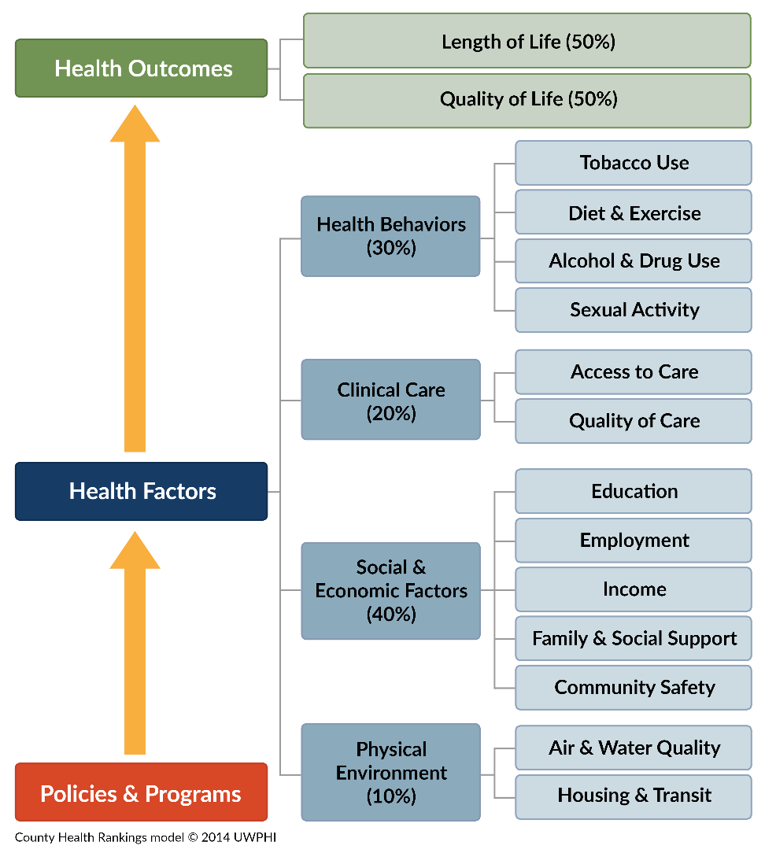

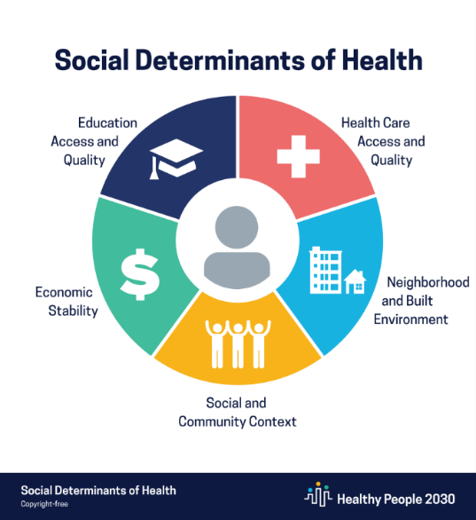
Throughout the process, the Steering Committee also considered Healthy People 2030’s “Social Determinants of Health and Health Equity.” The CDC defines social determinants of health (SDoH) as the conditions in the environments where people are born, live, learn, work, play, worship and age that affect a wide range of health, functioning and quality of life outcomes and risks. These factors can include healthcare access and quality, neighborhood and built environment, social and community context, economic stability, and education access and quality, as outlined in Figure 7.
Figure 7: Social Determinants of Health⁵

Recognizing that SDoH have an impact on health disparities and inequities in the community was a key point the Steering Committee considered throughout the CHNA process. Figure 8 describes the way various social and economic conditions may affect health and well-being.

Figure 8: SDoH and Health Disparities
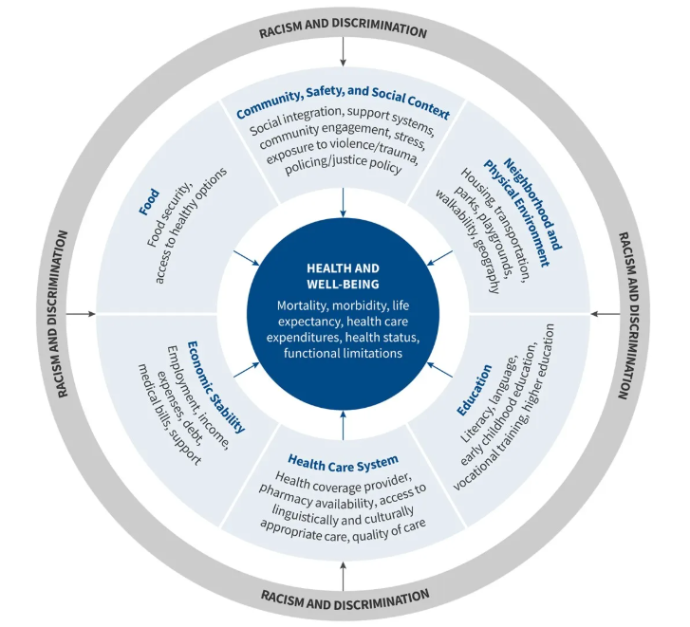

Prioritization Process Overview and Results
The process of identifying the priority health needs for the 2023-2024 CHNA began with the collection and analysis of hundreds of new and existing data measures. In order to create more easily discussable categories, all individual data measures were then grouped into six categories and 20 corresponding focus areas based on “common themes” that correspond to the Population Health Model, as seen in Figure 6. These focus areas are detailed further in Appendix 2.

Since a large number of individual data measures were collected and analyzed to develop these 20 focus areas, it was not reasonable to make each of them a priority. The Steering Committee considered which focus areas had data measures of high need or worsening performance, priorities from the primary data, and how possible it is for health departments or hospitals to impact the given need to help determine which health needs should be prioritized.

Once the primary and secondary data had been grouped into the focus areas detailed in Appendix 2, the CHNA Steering Committee evaluated and prioritized the health needs of Bladen County through group discussion, while considering the following factors:

- Size and scope of the health need;

- Severity and intensity of the health need;

- Whether possible interventions would be possible and effective;

- Health disparities associated with the need; and

- Importance the community places on addressing the need.

The final priority need areas were not ranked in any particular order of importance, and each will be addressed by the Steering Committee. The following three focus areas (Behavioral – Mental Health & Substance Misuse, Healthcare Access & Quality, and Nutrition & Physical Activity) were identified as Bladen County’s top priority health needs to be addressed over the next three years, as seen in Figure 9 below:
Figure 9: Bladen County 2024 Priority Health Needs
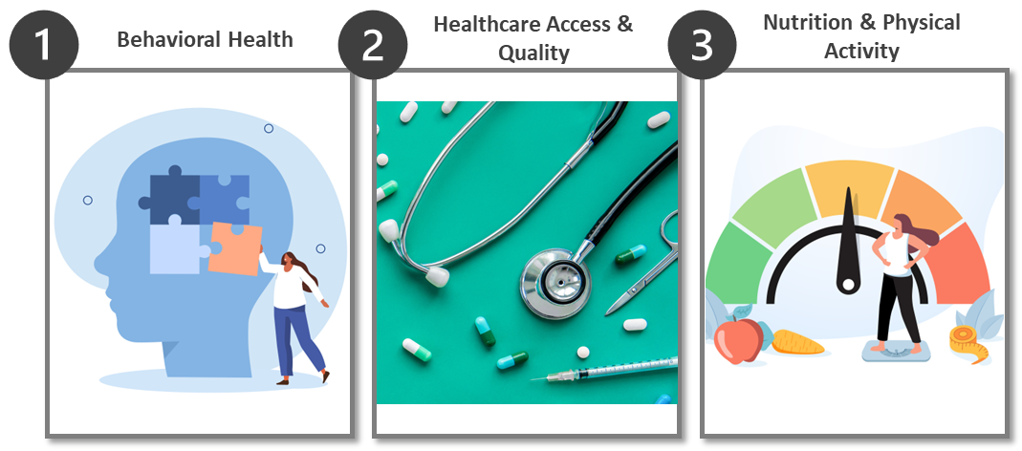

The list of organizations below had members that participated in the prioritization voting process. Most members were also part of the Healthy Bladen Collaborative.

- Bladen County Extension
- Bladen County Department of Social Services
- Bladen County Health Department
- Bladen County Library
- Bladen Health and Human Services Committee
- Cape Fear Valley Bladen County Hospital
- Elizabethtown Chamber of Commerce
- Healthy Bladen
- Region 8 Tobacco Prevention
- Trillium

Study Limitations

Developing a CHNA is a long and time-consuming process. Because of this, more recent data may have been made available after the collection and analysis timeframe. Existing data typically become available between one and three years after the data is collected. This is a limitation, because the “staleness” of certain data may not depict current trends. For example, the U.S. Census Bureau’s American Community Survey is a valuable source of demographic information, however data for a particular year is not published until late the following year. This means 2022 data on community characteristics, such as languages spoken at home, did not become available until late fall 2023. The Steering Committee tried to account for these limitations by collecting new data, including focus groups and web-based community member surveys. Another limitation of existing data is that, depending on the source, it may have limited demographic information, such as gender, age, race, and ethnicity.

Given the size of Bladen County in both population and geography, this study was limited in its ability to fully capture health disparities and health needs across racial and ethnic groups. Resource limitations meant that county leaders relied on convenience sampling to engage with the community via the web-based survey. This method of survey sampling may fail to capture a truly representative cross-section of the community, resulting in overrepresentation of some demographic groups and underrepresentation of others. This can lead to findings that don't accurately reflect the health needs and perspectives of the entire community, particularly those from underrepresented or marginalized groups. While efforts were made to include diverse community members in survey efforts, roughly 71% of all respondents were White compared to the White population of Bladen County comprising just over half (53%) of the total county population. Another 15% of respondents were Black or African American, which was less than the Black or African American total county population (32%). Hispanic representation in the survey was adequate, with nearly 12% of respondents identifying as Hispanic compared to 9% of the total county population being Hispanic. Additionally, 1.5% of survey respondents identified as American Indian and Alaska native, which was slightly less than the overall county population that is Indigenous (2.4%). Although survey respondents could choose from multiple races, limited responses were received from other groups. This made it difficult for the Steering Committee to assess health needs and disparities for some racial/ethnic minority groups in the community.

In addition, there are existing gaps in information for some population groups. Many available datasets are not able to isolate historically underserved populations, including the uninsured, low-income persons, and/or certain minority groups. Despite the lack of available data, attempts were made to include underserved sub-segments of the greater population through the new data gathered throughout the CHNA process. For example, the Steering Committee chose to focus on Spanish-speaking members of the community by providing a Spanish language version of the web-based community survey. Paper surveys were also distributed in an effort to reach as much of the community as possible. To increase future survey responses, members of the Steering Committee should consider working directly with partner organizations in the community who can connect directly with populations who are hard to access through traditional outreach methods, including people with disabilities, the uninsured and people who are disengaged.

In the future, assessments should make efforts to include other underserved communities whose needs are not specifically discussed here because of data and input limitations during this CHNA cycle. Of note, residents in the disabled, blind, deaf, and hard-of-hearing communities can be a focus of future new data collection methods. Using a primarily web-based survey collection method might have also impacted response rates of community members with no internet access or low technological literacy. Additionally, more input from both patients and providers of SUD services would also be helpful in future assessments.

Finally, parts of this assessment have relied on input from community members and key community health leaders through web-based surveys and focus groups. Since it would be unrealistic to gather input from every single member of the community, the community members that participated have offered their best expertise and understanding on behalf of the entire community. As such, the CHNA Steering Committee has assumed that participating community members accurately and completely represented their fellow residents.

CHAPTER 2 | COUNTY PROFILE

Geography

Bladen County, also called “Mother County,” is located in the Inner Coastal Plains region of North Carolina, characterized by the presence of low-lying areas and slow, winding rivers, and a hilly, sandy environment. It covers a total of 888 square miles, including 875 square miles of land and 13 square miles of water. Bladen is comprised of seven municipalities: Elizabethtown, Bladenboro, Clarkton, Dublin, East Arcadia, Tar Heel and White Lake. The entire population in Bladen County resides in rural areas.

Population

Population figures discussed throughout this chapter were obtained from Esri, a leading GIS provider that utilizes U.S. Census data projected forward using proprietary methodologies.

As a rural county, Bladen County has a small population that makes up approximately one-quarter of one percent of North Carolina’s population.

Table 1: Total Population, 2023
 | Bladen County | North Carolina | United States
Population | 28,692 | 10,765,678 | 337,470,185

Bladen County has a population density of 32.9 persons per square mile – significantly lower than the population density for North Carolina (214.7 persons per square mile). Elizabethtown is the most densely populated area in the county.
Figure 10: Bladen County Map: Population Density⁷
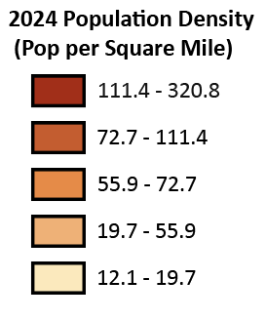
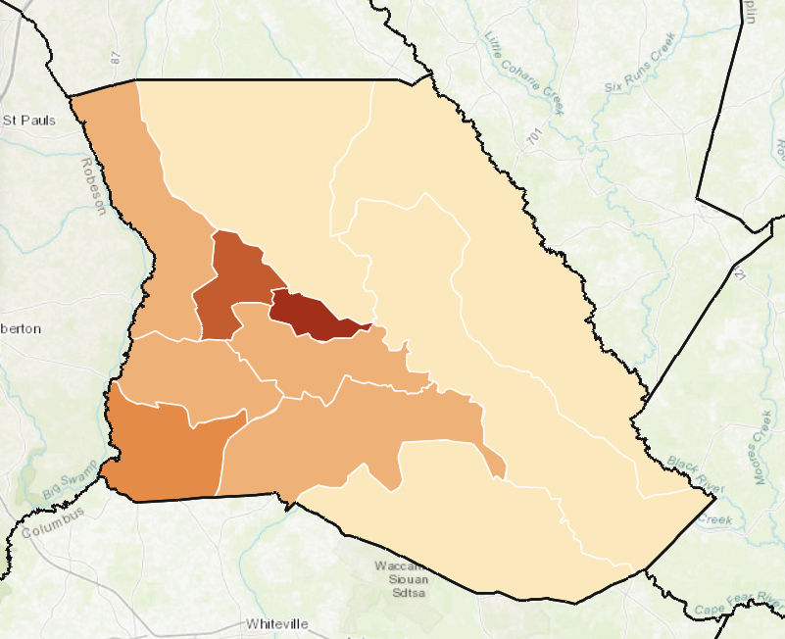
In total, the population of Bladen County is projected to decline 0.56% annually between 2024 and 2029. Areas in the southeastern parts of the county are experiencing the greatest declines.

Figure 11: Bladen County Map: Population Growth⁷
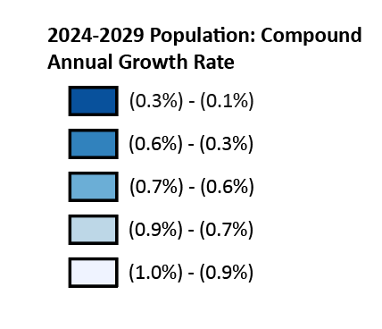
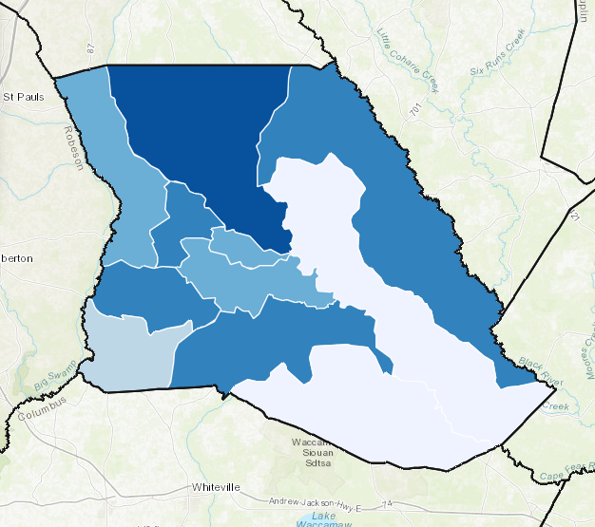

Age and Sex Distribution

Data on age and sex helps health providers understand who lives in the community and informs planning for needed health services. The age distribution of Bladen County skews slightly older than the state and the United States. The percentage of Bladen County residents ages 65 and older is nearly 5% higher than the state and national averages.

Table 2: Age Distribution, 2023⁷
 | Bladen County | North Carolina | United States
Percentage below 15 | 16.7% | 17.9% | 18.1%
Percentage between 15 and 44 | 34.3% | 39.3% | 39.5%
Percentage between 45 and 64 | 26.4% | 25.1% | 24.6%
Percentage 65 and older | 22.6% | 17.7% | 17.8%

Unlike the state and national population distribution by sex, Bladen County skews slightly more male than female.
Table 3: Sex Distribution, 2023⁷
 | Bladen County |  | North Carolina |  | United States
 | Count | Pct. of  Total | Count | Pct. of  Total | Count | Pct. of  Total
Female | 14,291 | 49.8% | 5,489,419 | 51.0% | 170,118,720 | 50.4%
Male | 14,401 | 50.2% | 5,276,259 | 49.0% | 167,351,465 | 49.6%

Race and Ethnicity

Data on race and ethnicity help us understand the need for healthcare services as well as cultural factors that can impact how care is delivered. In Bladen County, over half the population identifies as White and non-Hispanic. Compared to the state and national averages, there are more residents who identify as non-Hispanic Black (32.4%) and more residents who identify as American Indian and Alaska Native (AIAN) (2.8%). Asian and Native Hawaiian & Pacific Islander (NHPI) residents combined make up less than 1% of Bladen County.

Table 4: Racial Distribution, 2023⁷
 | Bladen County |  | North Carolina |  | United States
 | Count | Pct. of Total | Count | Pct. of Total | Count | Pct. of Total
Black (Non-Hispanic) | 9,306 | 32.4% | 2,199,488 | 20.4% | 42,132,758 | 12.5%
White (Non-Hispanic) | 15,374 | 53.6% | 6,590,161 | 61.2% | 204,562,590 | 60.6%
Asian | 50 | 0.2% | 379,374 | 3.5% | 21,088,177 | 6.2%
AIAN | 793 | 2.8% | 133,820 | 1.2% | 3,831,126 | 1.1%
NHPI | 11 | 0.1% | 9,214 | 0.1% | 712,229 | 0.2%
Some Other Race Alone | 1,851 | 6.5% | 677, 338 | 6.3% | 29,432,586 | 8.7%
Two or More Races | 1,307 | 4.6% | 776,283 | 7.2% | 35,710,719 | 10.6%

By ethnicity, 9.1% of Bladen County’s population is Hispanic. This is lower than state and national averages.

Table 5: Ethnic Distribution, 2023⁷
 | Bladen County |  | North Carolina |  | United States
 | Count | Pct. of Total | Count | Pct. of Total | Count | Pct. of Total
Non-Hispanic | 26,068 | 91.9% | 9,465,874 | 88.6% | 271,934,049 | 80.6%
Hispanic | 2,624 | 9.1% | 1,299,804 | 11.4% | 65,536,136 | 19.4%

The proportion of foreign-born individuals residing in Bladen County is 2.5%, significantly lower than state and national averages.

Table 6: Foreign Born Population, 2022
 | Bladen County | North Carolina | United States
Foreign Born | 2.5% | 9% | 13.9%

The diversity of Bladen County is reflected in the languages that residents speak at home. According to the most recent American Community Survey, approximately 7% of Bladen County residents speak a language other than English at home, compared to around 12.7% of North Carolina and 22% of U.S. residents. Spanish is the second most common language spoken at home in Bladen County.
Table 7: Language Spoken at Home, 2022⁸
 | Bladen County | North Carolina | United States
English Only | 92.7% | 87.3% | 78%
Spanish | 6.8% | 7.9% | 13.3%
Indo-European Languages | 0.3% | 2.1% | 3.8%
Asian and Pacific Islander Languages | 0.2% | 1.9% | 3.6%
Other Languages | - | 0.8% | 1.2%

Disability Status

Data on disabilities helps us understand how to create fair and equal opportunities for everyone in the county. In addition, individuals with disabilities may require targeted services and outreach by health and other service providers. The disability rate in Bladen County is slightly higher than the state and national averages.

Table 8: Disability Status, 2022⁸
 | Bladen County | North Carolina | United States
Population with a Disability | 14.8% | 13.3% | 12.9%

Veteran Status

Military veterans often need special services and support, so it is important to collect data about them to be better able to meet their specific needs. Nearly 10% of Bladen County’s population are veterans, which is higher than the state or the U.S.
Table 9: Veteran Status, 2022⁸
 | Bladen County | North Carolina | United States
Veterans | 9.5% | 7.8% | 6.2%

Economic Indicators

In addition to demographic data, socioeconomic factors in the community such as income, poverty, and food scarcity play a significant role in identifying health-related needs. The median household income in Bladen County is $38,607, roughly half the state or the U.S.

Table 10: Median Household Income, 2023⁷
 | Bladen County | North Carolina | United States
Median Household Income | $38,607 | $64,316 | $72,603

In 2023, approximately 20% of Bladen County households were below the federal poverty level (FPL). Poverty has a significant impact on health. Across the lifespan, people who live in impoverished communities have a higher risk of poor health outcomes, including mental illness, chronic diseases, higher mortality and lower life expectancy. Poverty is a concern across the lifespan; children who live in poverty are at risk for developmental delays, toxic stress and poor nutrition, and are likely to live in poverty as adults as well. Unmet social needs, including having low or no income, can also limit people’s ability to access healthcare when they need it, or to provide for basic necessities needed to live healthy lives, such as safe housing or healthy food.

Table 11: Percent of Households Below the FPL, 2023⁷
 | Bladen County | North Carolina | United States
Percent Below FPL | 19.9% | 10.1% | 9.5%

Exceeding the percentage of households living below the FPL, approximately one in three Bladen County households received Food Stamps/SNAP in 2022.

Table 12: Households Receiving Food Stamps/SNAP, 2022,
 | Bladen County | North Carolina | United States
Number of Households Receiving Food Stamps/SNAP | 3,865 | 575,860 | 16,072,733
Total Number of Households | 12,092 | 4,299,266 | 129,870,928
Percentage of Households receiving Food Stamps/SNAP | 32.0% | 13.4% | 12.4%

In Bladen County, most residents have either attained a high school diploma (24.5%) or completed some college (24.1%). There is a significantly higher percentage of residents who have not completed high school compared to the state or nation, and a lower percentage or residents with a Bachelor’s degree or higher.

Table 13: Educational Attainment, 2020,
 | Bladen County | North Carolina | United States
Less than 9th Grade | 4.8% | 6.0% | 3.5%
Some High School/No Diploma | 12.0% | 5.5% | 5.3%
High School Diploma | 24.4% | 21.2% | 28.5%
GED/Alternative Credential | 6.5% | 4.3% | *
Some College/No Diploma | 24.1% | 21.1% | 14.6%
Associate’s Degree | 10.0% | 9.9% | 10.5%
Bachelor’s Degree | 12.8% | 20.4% | 23.4%
Graduate/ Professional Degree | 5.3% | 11.6% | 14.2%

The total rate of unemployment in Bladen County is comparable to the state of North Carolina. The group with the highest unemployment rate in Bladen is the population ages 25 to 54 at nearly 7%.

Table 14: Unemployment, 2022,
 | Bladen County | North Carolina | United States
Percentage unemployed ages 16 to 24 | 5.0% | 12.4% | 11.0%
Percentage unemployed ages 25 to 54 | 6.7% | 4.7% | 3.4%
Percentage unemployed ages 55 to 64 | 5.2% | 3.3% | 2.7%
Percentage unemployed ages 65 or more | 0.5% | 3.0% | 2.9%
Total unemployment | 5.5% | 5.1% | 3.9%

In Bladen County, the population aged 19 to 34 has the lowest rate of insurance. – nearly a quarter of this age group is uninsured.

Table 15: Health Insurance Status, 2022
 | Bladen County | North Carolina | United States
Percentage uninsured ages 18 or below | 3.1% | 5.2% | 5.4%
Percentage uninsured ages 19 to 34 | 23.1% | 15.5% | 13.6%
Percentage uninsured ages 35 to 64 | 14.0% | 12.5% | 9.9%
Total % Uninsured | 14.0% | 12.0% | 10.0%

Social Determinants of Health
Figure 12: Social Determinants of Health
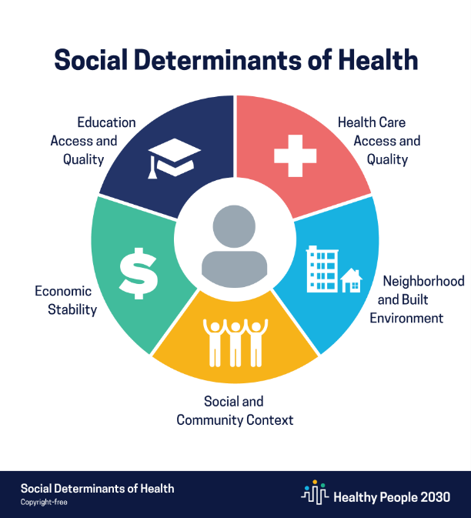
In addition to the considerations noted above, there are many other factors that can positively or negatively influence a person’s health. The Steering Committee recognizes this and believes that, to portray a complete picture of the county’s health status, it first must address the factors that impact community health. The Centers for Disease Control and Prevention (CDC) defines social determinants of health (SDoH) as the conditions in the environments where people are born, live, learn, work, play, worship and age that affect a wide range of health, functioning and quality of life outcomes and risks. According to the CDC’s “Social Determinants of Health” from its Healthy People 2030 public health priorities initiative, factors contributing to an individual’s health status can include the following: healthcare access and quality, neighborhood and built environment, social and community context, economic stability, and education access and quality.

As seen in Figure 12, many of the factors that contribute to health are hard to control or societal in nature. As such, health and healthcare organizations need to consider many underlying factors that may impact an individual’s health and not simply their current health conditions.

It is widely acknowledged that people with lower income, social status and levels of education find it harder to access healthcare services compared to people in the community with more resources. This lack of access is a factor that contributes to poor health status. Further, people in communities with fewer resources may also experience high levels of stress, which also contributes to worse health outcomes, particularly related to mental or behavioral health.

An analysis of the racial and geographic disparities that emerged in the information obtained and analyzed during this process is detailed below. The CHNA Steering Committee also collected new data via focus groups and surveys to ensure that residents and key community health leaders could provide input regarding the needs of their specific communities. This information will be presented in detail later in this report.

Disparities

Recognizing the diversity of Bladen County, as discussed above, the Steering Committee evaluated factors that may contribute to health disparities in its community. These included racial equity; racial segregation; financial barriers; nutrition; social, behavioral, and economic factors that influence health; and English language proficiency.

Residential segregation is measured by the index of dissimilarity, a demographic measure ranging from 0 to 100 that represents how evenly two demographic groups are distributed across a county’s census tracts. Lower scores represent a higher level of integration. Bladen County has a significantly lower amount of residential segregation than state and country statistics, as seen in Figure 13.

Figure 13: Residential Segregation⁴


Income inequality is measured as the ratio of household income at the 80th percentile to household income at the 20th percentile. Communities with greater income inequality may have worse outcomes on a variety of metrics, including mortality, poor health, sense of community, and social support. As seen in Figure 14, Bladen County has a higher ratio of income inequality compared to the North Carolina and United States.
Figure 14: Income Inequality Ratio⁴

People with limited English proficiency (LEP) may face challenges accessing care and resources that fluent English speakers do not. Language barriers may make it hard to access transportation, medical, and social services as well as limit opportunities for education and employment. Importantly, LEP community members may not understand critical public health and safety notifications, such as safety-focused communications during the COVID-19 pandemic. In Bladen County, only 2.5% of the population has limited English proficiency, as seen in Figure 15.

Figure 15: Percent of Population with Limited English Proficiency⁸

Social Vulnerability Index

One resource that can help show variation and disparities between geographic areas is the Social Vulnerability Index (SVI), which was developed by the CDC and the Agency for Toxic Substances and Disease Registry (ATSDR). Social vulnerability refers to negative effects communities may experience due to external stresses that impact human health, like natural or human-caused disasters, or disease outbreaks. Socially vulnerable populations are at especially high risk during public health emergencies.

The SVI uses 16 U.S. Census variables to help local officials identify communities that may need support before, during, or after a public health emergency. Communities with a higher SVI score are generally at a higher risk for poor health outcomes. Instead of relying on public health data alone, the SVI accounts for underlying economic and structural conditions that affect overall health, including SDoH. SVI scores are calculated at the census tract level and based on U.S. Census variables across four related themes: socioeconomic status, household characteristics, racial and ethnic minority status, and housing type/transportation. Figure 16 outlines the variables used to calculate SVI scores.

Figure 16: SVI Variables

The United States SVI by county is shown in Figure 17 below. As shown, a lot of variation exists across the country, and even within individual states.
Figure 17: United States SVI by County, 2022
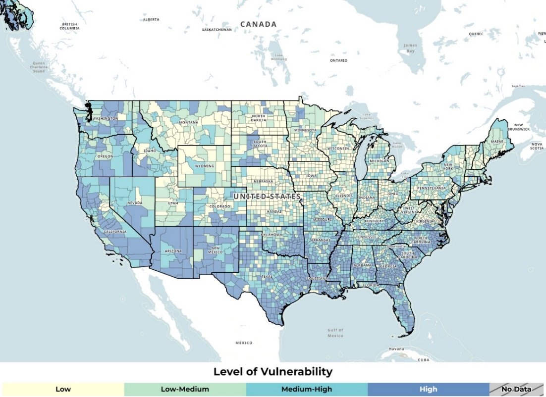
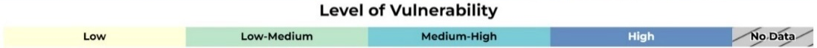

The 2022 SVI scores for Bladen County are shown in Figure 18 below. Possible scores range from 0 (lowest vulnerability) to 1 (highest vulnerability), and these scores show a relative comparison with other counties and census tracts in North Carolina. The vulnerability of Bladen County overall is higher than average compared to the state. Levels of vulnerability are variable across the county with the average being 0.64.

Figure 18: Bladen County SVI by Census Tract, 2022
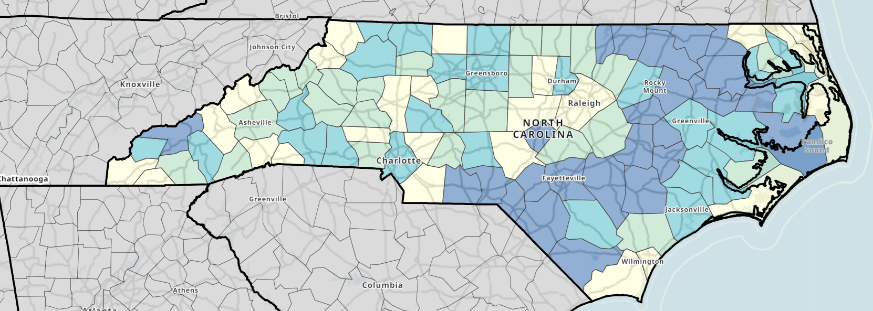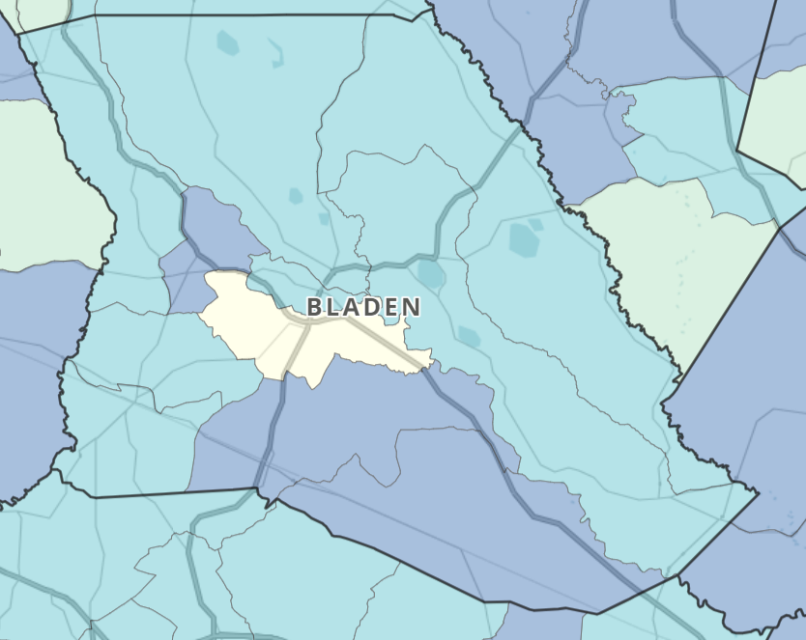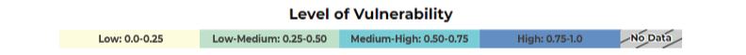

Environmental Justice Index

Environmental justice means the just treatment and meaningful involvement of all people, regardless of income, race, color, national origin, Tribal affiliation, or disability, in agency decision-making and other Federal activities that affect human health and the environment. It aims to protect everyone from disproportionate health and environmental risks, address cumulative impacts and systemic barriers, and provide equitable access to a healthy and sustainable environment for all activities and practices.

The CDC/ATSDR EJI is a database that ranks the impact of environmental injustice on health. It uses data from the U.S. Census Bureau, the U.S. Environmental Protection Agency, the U.S. Mine Safety and Health Administration, and the U.S. Centers for Disease Control and Prevention. The Index scores environmental burden and injustice at the census tract level in the U.S. based on multiple social, environmental, and health factors.

Over time, communities with a higher EJI score are generally shown to experience more severe impacts from environmental burden than communities in other census tracts. Figure 19 outlines the variables used to calculate EJI scores.

Figure 19: EJI Variables

The United States EJI by county is shown in Figure 20 below. As shown, a lot of variation exists across the country, and even within individual states.
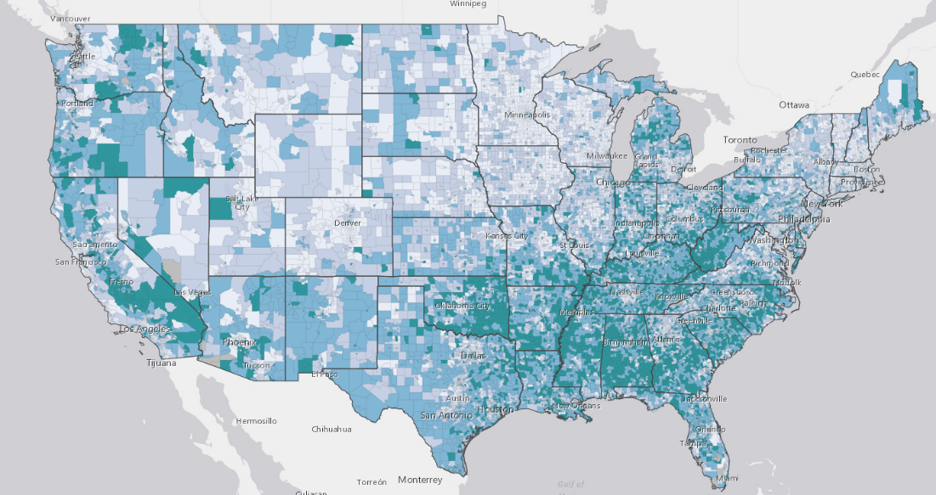
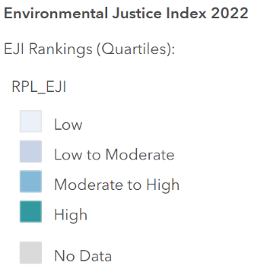
Figure 20: United States EJI by Census Tract, 2022

The 2022 EJI scores for Bladen County are shown in Figure 21 below. EJI scores use percentile ranking which represents the proportion of census tracts that experience environmental burden relative to other census tracts in North Carolina. The index ranges from 0-1 with higher scores indicating more environmental burden compared to other census tracts. Levels of environmental burden are variable across the county, but relatively high, with the average being 0.82.
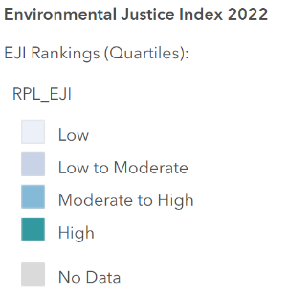
Figure 21: Bladen County EJI, 2022
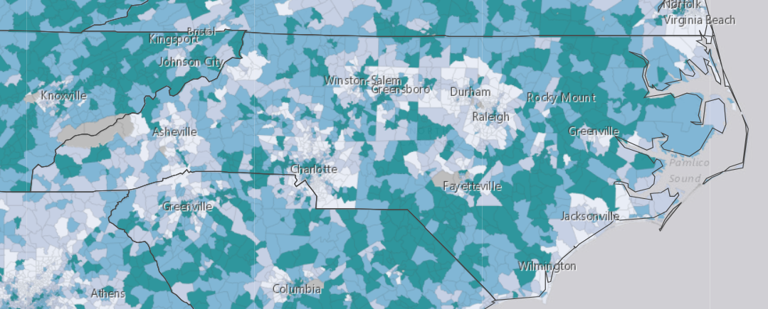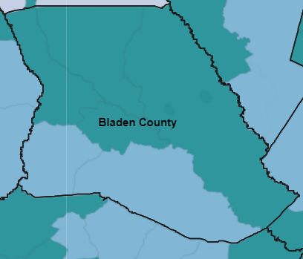

Health Outcome and Health Factor Rankings

County leaders also reviewed and analyzed data from the Robert Wood Johnson Foundation and the University of Wisconsin County Health Rankings for the year 2024. The Health Outcomes measure looks at how long people in a community live and how physically and mentally healthy they are. These categories are discussed further in Appendices 2 through 4. Bladen is behind the average for the country and the state, which means people there may be less healthy on average.

Figure 22: State Health Outcomes Rating Map⁴
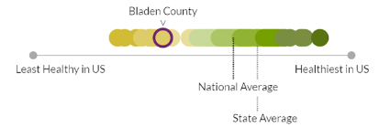
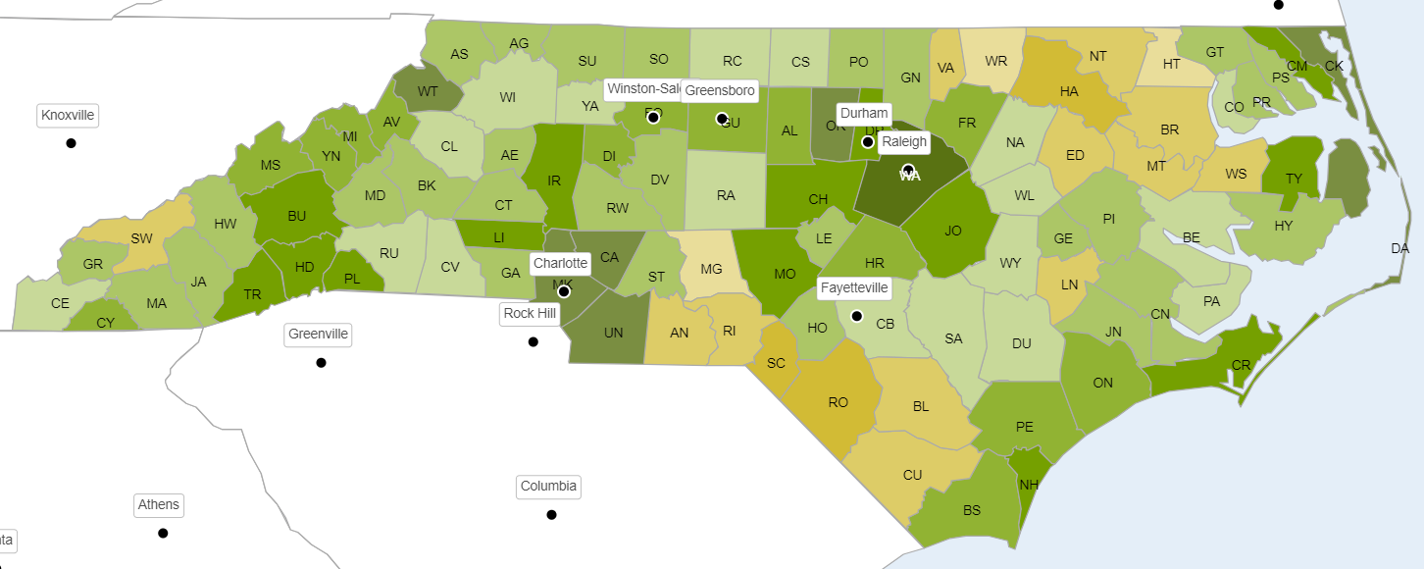

The Health Factors measure looks at variables that affect people's health including health behaviors, clinical care, social & economic factors, and the physical environment they live in. More details about these indicators can be found in Appendices 2 through 4. Similarly to the Health Outcome measure, Bladen falls behind the average for the country and the state.

Figure 23: State Health Factors Rating Map^{4Error! Bookmark not defined.}
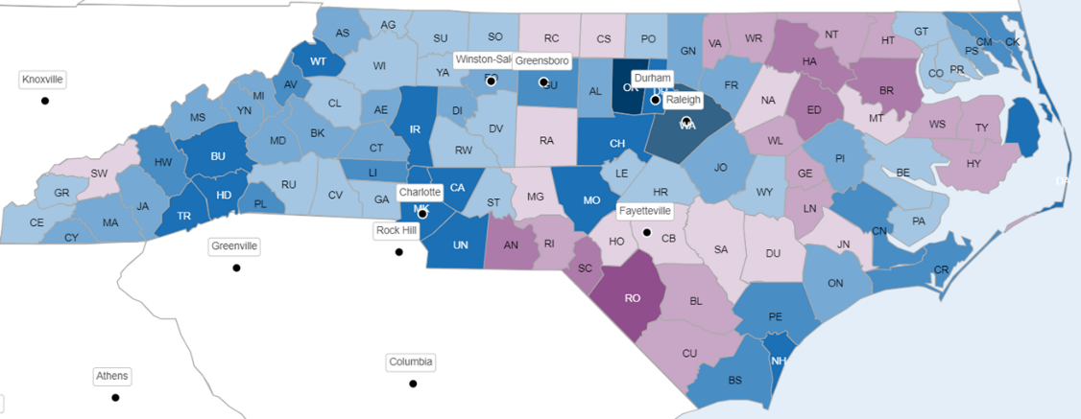
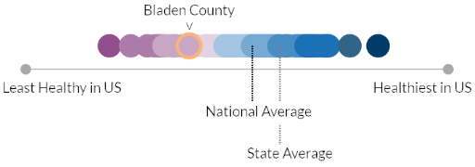

CHAPTER 3 | PRIORITY NEED AREAS

This chapter describes each of the three priority areas in more detail and discusses the data that supports each priority. The information in this section includes context and national perspective, secondary data findings, and primary data findings (including the community member survey and focus groups). As previously described in Chapter 1: Methodology, secondary data was primarily sourced using the North Carolina Data Portal. For additional descriptive information on data sources and methodology, please see Appendix 2.

Bladen County conducted a prioritization meeting on August 27, 2024, at the Bladen County Health Department. The meeting included representation from a diverse group of organizations and community members, including Cape Fear Valley Health System (CFVHS), Bladen Health and Human Services Committee, Healthy Bladen, Bladen County Health Department, Trillium, Bladen County Extension, Cape Fear Valley-Bladen Healthcare, and Bladen County Division of Aging. Participants included healthcare administrators, social workers, health educators, community outreach specialists, and community members. The prioritization process involved discussion and review of priority areas identified based on responses from the community to determine the greatest needs in Bladen County.

As mentioned previously, these priority needs areas are not listed in any hierarchical order of importance and all will be addressed by the Bladen County leaders in health improvement plans guided by this CHNA. As noted in Chapter 1, county health leadership considered the following factors when determining the priority needs reported in this assessment:

- Size and scope of the health need;

- Severity and intensity of the health need;

- Estimated feasability and effectiveness of possible interventions;

- Health disparities associated with the need; and

- Importance the community places on addressing the need.

Priority Need: Behavioral Health

Context and National Perspective

The definition of behavioral health often describes conditions related to both mental health and substance use. Mental health is defined as an emotional, psychological, and social state of well-being. Mental health impacts every stage of life and affects how one is able to handle their relationships, daily stressors, and health behaviors. After evaluating data from a variety of sources including surveys and focus groups conducted throughout the assessment process, the Steering Committee identified behavioral health, including both mental health and substance use, to be an area of urgent need within Bladen County.

Mental illnesses are common in the United States: in 2021, an estimated 57.8 million U.S. adults – nearly one in five – were living with a mental illness. There is risk for developing a mental illness across the lifespan, with over one in five children and adults in the U.S. reported to have a mental illness, and nearly one in twenty-five adults currently coping with a serious mental illness (SMI) such as major depression, schizophrenia or bipolar disorder.

Mental illness can occur due to multiple different factors, such as genetics, drug and/or alcohol usage, isolation, adverse childhood experiences, and chronic health conditions. Additionally, mental illness can act like other chronic health conditions, in that it can worsen or improve depending on the environment. Mental health services have evolved in the past five years, especially during the COVID-19 pandemic. However, accessing mental health care services can be challenging. According to the National Institute of Mental Health, less than half (47.2%) of adults with a common mental illness received any mental health services in 2021. Those who had an SMI were more likely (65.4%) to have received mental health services that same year.24 While access to telehealth mental health services has increased, those living in rural areas may still find it difficult to access care. This is a particular concern among those who are low-income or experiencing homelessness, two groups at high risk for developing an acute or chronic mental health condition. As of 2023, over seven million people in the U.S. who reported having a mental illness lived in a rural area.

Mental illness is a prevalent concern in North Carolina, with nearly 1.5 million adults reported to have a mental health condition in 2023. Additionally, that same year, 1 in 7 individuals who were identified as homeless also were living with an SMI. Access to mental health care in North Carolina is changing, however it is still unavailable to many. Specifically, over 452,000 individuals did not seek care in 2023, with 44.8% citing cost as the main reason. Additionally, those in live in North Carolina are seven times more likely to be pushed out of network of their behavioral health providers, than a primary care provider, furthering cost as a cause for stopping treatment.

Substance use disorders (SUDs) are one of the fastest rising categories of behavioral health disorders. According to the American Psychiatric Association, SUDs are a complex condition in which there is uncontrolled use of a substance (such as alcohol or drugs), despite harmful consequences. SUDs often occur in conjunction with other mental illness. In 2023, 16 million (46.9%) young adults aged 18-25 reported having either a SUD or Acute Mental Illness (AMI) in the past year. In that same year, 17.1% (48.5 million) of all U.S. adults were reported as having an SUD. These trends have been increasing in recent years. According to the National Center for Drug Abuse Statistics, in 2018 (3.7%) of all adults aged 18 and older (9.2 million) had both an AMI and at least one SUD. By 2021, this had increased to 13.5% of U.S. adults, with the highest incidence among Multiracial adults.

There are multiple common forms of SUD, such as alcohol use, cocaine use, cannabis use, opioid use, and methamphetamine use disorders. An individual living with one SUD can also be coping with another at the same time, such as co-occurring use of alcohol and cannabis. Treatment SUDs generally cannot follow a cookie-cutter approach, as each person receiving treatment will have different withdrawal and coping needs. Treatment is typically provided through various therapies, inpatient admissions, and forms of medication-assisted treatment such as methadone. Opioid overdoses are one of the most common types of deaths related to SUDs, and can be preventable and treatable if caught in time. Multiple efforts have been coordinated within the past two years to incorporate the storage of overdose reversing medications such as Naloxone in public facilities such as federal facilities, and over the counter, as was approved in 2023 by the FDA. This is critical, as in 2022, the number of opioid overdoses nationwide surpassed 81,051 – a 63% increase in overdoses since 2019.

Substance use disorders have also had an impact in North Carolina. Over 36,000 overdose deaths occurred in the state between 2000 and 2022 – an average of more than 1,600 deaths each year. Multiple programs have been developed in North Carolina to combat substance use disorder, notably surrounding opioid usage, which has led to an increase in access and usage of Medication Assisted Treatment (MAT) and methadone clinics within the state. Additionally, North Carolina launched the Opioid and Substance use action plan, which involved the development of multiple interventions, dashboards, and educational materials to help support counties and organizations with reducing not only overdose deaths, but the incidence of SUDs as well.

The pandemic impacted public mental health and well-being in many ways. Community members continue to grapple with the pandemic-related effects of isolation and loneliness, financial instability, long-term health impacts and grief, all of which are drivers for developing a substance use disorder. In addition, both drug overdose and suicide deaths have sharply increased over the past several years – often disproportionately impacting younger people and communities of color.

Access to services that address mental health and substance use is an ongoing challenge across the U.S. According to the Substance Abuse and Mental Health Services Administration (SAMHSA), in 2021, less than half (47.2%) of U.S. adults who reported having a mental illness utilized any type of mental health services, including inpatient, outpatient or telehealth services or prescription drug therapies. Demand for mental health services, particularly anxiety and depression treatment, remains high across the nation, while the prevalence of stress- and trauma-related disorders, along with substance use disorders, continues to grow. The American Psychological Association reports that the percentage of psychologists in the U.S. seeing more patients than they did before the pandemic increased from 15% in 2020 to 38% in 2021 to 43% in 2022. Further, 60% of psychologists reported having no openings for new patients and 38% maintained a waitlist for their services.

Secondary Data Findings

Secondary data collected through the CHNA process identified behavioral health as an area of significant concern for residents of Bladen County. The county has a markedly higher crude mortality rate for deaths of despair (83.7 per 100,000 population) compared to both North Carolina (58.7) and the United States (55.9). This concerning trend shows notable gender disparities, with men experiencing significantly higher rates of deaths of despair than women, as displayed in the figure below.

While the county's suicide rate (12.7 per 100,000 population) is slightly lower than state (14.0) and national (14.5) averages, residents report a higher average number of poor mental health days per month (5.0) compared to both North Carolina (4.6) and national (4.9) figures.

Table 16: Mental Health Indicators
Indicator | Bladen County | North Carolina | United States
Deaths of Despair  (Crude Rate per 100,000 Population) | 83.7 | 58.7 | 55.9
Suicide  (Crude Rate per 100,000 Population) | 12.7 | 14.0 | 14.5
Average Number of Poor Mental Health Days  (per Month) | 5.0 | 4.6 | 4.9

Figure 24: Crude Rate of Deaths of Despair by Gender
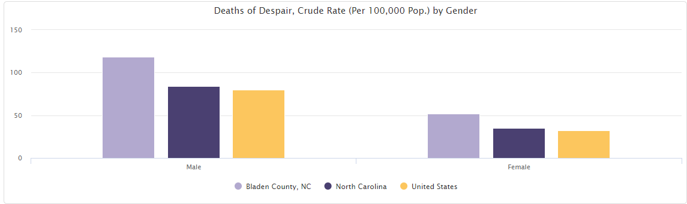

Regarding substance use disorders, Bladen County presents a complex picture. While the percentage of adults reporting excessive drinking (15%) is lower than both state and national averages (18%), the county faces significant challenges with alcohol-related incidents and opioid use. The rate of alcohol-involved crash deaths (9.5 per 100,000 population) is more than three times the state average (2.9) and four times the national rate (2.3). Additionally, the county's opioid overdose death rate (40.6 per 100,000 population) is substantially higher than North Carolina's rate (25.1), and the county has seen an increase in opioid use disorder emergency department utilization (44 per 100,000 beneficiaries) compared to the state average (43).

Table 17: Substance Use Disorder Indicators
Indicator | Bladen County | North Carolina | United States
Percentage of Adults Reporting Excessive Drinking | 15% | 18% | 18%
Opioid Use Disorder Emergency Department Utilization (Rate per 100,000 Beneficiaries) | 44 | 43 | 41
Alcohol-Involved Crash Deaths, Annual  (Rate per 100,000 Population) | 9.5 | 2.9 | 2.3
Opioid Overdose Death Rate  (Crude Rate per 100,000 Population) | 40.6 | 25.1 | 15.7

For additional detail on secondary data findings, see Appendix 3.

Primary Data Findings – Community Member Web Survey

Nearly 400 Bladen residents responded to the web-based survey. Respondents identified several behavioral health needs in Bladen County. In the survey, community members were asked to identify the top three health problems. Alcohol/drug addiction (57%) and mental health (depression/anxiety) (42%) were the first and third most identified health concerns affecting the community.

Figure 25: What are the three most important health problems that affect the health of your community? Please select up to three.
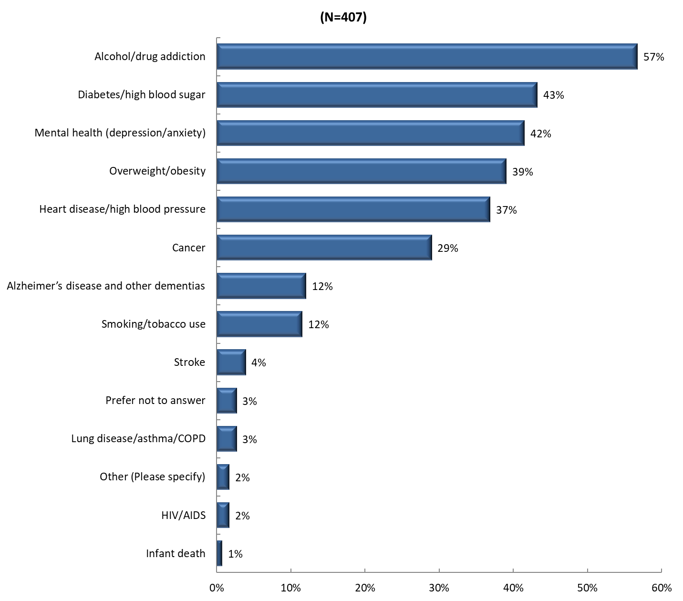
When these data were examined by age group, the age group that most frequently identified alcohol/drug addiction (80.8%) and mental health (50.0%) as top health problems was those ages 18 to 24. Respondents ages 18 to 24 were more than twice as likely as those ages 65 and older to identify alcohol/drug addiction and mental health as important health needs.

Figure 26: What are the three most important health problems that affect the health of your community? Please select up to three. (by age)
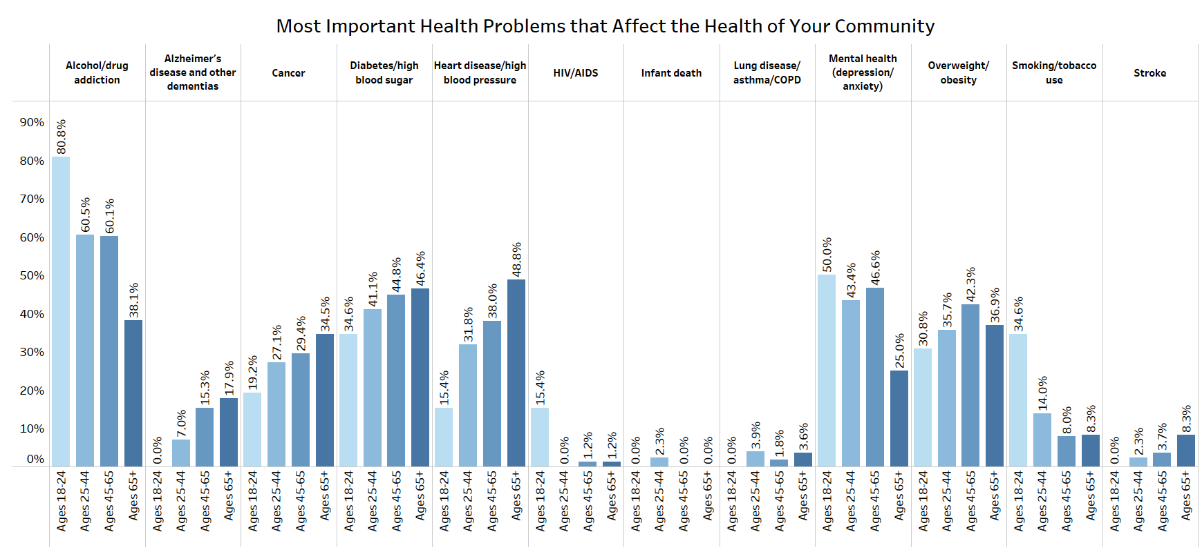

Responses also differed by race and ethnicity. Half of respondents who identified as Black or African American selected mental health (50.0%) compared to those who identified as White (41.0%) or identified with the “Other” race category (36.4%), which includes those who identified as American Indian and Alaska Native, Asian, Native Hawaiian and other Pacific Islander, and/or those who selected more than one race or “other.” Conversely, respondents identifying with the “Other” race category were more likely to select alcohol/drug addiction (59.1%) compared to those who identified as Black or African American (51.6%), or White (58.0%).

Figure 27: What are the three most important health problems that affect the health of your community? Please select up to three. (by race)
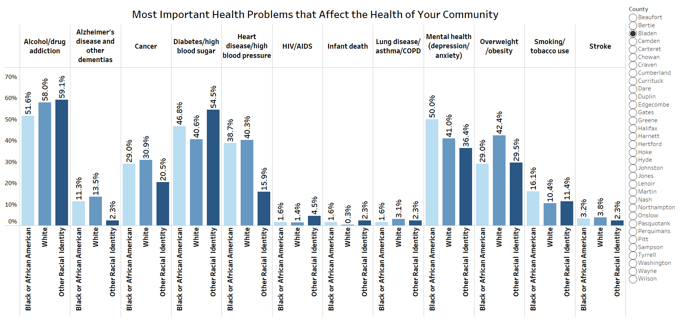

Notably, Hispanic and non-Hispanic respondents differed in their responses. Non-Hispanic respondents were more likely to identify alcohol/drug addiction (59.2% vs. 40.4%) and mental health (44.5% vs. 23.4%) as top health problems. By contrast, the largest percentage of Hispanic respondents identified diabetes/high blood sugar, the second most selected problem across the entire respondent pool.

Figure 28: What are the three most important health problems that affect the health of your community? Please select up to three. (by ethnicity)
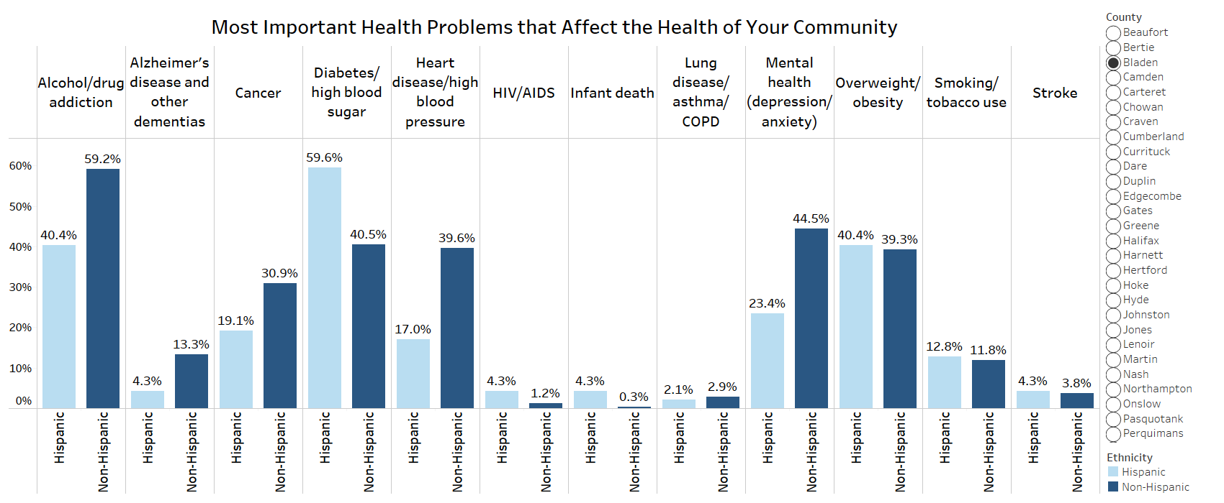

When compared by gender, male (55.4%) and female (52.3%) respondents were almost equally likely to identify alcohol/drug addiction as an important health concern within the community, however, women (43.9%) were nearly twice as likely to identify mental health as a health problem than men (26.8%).

Figure 29: What are the three most important health problems that affect the health of your community? Please select up to three. (by gender)
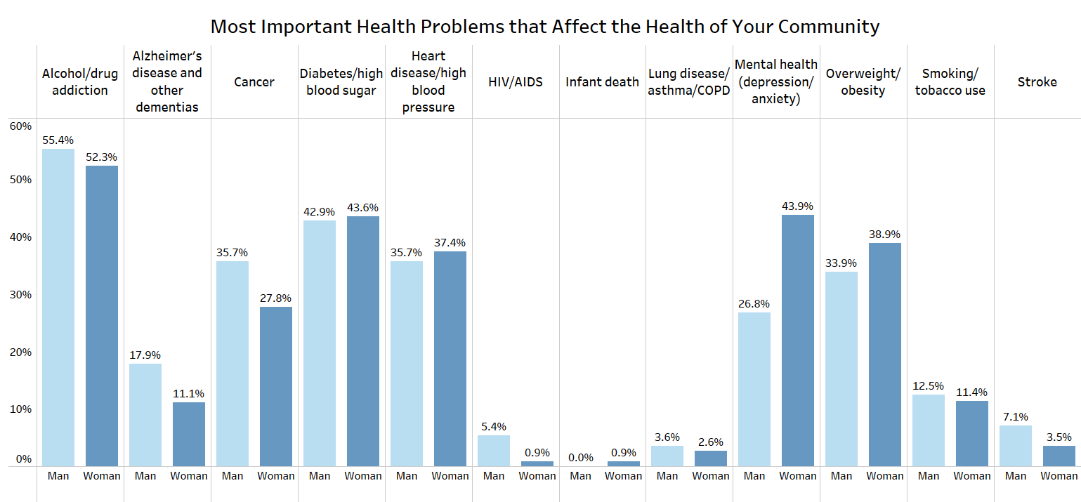

When respondents were asked about their own mental health, more than half of respondents indicated having one or more poor mental health days in the past 30 days, with an average of 6 poor mental health days among all respondents.

Figure 30: Now thinking about your MENTAL health, which includes stress, depression, and problems with emotions, for how many days during the past 30 days was your mental health NOT good?
- (N = 391)
- 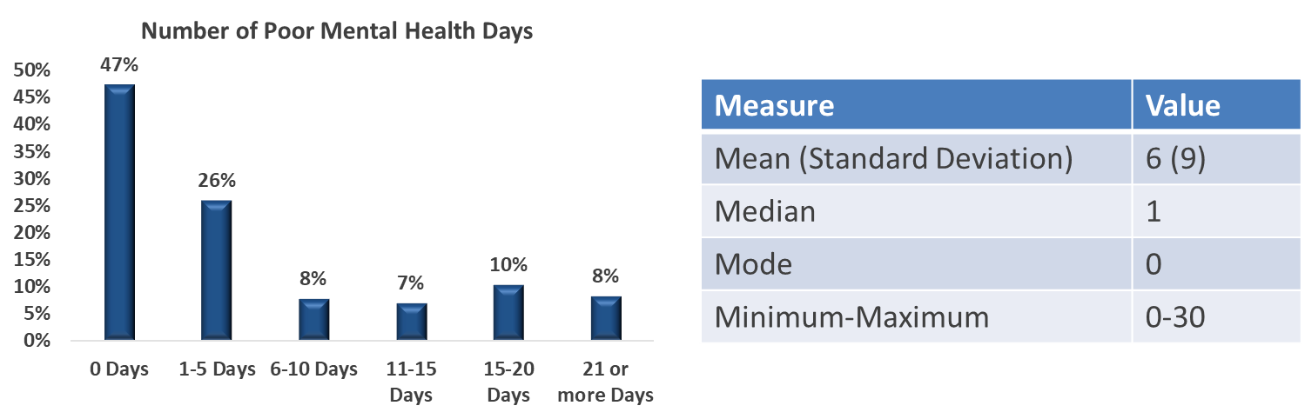
Community members respondents who indicated they experienced at least one poor mental health day were asked if there was a time in the past 12 months when they needed mental health care or counseling but did not get it at that time. One-third of these respondents answered yes.

Figure 31: Was there a time in the past 12 months when you needed mental health care or counseling, but did not get it at that time?
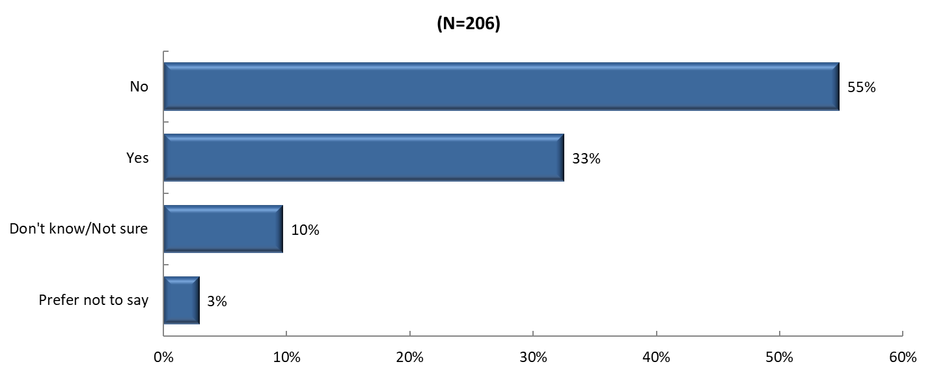

The top responses for why this group did not receive care included lack of providers (19%), not knowing where to go (15%), and cost/no insurance coverage (12%), suggesting accessibility and resource awareness issues exist in the community impacting access to needed mental healthcare.

Figure 32: What was the MAIN reason you did not get mental health care or counseling?
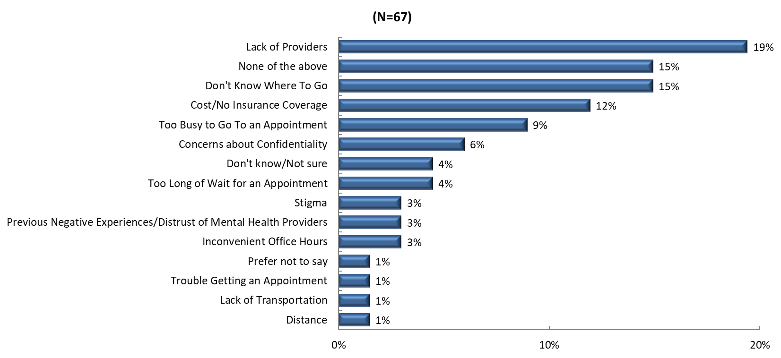

Community member respondents were also asked about their personal substance use as well as the substance use of those living in their household. Although 82% of respondents reported having no drinks during the past 30 days, and 94% of respondents indicated that neither they nor individuals living in their household misused any form of prescription drugs, these data points are specifically reflective of the population who responded to the survey. Considered alongside the secondary data, substance use was still determined to be a significant local need by county leaders.

For additional detail on survey findings, please see Appendix 5.

Primary Data Findings – Focus Groups

Focus group participants identified mental health as a significant concern in Bladen County. Specifically, participants emphasized that there is a high need for quality mental health resources and facilities in the county. Youth mental health emerged as a particular area of concern, with participants noting the critical importance of providing resources to address mental health needs among young people in the community. While the focus groups acknowledged that work has been done to improve the number of mental health resources available, including mobile vans, brick and mortar buildings, and suicide hotline services, participants indicated that stigma related to mental health continues to be a barrier in the community.
For a more detailed description of focus group findings, see Appendix 5.

Priority Need: Healthcare Access & Quality

Context and National Perspective

Access to care means patients are able to get high quality, affordable healthcare in a timely fashion to achieve the best possible health outcomes. It includes several components, including coverage (i.e. insurance), a physical location where care is provided, the ability to receive timely care, and enough providers in the workforce. The CHNA Steering Committee identified access to care as a high priority need for residents of Bladen County

From a national perspective, according to Healthy People 2030, approximately one in ten people in the U.S. do not have health insurance, which means they are less likely to have a primary care provider or to be able to afford the services or medications they need. Access is a challenge even for those who are insured.

The availability and distribution of health providers in the U.S. contributes to healthcare access challenges. According to the Association of American Medical Colleges (AAMC), there is estimated to be a shortage of 13,500 to 86,000 physicians in the U.S. by 2036, which will impact both primary and specialty care. Access issues are anticipated to increase in coming years. Growing shortages of both nurses and doctors are being driven by several factors, including population growth, the aging U.S. population requiring higher levels of care, provider burnout (physical, mental and emotional exhaustion) made worse by the COVID-19 pandemic, and a lack of clinical training programs and faculty – particularly for nurses. The aging of the current physician workforce is also driving anticipated personnel shortages. In North Carolina, 30.6% of actively practicing physicians were over the age of 60 in 2020. Access is also impacted by the number of actively practicing physicians overall. In 2020, there were just 9,211 primary care physicians in North Carolina, with 27,650 physicians actively practicing overall.39

The ability to access healthcare is not evenly distributed across groups in the population. Groups who may have trouble accessing care include the chronically ill and disabled (particularly those with mental health or substance use disorders), low-income or homeless individuals, people located in certain geographical areas (rural areas; tribal communities), members of the LGBTQIA+ community, and certain age groups – particularly the very young or the very old. In addition, individuals with limited English proficiency (LEP) face barriers to accessing care, experience lower quality care and have worse outcomes for health concerns. LEP is known to worsen health disparities and can make challenges related to other SDoH (access to housing, employment, etc.) worse. Both primary and secondary data resources analyzed for this report highlight the need for greater access to health services within Bladen County.

Secondary Data Findings

Secondary data analysis revealed significant healthcare access and quality challenges in Bladen County. The county shows consistently lower rates across multiple types of health providers compared to state and national averages. The rate of primary care providers (47.3 per 100,000 population) is less than half the state average (101.1), while mental health providers (47.3 per 100,000 population) are available at less than one-third the state rate (155.7). Dental care access is particularly concerning, with 61% of the population living in areas designated as Dental Health Professional Shortage Areas, compared to 34% statewide.

Table 18: Healthcare Provider Rates Per 100,000 Population
Indicator | Bladen County | North Carolina | United States
Dental Providers (Rate per 100,000 Population) | 23.6 | 31.5 | 39.1
Mental Health Providers  (Rate per 100,000 Population) | 47.3 | 155.7 | 178.7
Primary Care Providers (Rate per 100,000 Population) | 47.3 | 101.1 | 112.4

Transportation barriers compound these access challenges. The county has a higher percentage of households with no motor vehicle (7.9%) compared to the state average (5.4%), and public transit options are extremely limited. Data shows that none of the population lives within a half-mile of public transit, compared to 10.9% statewide and 34.8% nationally. Additionally, none of Bladen’s population uses public transit for commuting, compared to 0.8% statewide and more than one-third nationally, indicating there may be significant transportation barriers to accessing healthcare services.

Table 19: Transportation Access Indicators
Indicator | Bladen County | North Carolina | United States
Households with No Motor Vehicle, Percent | 7.9% | 5.4% | 8.3%
Percent Population Using Public Transit for Commute to Work | 0.0% | 0.8% | 3.8%
Percentage of Population within Half Mile of Public Transit | 0.0% | 10.9% | 34.8%

Quality of care indicators also highlight areas of concern. The county's rate of preventable hospitalizations (3,711 per 100,000 Medicare beneficiaries) significantly exceeds both state (2,957) and national (2,752) averages. The 30-day hospital readmission rate (20%) is also higher than state and national figures (both 18%). Interestingly, racial disparities in preventable hospital stays show a lower rate among Black Medicare beneficiaries (2,176) compared to White Medicare beneficiaries (3,171), contrary to many typical health disparity patterns. Data for Hispanic/Latino beneficiaries in the county was not available.

Figure 33: Preventable Hospital Stays by Race/Ethnicity
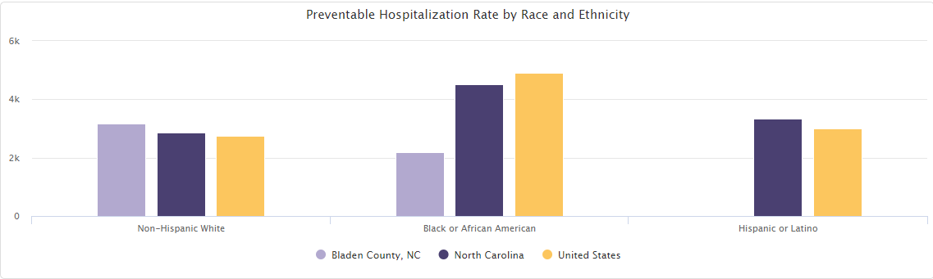

Insurance coverage presents additional challenges, with the county showing higher rates of uninsured individuals across all age groups compared to state averages. Particularly notable is the uninsured rate for ages 35 to 64, where more than one-third (37.4%) lack coverage. However, the county does show some positive indicators, including a higher rate of Federally Qualified Health Centers (13.5 per 100,000 population) compared to state (4.0) and national (3.5) averages.

Figure 34: Health Insurance Status by Age Group

For additional detail on secondary data findings, see Appendix 3.

Primary Data Findings – Community Member Web Survey

Among respondents who took the community survey, several access to care needs in Bladen County emerged. In the survey, community members were asked to identify the top barriers to receiving healthcare. Cost (83%), no insurance (71%), and lack of transportation (36%) were the top three identified reasons why people in the community are not getting care when they need it. Another quarter of responses identified long wait time as a top barrier to care.

Figure 35: What are the three most important reasons people in your community do not get health care when they need it? Please select up to three.
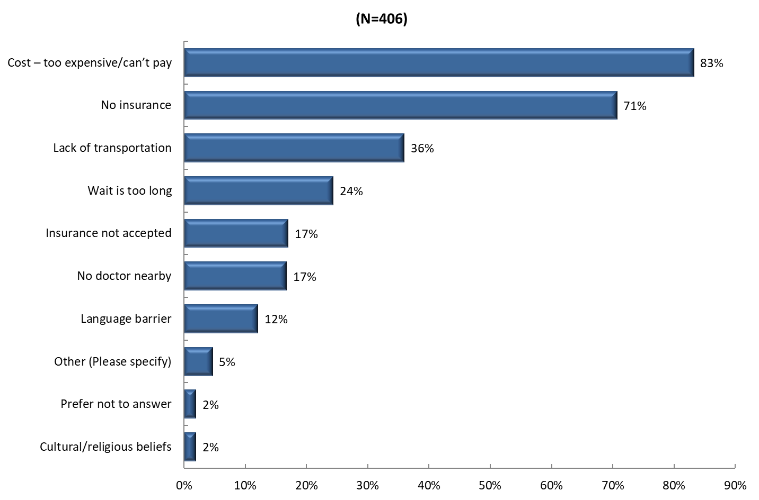
When these data were examined by age group, the age group that most frequently identified cost (85.9%) was those aged 45 to 65, while the age group that most frequently identified lack of insurance (80.8%) was those aged 18 to 24. Notably, cost was the most frequently identified barrier across all age groups. Responses did not differ significantly by race. However, Black or African American respondents were more slightly likely to select cost (87.1%) and lack of insurance (72.6%) as barriers than White respondents or respondents identifying with the “Other” race category, which includes those who identified as American Indian and Alaska Native, Asian, Native Hawaiian and other Pacific Islander, and/or those who selected more than one race or “other.”

Figure 36: What are the three most important reasons people in your community do not get health care when they need it? Please select up to three. (by race)
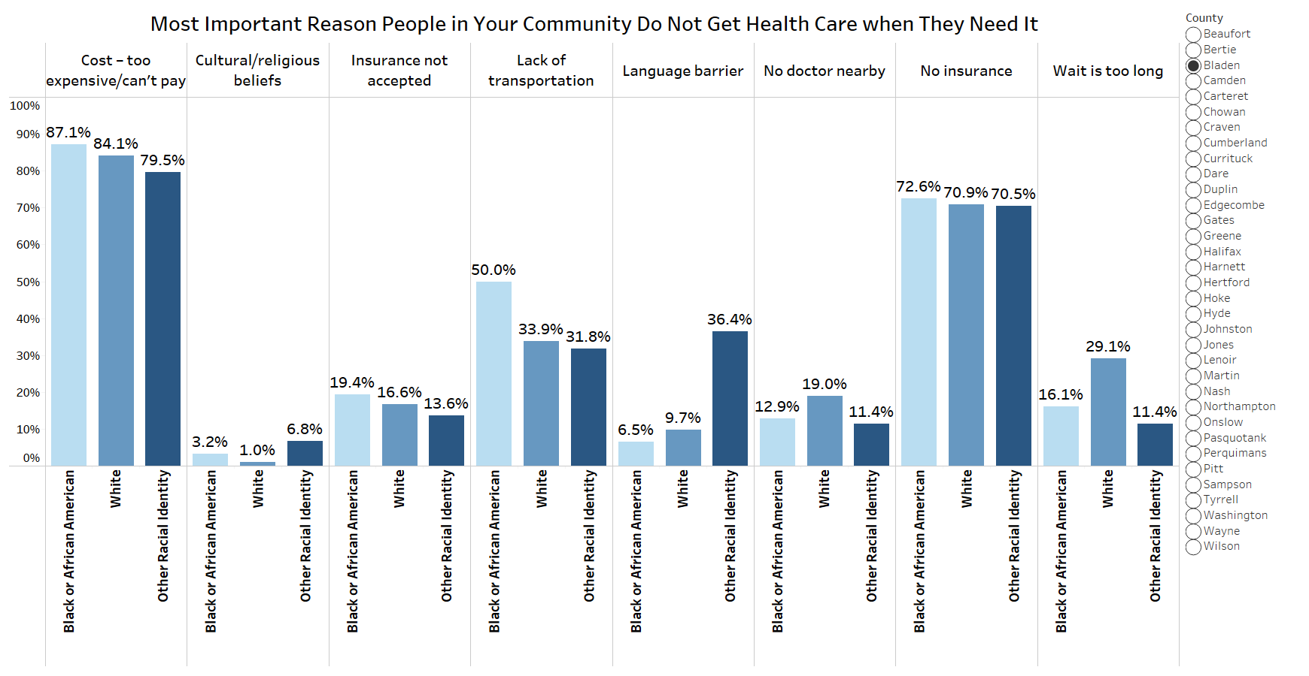

Community members were also asked to identify the most important social or environmental problems that affect the health of the community. As displayed in the figure below, the most frequent problem identified was poverty (32%). Availability or access to doctor’s offices (22%) was identified as the third most frequent social or environmental problem that affects the health of the community, again highlighting access to care challenges within the community.

Figure 37: What are the three most important social or environmental problems that affect the health of your community? Please select up to three.
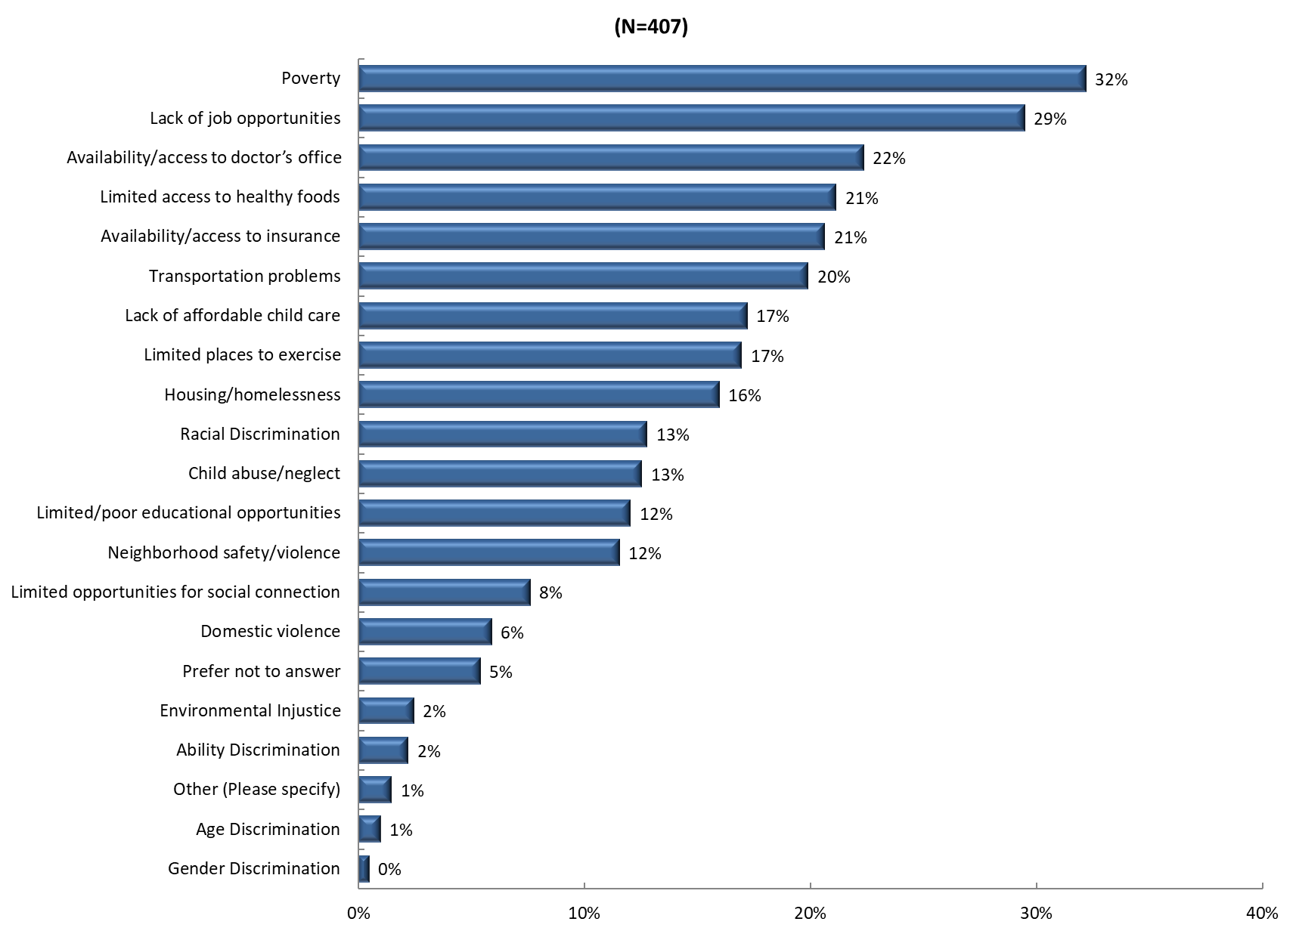

Notably, men and women differed in their responses. More men identified poverty (36% for men vs. 32% for women) and availability and access to doctor’s offices (29% for men vs. 21% for women) as a top social and environmental problems. Conversely, women were more likely than men to identify transportation problems as an important social and environmental problem (22% compared to 7%). Responses also varied by ethnicity. Those identifying as Hispanic/Latino were more slightly likely to cite availability of doctor’s offices (23%) and much more likely to cite availability or access to insurance (40%) than respondents identifying as non-Hispanic (22%, 18%).

Bladen County community member respondents were also asked if there was a time during the past 12 months that they needed specific types of care or health-related items and were unable to receive it due to the cost. As displayed in the figure below, one-quarter of respondents indicated affordability barriers prevented them from accessing dental care. The second highest response (18%) identified that prescription medication access was impacted due to lack of affordability, followed by eyeglasses (15%).

Figure 38:During the past 12 months, was there any time when you needed any of the following, but didn't get it because you couldn't afford it?
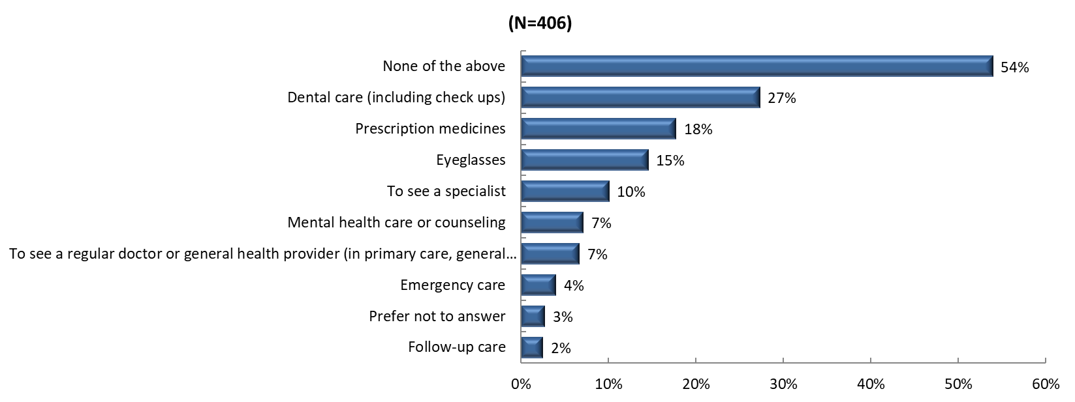

Respondents were also asked to agree or disagree with statements related to telehealth, including statements about access to the necessary resources for telehealth, past experience using telehealth, and comfort level in using technology or patient portals to communicate with health professionals. While 49% of respondents strongly agreed to having access to the necessary resources and 52% of respondents strongly agreed to being comfortable using an online patient portal, only 33% strongly agreed to being open to using telehealth to access medical care in the future.

For additional detail on survey findings, see Appendix 5.

Primary Data Findings – Focus Groups

Focus group participants highlighted several critical barriers to healthcare access in Bladen County. The high cost of healthcare emerged as a primary concern, along with extended wait times to see providers and significant issues with obtaining insurance coverage. The lack of specialty care providers in the county was specifically noted as problematic. Participants suggested bringing more specialists into the county to address the long wait times people currently face when seeking healthcare. They also recommended expanding hospital and health department services with a specific community focus.
Additionally, participants emphasized the importance of getting health providers more involved in community activities to help meet Bladen County residents where they are. The groups noted that better advertising of available services and resources is needed to ensure community members are aware of what is available to them.
For a more detailed description of focus group findings, see Appendix 5.

Priority Need: Nutrition & Physical Activity

Context and National Perspective

Nutrition and physical activity have a major impact on physical health, which can be defined as the monitoring and maintenance of the human body. There are many factors involved in an individual’s overall physical health status, such as disease prevention, timely access to primary and preventive healthcare, exercise, and maintaining a healthy diet. Living a healthy lifestyle is not a one size fits all approach, and many individuals choose to incorporate different healthy behaviors at different times, slowly building more and more healthy habits. The CDC recommends multiple healthy behaviors that can be integrated for healthier living, such as getting enough sleep, moving more and sitting less, limiting alcohol intake, and eating healthy food. Sleep needs can vary from person to person; however, the CDC recommends that an adult gets at least 7 hours of regular sleep. Another healthy behavior that can be incorporated is movement, starting at least 20 minutes a day with some light activity, such as walking or dancing.

Another form of healthy living and disease prevention is taking a proactive role in preventative health care, which can often start with one’s diet. According to experts, losing just 5-10 % of one’s current weight can lower the risk for multiple chronic conditions such as diabetes, arthritis, cancer, and high blood pressure. When speaking with a primary doctor, or a nutritionist about creating a healthy diet, it is important to have some information prepared, such as food allergies, health goals, the types of medication taken, and any other health concerns that one may have. When considering a diet for weight loss, ensuring that the diet is both filling and matches a daily activity level is key. When implementing a new diet, there are a few recommendations for success. First, eating when hungry and stopping when full is key, and choosing to eat filling foods that one might enjoy, such as one’s favorite vegetables, fruit, or lean protein. Secondly, seasoning the food with different herbs and spices, and reducing the amount of salt and sugar in a recipe if possible. Finally, drinking enough water throughout the day helps with digestion and other body functions.

When considering healthy living in rural communities, research has shown that just one in four adults in rural areas are consistently performing at least four healthy behaviors. Rural areas often have fewer or less diverse grocery stores, with many relying on smaller general stores, which may not always have fresh produce and meat. Additionally, these areas may also not have safe places to walk or exercise, such as sidewalks, recreation centers, or parks.

In North Carolina, over half (52%) of adults do not get at least two and a half hours of moderate exercise per week, and over 70% don’t meet weekly muscle strengthening recommendations. However, 84% of adults eat at least one vegetable a day, and over 60% eat fruit at least once a day. North Carolina’s Department of Health and Human Services has implemented several workshops and classes that individuals can take to learn healthy habits, such as Living Healthy workshops. Additionally, several nonprofits have implemented programs to help individuals learn healthy behaviors, and North Carolina also has an extensive WIC program, as well as the NCCARE360 program, which seeks to connect individuals with all necessary resources for living a healthier life.

Secondary Data Findings

Data related to the built environment in Bladen County reveals several barriers to physical activity. The county's walkability index score (4) is notably lower than both state (7) and national (10) averages. A larger percentage of Bladen County residents are physically inactive (29.1%) compared to the statewide figure (21.6%). Additionally, the percentage of Bladen County residents with access to exercise opportunities (47%) is considerably lower than both state (73%) and national (84%) averages. Specific data on access to recreation and fitness facilities was not available for comparison to state (13.1 per 100,000 population) and national (14.7) averages.

Table 20: Physical Activity Indicators
Indicator | Bladen County | North Carolina | United States
Recreation and Fitness Facility Establishments (Rate per 100,000 Population) | N/A | 13.1 | 14.7
Walkability Index Score | 4 | 7 | 10
% Physically Inactive | 29.1 | 21.6 | -
Percentage of Population with Access to Exercise Opportunities | 47% | 73% | 84%

Food security emerged as a critical concern in the county through this analysis. Bladen County's food insecurity rate (15%) and child food insecurity rate (24%) both significantly exceed state (11% and 15% respectively) and national (10% and 13% respectively) averages. The food environment shows mixed indicators, with a higher rate of grocery stores (20.3 per 100,000 population) compared to the state average (18.7), but this remains below the national rate (23.4). Fast food restaurant density (81.1 per 100,000 population) is slightly higher than the state average (77.4) but lower than the national rate (96.2).

Table 21: Food Security and Food Environment Indicators
Indicator | Bladen County | North Carolina | United States
Food Insecurity Rate | 15% | 11% | 10%
Child Food Insecurity Rate | 24% | 15% | 13%
Percent Low Income Population  with Low Food Access | 15% | 21% | 19%
Food Environment - Fast Food Restaurants Establishments (Rate per 100,000 Population) | 81.1 | 77.4 | 96.2
Food Environment - Grocery Stores  Establishments (Rate per 100,000 Population) | 20.3 | 18.7 | 23.4

The impact of these factors is reflected in health outcomes, with 32% of Bladen County adults having a BMI greater than 30.0 (classified as obese), exceeding both state (29.7%) and national (30.1%) averages.

For additional detail on secondary data findings, see Appendix 3.

Primary Data Findings – Community Member Web Survey

Bladen County residents identified several nutrition and physical activity concerns in the community in their responses to the web survey. Among the most important health problems, 43% of respondents identified diabetes/high blood sugar as a concern, while 39% identified overweight/obesity. Heart disease and high blood pressure, which are outcomes frequently related to nutrition and activity levels, was another health problem named by 39% of respondents.

Figure 39: What are the three most important health problems that affect the health of your community? Please select up to three.

When these results were examined by respondent demographics, responses varied. Older adults were more likely to view diabetes, heart disease, and obesity as more significant problems than younger respondents. Respondents identifying as Hispanic/Latino more frequently identified diabetes and high blood sugar (60%) than non-Hispanic respondents (41%), while respondents identifying as non-Hispanic more frequently identified heart disease and high blood pressure (40% vs. 17%), as displayed in Figure 3.17 below. When considering responses by gender identity, women were slightly more likely than men to identify diabetes/high blood sugar, heart disease/high blood pressure, and obesity as significant problems than men. Addressing these differences across age, gender, and ethnicity may be important when developing targeted efforts to improve specific community health indicators.

Figure 40: What are the three most important health problems that affect the health of your community? Please select up to three. (by ethnicity)

In terms of community perspectives on health behaviors like physical activity and food security, one in five Bladen County respondents viewed limited access to healthy foods as an important social or environmental problem in the community and one in six selected limited places to exercise as a top concern. Men were more likely to view limited access to healthy foods as a top concern (25% vs. 21% for women), while women were slightly more likely to identify limited places to exercise (17% vs. 16%). Notably, respondents identifying as non-Hispanic more frequently identified limited access to health foods (23% vs. 9%) and limited places to exercise (19% vs. 2%) compared to respondents identifying as Hispanic/Latino.

For additional detail on survey findings, see Appendix 5.

Primary Data Findings – Focus Groups

Focus group participants identified several barriers to maintaining good nutrition and physical activity levels in Bladen County. The high cost of healthy foods emerged as a significant concern, with participants emphasizing the need for better nutrition education in the community. The groups specifically discussed the importance of efforts to engage residents through the availability of safe walking trails and low impact physical activities. Participants noted that the lack of free or affordable locations for safe walking and exercise creates barriers to physical activity in the community. The focus groups suggested that faith-based involvement and initiatives may be key to improving the health of Bladen County residents in this area.
For a more detailed description of focus group findings, see Appendix 5.

CHAPTER 4 | HEALTH RESOURCE INVENTORY

NCLHDA requirements for local health departments and IRS requirements for nonprofit hospitals require the CHNA report to include a description of the resources available in a county to address the significant health needs identified in the assessment. This section includes information about local organizations in Bladen County that provide resources to address general community health needs, as well as the county’s 2024 priority need areas: Behavioral Health; Healthcare Access and Quality; and Nutrition and Physical Activity.
Category | Organization Name
County Resource Directories | - NC 211: Information and referral service provided by United Way of North Carolina. Call 2-1-1 or 1-888-892-1162 for assistance.
Healthcare Facilities | - Bladen County Health Department: Provides immunizations, maternal health, child health, and more. (300 Mercer Mill Rd., Elizabethtown, NC 28337, (910) 862-6900)  - Bladen Medical Associates: Offers primary care at multiple locations.  - Elizabethtown: 300 E. McKay St., Suite A, Elizabethtown, NC 28337, (910) 862-5500  - Bladenboro: 1106 W. Seaboard St., Bladenboro, NC 28320, (910) 863-3138  - Clarkton: 9858 N. WR Latham St., Clarkton, NC 28433, (910) 862-1217  - Dublin: 16 Third St., Dublin, NC 28332, (910) 862-3528  - White Lake: 273 White Lake Dr., Elizabethtown, NC 28337, (910) 862-1266  - ExpressCare: 107 E Dunham St, Elizabethtown, NC 28337, (910) 862-2122  - Bladen Healthcare, LLC: Offers comprehensive healthcare services. (501 S. Poplar St., Elizabethtown, NC 28337, (910) 862-5100)  - Bladen Kids Care: 300 E. McKay St, Suite A, Elizabethtown, NC, 28337, (910) 862-8677  - Bladen Surgical Specialists: 300 E. McKay St, Suite A, Elizabethtown, NC, 28337, (910) 862-1272  - Cape Fear Valley Bladen Sleep Lab: 501 Poplar St, Elizabethtown, NC 28337, (910) 862-5183  - Women’s Health Specialists: 300 E. McKay St, Suite F, Elizabethtown, NC 28337, (910) 862-6672
Other Healthcare Services | Substance Abuse and Recovery Services  - Myrover Reese Fellowship Homes Inc.: Recovery services for substance abuse users. (1418 Clinton Rd., Fayetteville, NC 28301, (910) 223-1148)  - Operation Blessing: Emergency food, clothing, and assistance with utility and rent bills. (1337 Ramsey St., Fayetteville, NC 28301, (910) 483-1119)  - Oxford Houses: Recovery housing for substance abuse. (5307 Cypress Rd. for Women, 5214 Cypress Rd. for Men, Fayetteville, NC, (910) 433-9123 for women, (910) 425-8221 for men  Services for the Disabled  - North Carolina Department of Health & Human Services - Division of Services for the Blind: Vocational rehabilitation and social work services. (225 Green St., Suite 500, Fayetteville, NC 28301, (910) 486-1582)  - Vision Resource Center: Rehabilitation, educational, and social programs for the blind and visually impaired. (1600 Purdie Dr., Fayetteville, NC 28301, (910) 483-2719)
Community Services | Emergency and Crisis Services  - Rape Crisis Center: Support and resources for individuals affected by sexual violence. (515 Ramsey St., Fayetteville, NC 28301, (910) 485-7273)  Bladen County  - Bladen Crisis Assistance: Provides emergency assistance with food, clothing, and utilities. (208 S Morehead St, Elizabethtown, NC 28337, (910) 862-7864)  - Bladen County United Way: Supports various community service programs. (1230 West Broad St., Elizabethtown, NC 28337, (910) 862-4900)
Additional Resources | - Assurance Wireless and SafeLink Wireless: Provides cell phones for low-income and homeless individuals. (Assurance: (888) 321-5880, SafeLink: (800) 977-3768)  - Greater Image Healthcare: Mental health services. (401 Robeson St., Fayetteville, NC 28301, (910) 321-0069)  - PATH (Projects for Assistance in Transition from Homelessness): Assistance for the homeless with mental health issues. (711 Executive Pl., Fayetteville, NC 28305, (910) 491-4800)

CHAPTER 5 | NEXT STEPS

The CHNA findings are used to develop effective community health improvement strategies to address the priority needs identified throughout the process. The next and final step in the CHNA process is to develop community-based health improvement strategies and action plans to address the priorities identified in this assessment. Health leaders in Bladen County will leverage information from this CHNA to develop implementation and action plans for their local community, while also working together with other community partners to ensure the priority need areas are being addressed in the most efficient and effective way. Bladen County leaders recognize that the most effective strategies will be those that have the collaborative support of community organizations and residents. The strategies developed will include measurable objectives through which progress can be measured.

APPENDIX 1 | STATE OF THE COUNTY HEALTH REPORT

Results-Based Accountability Framework

To meet North Carolina accreditation requirements, LHDs are required to track progress on their implementation plans by publishing an annual State of the County Health Report (SOTCH). The SOTCH is guided by the Clear Impact Results-Based Accountability (RBA)™ Framework, and demonstrates that the LHD is tracking priority issues identified in the community health (needs) assessment process, identifying emerging issues, and implementing any relevant new initiatives to address community concerns.

RBA provides a disciplined way of thinking about – and acting upon – complex social issues, with the goal of improving the lives of all members of the community. The framework is organized to recognize two distinct types of accountability: population and performance. Population accountability refers to the well-being of entire populations, and RBA recognizes that it is challenging, if not impossible, to hold individual organizations accountable for solving systemic problems. Conversely, performance accountability recognizes that individual organizations are accountable for the outcomes and impact of their programs, policies and practices as they relate to their client populations.

In the CHIP process, RBA asks three key questions: how much did we do, how well did we do it, and is anyone better off? To more effectively answer these questions, and develop measurable strategies to address community health concerns, North Carolina LHDs use a software called Clear Impact Scorecard to develop their SOTCH and track progress against their goals. Clear Impact Scorecard is performance management and reporting software used by non-profit and government agencies to efficiently and effectively explain the impact of their work. The scorecard mirrors RBA and links results with indicators and programs with performance measures. Bladen County’s most recent SOTCH is presented on the following pages.

State of the County Health Report
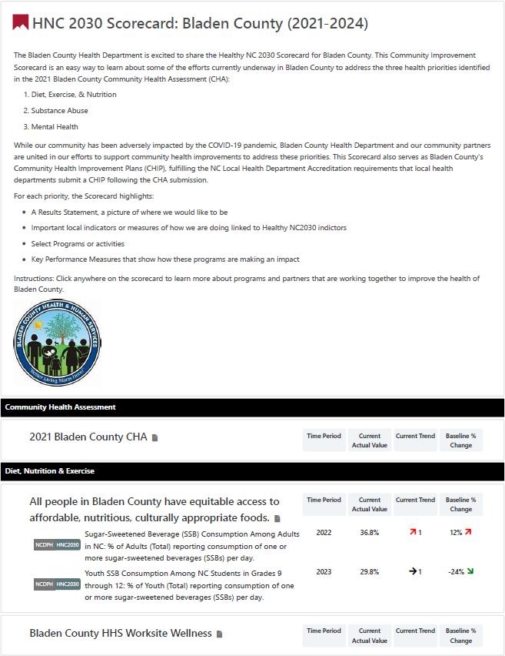
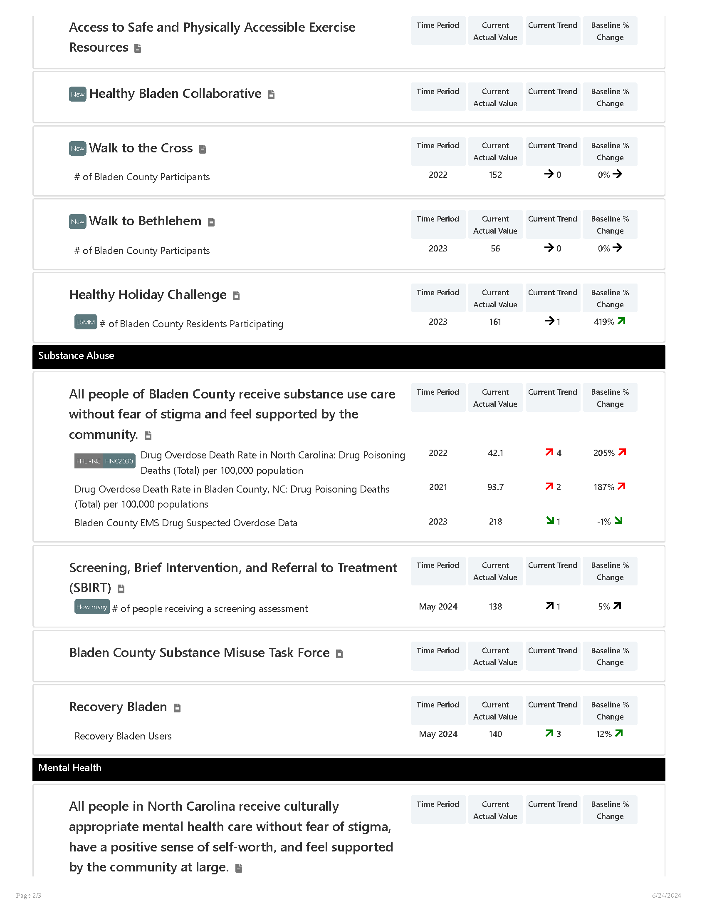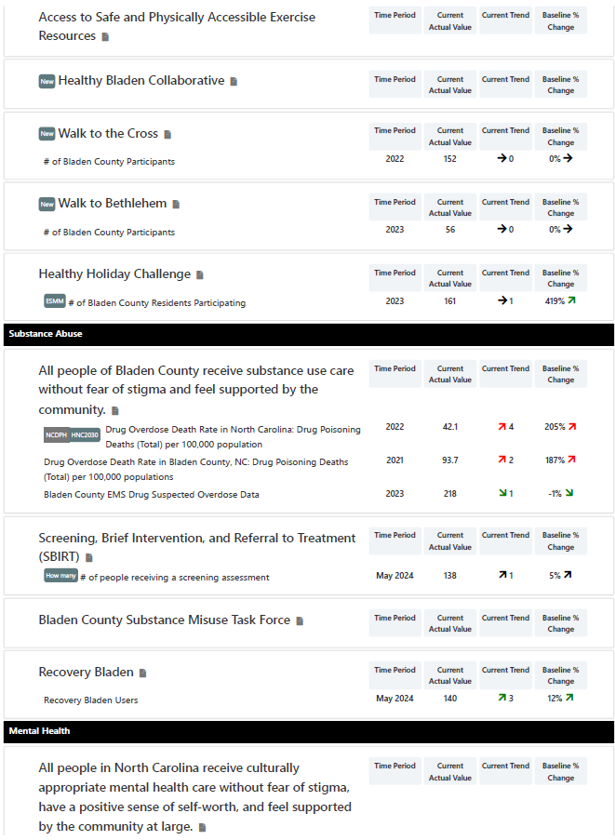
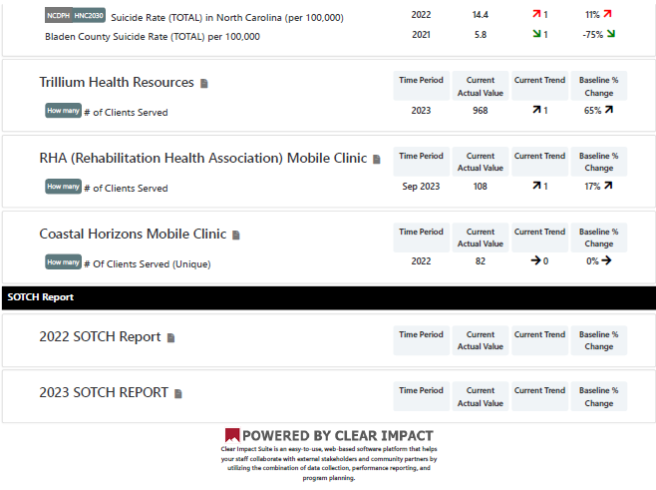

APPENDIX 2 | SECONDARY DATA METHODOLOGY AND SOURCES

Many individual secondary data measures were analyzed as part of the CHNA process. These data provide detailed insight into the health status and health-related behavior of residents in the county. These secondary data are based on statistics of actual occurrences, such as the incidence of certain diseases, as well as statistics related to SDoH.

Methodology

All individual secondary data measures were grouped into six categories and 20 corresponding focus areas based on “common themes.” In order to draw conclusions about the secondary data for Bladen County, its performance on each data measure was compared to targets/benchmarks. If Bladen County’s performance was more than five percent worse than the comparative benchmark, it was concluded that improvements could be needed to better the health of the community. Conversely, if an area performed more than five percent better than the benchmark, it was concluded that while a need is still present, the significance of that need relative to others is likely less acute. The most recently available data were compared to these targets/benchmarks in the following order (as applicable):

- For all available data sources, state and national averages were compared.

The following methodology was used to assign a priority level to each individual secondary data measure:
- If the data were more than 5 percent worse = High need
- If the data were within or equal to 5 percent (better or worse) = Medium need
- If the data were more than 5 percent better = Low need

These measures are noted with an asterisk.

Additionally, data measures were also viewed with regard to performance over time and whether the measure has improved or worsened compared to the prior CHNA timeframe.

Data Sources

The following tables are organized by each of the twenty focus areas and contain information related to the secondary data measures analyzed including a description of each measure, the data source, and most recent data time periods.
Table 22: Access to Care
Measure | Description | Data Source | Most Recent Data Year(s)
Primary Care Providers (per 100,000 population) | Number of providers with a CMS National Provider Identifier (NPI) that specialize in primary care. Primary health providers include practicing physicians specializing in general practice medicine, family medicine, internal medicine, and pediatrics. | Centers for Medicare and Medicaid Services (CMS) – National Plan and Provider Enumeration System (NPPES). Data accessed via the North Carolina Data Portal, June 2024. | 2024
Mental Health Providers (per 100,000 population) | Number of providers with a CMS National Provider Identifier (NPI) that specialize in mental health. Mental health providers include licensed clinical social workers and other credentialed professionals specializing in psychiatry, psychology, counseling, or child, adolescent, or adult mental health. | CMS –NPPES. Data accessed via the North Carolina Data Portal, June 2024. | 2024
Addiction/Substance Abuse Providers (per 100,000 population) | Number of providers who specialize in addiction or substance abuse treatment, rehabilitation, addiction medicine, or providing methadone. The providers include Doctors of Medicine (MDs), Doctors of Osteopathic Medicine (DOs), and other credentialed professionals with a Center for Medicare and Medicaid Services and a valid National Provider Identifier (NPI). | CMS –NPPES. Data accessed via the North Carolina Data Portal, June 2024. | 2024
Buprenorphine Providers (per 100,000 population) | Number of providers authorized to treat opioid dependency with buprenorphine. Buprenorphine is the first medication to treat opioid dependency that is permitted to be prescribed or dispensed in physician offices, significantly increasing treatment access. Qualified physicians are required to acquire and maintain certifications to legally dispense or prescribe opioid dependency medications. | US Department of Health and Human Services (DHHS), Substance Abuse and Mental Health Services Administration. Data accessed via the North Carolina Data Portal, June 2024. | 2023
Dental Health Providers (per 100,000) | Number of oral health providers with a CMS National Provider Identifier (NPI). Providers included are those who list “dentist”, “general practice dentist”, or “pediatric dentistry” as their primary practice classification, regardless of sub-specialty. | CMS – NPPES. Data accessed via the North Carolina Data Portal, June 2024. | 2024
Health Professional Shortage Areas - Dental Care | Percentage of the population that is living in a geographic area designated as a “Health Professional Shortage Area” (HSPA), defined as having a shortage of dental health professionals. This indicator is relevant because a shortage of health professionals contributes to access and health status issues. | U.S. Census Bureau, American Community Survey (ACS). Data accessed via the North Carolina Data Portal, June 2024. | 2018-2022
Federally Qualified Health Centers (FQHCs) | Number of Federally Qualified Health Centers (FQHCs) in the community. This indicator is relevant because FQHCs are community assets that provide health care to vulnerable populations; they receive extra funding from the federal government to promote access to ambulatory care in areas designated as medically underserved. | U.S. DHHS, CMS, Provider of Services File. Data accessed via the North Carolina Data Portal, June 2024. | 2023
Population Receiving Medicaid | Percentage of the population with insurance enrolled in Medicaid (or other means-tested public health insurance). This indicator is relevant because it assesses vulnerable populations which are more likely to have multiple health access, health status, and social support needs; when combined with poverty data, providers can use this measure to identify gaps in eligibility and enrollment. | U.S. Census Bureau, ACS. Data accessed via the North Carolina Data Portal, June 2024. | 2018-2022
Uninsured Population (SAHIE) | Percentage of adults under age 65 without health insurance coverage. This indicator is relevant because lack of health insurance is a primary barrier to healthcare access including regular primary care, specialty care, and other health services that contribute to poor health status. The lack of health insurance is considered a key driver of health status. | U.S. Census Bureau, Small Area Health Insurance Estimates (SAHIE). Data accessed via the North Carolina Data Portal, June 2024. | 2022

Table 23: Built Environment
Measure | Description | Data Source | Most Recent Data Year(s)
Broadband Access (Access to DL Speeds >= 25MBPS and UL Speeds >= 3 MBPS) | Percentage of population with access to high-speed internet. Data are based on the reported service area of providers offering download speeds of 25 MBPS or more and upload speeds of 3 MBPS or more. These data represent both wireline and fixed/terrestrial wireless internet providers. Cellular internet providers are not included. | Federal Communications Commission (FCC) FABRIC Data. Additional data analysis by CARES. Data accessed via the North Carolina Data Portal, June 2024. | 2023
Broadband Access (Access to DL Speeds >= 100MBPS and UL Speeds >= 20 MBPS) | Percentage of population with access to high-speed internet. Data are based on the reported service area of providers offering download speeds of 100 MBPS or more and upload speeds of 20 MBPS or more. These data represent both wireline and fixed/terrestrial wireless internet providers. Cellular internet providers are not included. | FCC FABRIC Data. Additional data analysis by CARES. Data accessed via the North Carolina Data Portal, June 2024. | 2023
Households with No Computer | Percentage of households who don’t own or use any types of computers, including desktop or laptop, smartphone, tablet, or other portable wireless computer, and some other type of computer, based on the 2018-2022 American Community Survey estimates. | U.S. Census Bureau, ACS. Data accessed via the North Carolina Data Portal, June 2024. | 2018-2022
Households with No or Slow Internet | Percentage of households who either use dial-up as their only way of internet connection or have internet access but don’t pay for the service, or have no internet access in their home, based on the 2018-2022 American Community Survey estimates. | U.S. Census Bureau, ACS. Data accessed via the North Carolina Data Portal, June 2024. | 2018-2022
Liquor Stores | Number of liquor stores per 100,000 population provides a measure of environmental influences on dietary behaviors and the accessibility of healthy foods. Note this data excludes establishments preparing and serving alcohol for consumption on premises (including bars and restaurants) or which sell alcohol as a secondary retail product (including gas stations and grocery stores). | U.S. Census Bureau, County Business Patterns. Additional data analysis by CARES. Data accessed via the North Carolina Data Portal, June 2024. | 2022
Adverse Childhood Experiences (ACEs) | Percentage of children in North Carolina (total) with two or more ACEs. ACEs are potentially traumatic events that occur in childhood (0-17 years), including experiencing violence, abuse, or neglect; witnessing violence in the home or community; and having a family member attempt or die by suicide. Also included are aspects of the child’s environment that can undermine their sense of safety, stability, and bonding, such as substance abuse problems, mental health problems, instability due to parental separation, and instability due to household members being in jail or prison. Other traumatic experiences that impact health and well-being may include not having enough food to eat, experiencing homelessness or unstable housing, or experiencing discrimination. ACEs can have lasting effects on health and well-being in childhood and life opportunities well into adulthood, for example, education and job potential. These experiences can increase the risks of injury, sexually transmitted infections, teen pregnancy, suicide, and a range of chronic diseases including cancer, diabetes, and heart disease. | Clear Impact Healthy North Carolina (HNC) 2030 Scorecard, 2021-2024. Data accessed June 2024. | 2022

Table 24: Diet and Exercise
Measure | Description | Data Source | Most Recent Data Year(s)
Physical inactivity (percent of adults that report no leisure time physical activity) | Percentage of adults ages 20 and over reporting no leisure-time physical activity in the past month. Examples of physical activities include running, calisthenics, golf, gardening, or walking for exercise.  The method for calculating Physical Inactivity changed. Data for Physical Inactivity are provided by the CDC Interactive Diabetes Atlas which combines 3 years of survey data to provide county-level estimates. In 2011, BRFSS changed their methodology to include cell phone and landline participants. Previously only landlines were used to collect data. Physical Inactivity is created using statistical modeling. | Behavioral Risk Factor Surveillance System. Data accessed via Robert Wood Johnson Foundation & University of Wisconsin Population Health Institute County Health Rankings & Roadmaps, June 2024. | 2021
Community Design - Walkability Index Score | The National Walkability Index (2021) is a nationwide index score developed by the Environmental Protection Agency (EPA) that ranks block groups according to their relative walkability using selected variables on density, diversity of land uses, and proximity to transit from the Smart Location Database. The block groups are assigned their final National Walkability Index scores on a scale of 1 to 20 where the higher a score, the more walkable the community is. | EPA – Smart Location Database. Data accessed via the North Carolina Data Portal, June 2024. | 2021
Access to Exercise Opportunities | Percentage of individuals in the county who live reasonably close to a location for physical activity. Locations for physical activity are defined as parks or recreational facilities. The numerator is the 2020 total population living in census blocks with adequate access to at least one location for physical activity (adequate access is defined as census blocks where the border is a half-mile or less from a park, 1 mile or less from a recreational facility in an urban area, or 3 miles or less from a recreational facility in a rural area) and the denominator is the 2020 resident county population. This indicator is used in the 2024 County Health Rankings. | ArcGIS Business Analyst and Living Atlas of the World, YMCA & U.S. Census Tigerline Files. Data accessed via the North Carolina Data Portal, June 2024. | 2023
Recreation and Fitness Facility Access (per 100,000 population) | Number of establishments primarily engaged in operating fitness and recreational sports facilities featuring exercise and other active physical fitness conditioning or recreational sports activities, such as swimming, skating, or racquet sports. Access to recreation and fitness facilities encourages physical activity and other healthy behaviors. | U.S. Census Bureau, County Business Patterns. Additional data analysis by CARES. Data accessed via the North Carolina Data Portal, June 2024. | 2022
Sugar-Sweetened Beverage (SSB) Consumption Among Adults | Percentage of total adults reporting consumption of one or more SSBs per day. | Clear Impact. HNC2030 Scorecard, 2021-2024. Data accessed June 2024. | 2022

Table 25: Education
Measure | Description | Data Source | Most Recent Data Year(s)
Population with Limited English Proficiency | Percentage of the population aged 5 and older who speak a language other than English at home and speak English less than "very well". This indicator is relevant because an inability to speak English well creates barriers to healthcare access, provider communications, and health literacy/education. | U.S. Census Bureau, ACS. Data accessed via the North Carolina Data Portal, June 2024. | 2018-2022
High School Graduation Rate | Percentage of high school students who graduate within four years. The adjusted cohort graduation rate (ACGR) is a graduation metric that follows a “cohort” of first-time 9th graders in a particular school year, and adjusts this number by adding any students who transfer into the cohort after 9th grade and subtracting any students who transfer out, emigrate to another county, or pass away. | U.S. Department of Education, EDFacts. Additional data analysis by CARES. Data accessed via the North Carolina Data Portal, June 2024. | 2020-2021
No High School Diploma | Percentage of the population aged 25 and older without a high school diploma (or equivalency) or higher. This indicator is relevant because educational attainment is linked to positive health outcomes. | U.S. Census Bureau, ACS. Data accessed via the North Carolina Data Portal, June 2024. | 2018-2022
Student Math Proficiency (4th Grade) | Percentage of 4th grade students testing below the “proficient” level on the Math portion of state-specific standardized tests. | U.S. Department of Education, EDFacts. Additional data analysis by CARES. Data accessed via the North Carolina Data Portal, June 2024. | 2020-2021
Student Reading Proficiency (4th Grade) | Percentage of 4th grade students testing below the “proficient” level on the English Language Arts portion of state-specific standardized tests. | US Department of Education, EDFacts. Additional data analysis by CARES. Data accessed via the North Carolina Data Portal, June 2024. | 2020-2021
School Funding Adequacy | The average gap in dollars between actual and required spending per pupil among public school districts. Required spending is an estimate of dollars needed to achieve U.S. average test scores in each district. | School Finance Indicators Database. Data accessed via RWJF & UWPHI County Health Rankings & Roadmaps, June 2024. | 2021
School Funding Adequacy – Spending per Pupil | Actual spending per pupil among public school districts. | School Finance Indicators Database. Data accessed via RWJF & UWPHI County Health Rankings & Roadmaps, June 2024. | 2021

Table 26: Employment
Measure | Description | Data Source | Most Recent Data Year(s)
Unemployment Rate (percent of population age 16+ but unemployed) | Percentage of the civilian non-institutionalized population age 16 and older (non-seasonally adjusted) that is unemployed but seeking work. This indicator is relevant because unemployment creates financial instability and barriers to access including insurance coverage, health services, healthy food, and other necessities that contribute to poor health status. | U.S. Department of Labor, Bureau of Labor Statistics. Data accessed via the North Carolina Data Portal, June 2024. | 2024
Average Annual Unemployment Rate, 2013-2023 | Average yearly percentage across the given time period of the civilian non-institutionalized population age 16 and older (non-seasonally adjusted) that is unemployed but seeking work. This indicator is relevant because unemployment creates financial instability and barriers to access including insurance coverage, health services, healthy food, and other necessities that contribute to poor health status. | U.S. Census Bureau, ACS. Data accessed via the North Carolina Data Portal, June 2024. | 2024

Table 27: Environmental Quality
Measure | Description | Data Source | Most Recent Data Year(s)
Climate and Health – Flood Vulnerability | Estimated number of housing units within the special flood hazard area (SFHA) per county. The SFHAs have 1% annual chance of coastal or riverine flooding. | Federal Emergency Management Agency (FEMA), National Flood Hazard Layer. Data accessed via the North Carolina Data Portal, June 2024. | 2011
Air and Water Quality – Drinking Water Safety | Number of drinking water violations recorded in a two-year period. Health-based violations include incidents where either the amount of contaminant exceeded the maximum contaminant level (MCL) safety standard, or where water was not treated properly. In cases where a water system serves multiple counties and has a violation, each county served by the system is given a violation. | EPA. Data accessed via the North Carolina Data Portal, June 2024. | 2023

Table 28: Family, Community, and Social Support
Measure | Description | Data Source | Most Recent Data Year(s)
Childcare Cost Burden | Childcare costs for a median-income household with two children as a percentage of household income. Data are included as part of the 2024 County Health Rankings. | The Living Wage Calculator, Small Area Income and Poverty Estimates. Data accessed via the North Carolina Data Portal, June 2024. | 2023
Young People Not in School and Not Working | Percentage of youth ages 16-19 who are not currently enrolled in school and who are not employed. | U.S. Census Bureau, ACS. Data accessed via the North Carolina Data Portal, June 2024. | 2018-2022

Table 29: Food Security
Measure | Description | Data Source | Most Recent Data Year(s)
Food Insecurity Rate | Estimated percentage of the population that experienced food insecurity at some point during the report year. Food insecurity is the household-level economic and social condition of limited or uncertain access to adequate food. | Feeding America. Data accessed via the North Carolina Data Portal, June 2024. | 2021
Food Insecure Children | Estimated percentage of the population under age 18 that experienced food insecurity at some point during the report year. Food insecurity is the household-level economic and social condition of limited or uncertain access to adequate food. | Feeding America. Data accessed via the North Carolina Data Portal, June 2024. | 2021
Low-Income and Low Food Access | Percentage of the low-income population with low food access. Low food access is defined as living more than 1 mile (urban) or 10 miles (rural) from the nearest supermarket, supercenter, or large grocery store. Data are from the April 2021 Food Access Research Atlas dataset. This indicator is relevant because it highlights populations and geographies facing food insecurity. | U.S. Department of Agriculture (USDA), Economic Research Service, USDA – Food Access Research Atlas. 2019. Data accessed via the North Carolina Data Portal, June 2024. | 2019
Limited access to healthy foods | Percentage of population who are low-income and do not live close to a grocery store. | USDA Food Environment Atlas. Data accessed via RWJF & UWPHI County Health Rankings & Roadmaps, June 2024. | 2019
Food Environment - Fast Food Restaurants (per 100,000 population) | Number of fast food restaurants per 100,000 population. The prevalence of fast food restaurants provides a measure of both access to healthy food and environmental influences on dietary behaviors. Fast food restaurants are defined as limited-service establishments primarily engaged in providing food services (except snack and nonalcoholic beverage bars) where patrons generally order or select items and pay before eating. | US Census Bureau, County Business Patterns. Additional data analysis by CARES. 2022. Data accessed via the North Carolina Data Portal, June 2024. | 2022
Food Environment - Grocery Stores (per 100,000 population) | Number of grocery establishments per 100,000 population. Grocery stores are defined as supermarkets and smaller grocery stores primarily engaged in retailing a general line of food, such as canned and frozen foods; fresh fruits and vegetables; and fresh and prepared meats, fish, and poultry. Delicatessen-type establishments are also included. Convenience stores and large general merchandise stores that also retail food, such as supercenters and warehouse club stores, are excluded. Healthy dietary behaviors are supported by access to healthy foods, and grocery stores are a major provider of these foods. | US Census Bureau, County Business Patterns. Additional data analysis by CARES. 2022. Data accessed via the North Carolina Data Portal, June 2024. | 2022

Table 30: Housing and Homelessness
Measure | Description | Data Source | Most Recent Data Year(s)
Renter Costs – Average Gross Rent | Average gross rent is the contract rent plus the estimated average monthly cost of utilities (electricity, gas, and water and sewer) and fuels (oil, coal, kerosene, wood, etc.) if these are paid by the renter (or paid for the renter by someone else). Gross rent provides information on the monthly housing cost expenses for renters. When the data is used in conjunction with income data, the information offers an excellent measure of housing affordability and excessive shelter costs. The data also serve to aid in the development of housing programs to meet the needs of people at different economic levels, and to provide assistance to agencies in determining policies on fair rent. | U.S. Census Bureau, ACS. Data accessed via the North Carolina Data Portal, June 2024. | 2018-2022
Housing Cost Burden, Severe (50%) | Percentage of the households where housing costs are 50% or more total household income. This indicator provides information on the cost of monthly housing expenses for owners and renters. The information offers a measure of housing affordability and excessive shelter costs. The data also serve to aid in the development of housing programs to meet the needs of people at different economic levels. | U.S. Census Bureau, ACS. Data accessed via the North Carolina Data Portal, June 2024. | 2018-2022
Housing & Urban Development (HUD)-Assisted Housing Units (per 10,000 households) | Number of HUD-funded assisted housing units available to eligible renters as well as the unit rate (per 10,000 total households). | U.S. Department of HUD. Data accessed via the North Carolina Data Portal, June 2024. | 2017-2021
Substandard Housing, Severe | Percentage of owner- and renter-occupied housing units having at least one of the following conditions: 1) lacking complete plumbing facilities, 2) lacking complete kitchen facilities, 3) with 1.51 or more occupants per room, 4) selected monthly owner costs as a percentage of household income greater than 50%, and 5) gross rent as a percentage of household income greater than 50%. Selected conditions provide information in assessing the quality of the housing inventory and its occupants. This data is used to easily identify homes where the quality of living and housing can be considered substandard. | U.S. Census Bureau, ACS. Data accessed via the North Carolina Data Portal, June 2024. | 2011-2015
Homeless Children and Youth | Number of homeless children and youth enrolled in the public school system during the school year 2019-2020. According to the data source definitions, homelessness is defined as lacking a fixed, regular, and adequate nighttime residence. Those who are homeless may be sharing the housing of other persons, living in motels, hotels, or camping grounds, in emergency transitional shelters, or unsheltered. Data are aggregated to the report-area level based on school-district summaries where three or more homeless children are counted. | US Department of Education, EDFacts. Additional data analysis by CARES. 2019-2020. Data accessed via the North Carolina Data Portal, June 2024. | 2019-2020

Table 31: Income
Measure | Description | Data Source | Most Recent Data Year(s)
Median Family Income | Median family income based on the latest 5-year American Community Survey estimates. A family household is any housing unit in which the householder is living with one or more individuals related to him or her by birth, marriage, or adoption. Family income includes the incomes of all family members ages 15 and older. | U.S. Census Bureau, ACS. Data accessed via the North Carolina Data Portal, June 2024. | 2018-2022
Gender Pay Gap | Ratio of women's median earnings to men's median earnings for all full-time, year-round workers, presented as "cents on the dollar." Data are acquired from the 2018-2022 ACS and are used in the 2024 County Health Rankings. | U.S. Census Bureau, ACS. Data accessed via the North Carolina Data Portal, June 2024. | 2018-2022
Population Below 100% Federal Poverty Level (FPL) | Percentage of population living in households with income below the FPL. This indicator is relevant because poverty creates barriers to access including health services, healthy food, and other necessities that contribute to poor health status. | U.S. Census Bureau, ACS. Data accessed via the North Carolina Data Portal, June 2024. | 2022
Population Below 200% FPL | Percentage of population living in households with income below 200% of the FPL. This indicator is relevant because poverty creates barriers to access including health services, healthy food, and other necessities that contribute to poor health status. | U.S. Census Bureau, ACS. Data accessed via the North Carolina Data Portal, June 2024. | 2018-2022
Children Below 200% FPL | Percentage of children living in households with income below 200% of the FPL. This indicator is relevant because poverty creates barriers to access including health services, healthy food, and other necessities that contribute to poor health status. | U.S. Census Bureau, ACS. Data accessed via the North Carolina Data Portal, June 2024. | 2018-2022
Population Receiving SNAP (SAIPE) | Average percentage of the population receiving SNAP benefits during the month of June during the most recent report year. The Supplemental Nutrition Assistance Program, or SNAP, is a federal program that provides nutrition benefits to low-income individuals and families that are used at stores to purchase food. | U.S. Census Bureau, Small Area Income and Poverty Estimates. Data accessed via the North Carolina Data Portal, June 2024. | 2021
Children Eligible for Free/Reduced Price Lunch | Percentage of public school students eligible for the free or reduced price lunch program in the latest report year. Free or reduced price lunches are served to qualifying students in families with income between 185 percent (free lunch) and or 130 percent (reduced price) of the US federal poverty threshold as part of the federal National School Lunch Program (NSLP). | National Center for Education Statistics (NCES) – Common Core of Data. Data accessed via the North Carolina Data Portal, June 2024. | 2022-2023

Table 32: Length of Life
Measure | Description | Data Source | Most Recent Data Year(s)
Premature Death (years of potential life lost before age 75 per 100,000 population age-adjusted) | Number of events (i.e., deaths, births, etc.) in a given time period (three-year period) divided by the average number of people at risk during that period. Years of potential life lost measures mortality by giving more weight to deaths at earlier ages than deaths at later ages. Premature deaths are deaths before age 75. All of the years of potential life lost in a county during a three-year period are summed and divided by the total population of the county during that same time period-this value is then multiplied by 100,000 to calculate the years of potential life lost under age 75 per 100,000 people. These are age-adjusted. | National Center for Health Statistics – Natality and Mortality Files; Census Population Estimates Program. Data accessed via RWJF & UWPHI County Health Rankings & Roadmaps, June 2024. | 2019-2021
Premature Age-Adjusted Mortality | Number of deaths among residents under age 75 per 100,000 population (age-adjusted). | National Center for Health Statistics – Natality and Mortality Files; Census Population Estimates Program. Data accessed via RWJF & UWPHI County Health Rankings & Roadmaps, June 2024. | 2019-2021
Life expectancy | Average life expectancy at birth (age-adjusted to 2000 standard). Data were from the National Center for Health Statistics - Mortality Files (2019-2021) and are used for the 2024 County Health Rankings. | National Center for Health Statistics – Natality and Mortality Files; Census Population Estimates Program. Data accessed via RWJF & UWPHI County Health Rankings & Roadmaps, June 2024. | 2019-2021

Table 33: Maternal and Infant Health
Measure | Description | Data Source | Most Recent Data Year(s)
Births with no or late prenatal care | Percentage of women who did not obtain prenatal care until the 7th month (or later) of pregnancy or who didn't have any prenatal care, as of all who gave birth during the three-year period from 2017 to 2019. This indicator is relevant because engaging in prenatal care decreases the likelihood of maternal and infant health risks. This indicator can also highlight a lack of access to preventive care, a lack of health knowledge, insufficient provider outreach, and/or social barriers preventing utilization of services. | CDC – National Vital Statistics System (NVSS). CDC WONDER. CDC, Wide-Ranging Online Data for Epidemiologic Research. Data accessed via the North Carolina Data Portal, June 2024. | 2017-2019
Low birthweight (percent of live births with birthweight < 2500 grams) | Percentage of live births where the infant weighed less than 2,500 grams (approximately 5 lbs., 8 oz.). The numerator is the number of low birthweight infants born over a 7-year time span, while the denominator is the total number of births in a county during the same time. | National Center for Health Statistics – Natality Files. Data accessed via RWJF & UWPHI County Health Rankings & Roadmaps, June 2024. | 2016-2022
Infant Mortality | Number of all infant deaths (within 1 year) per 1,000 live births. Data were from the National Center for Health Statistics - Mortality Files (2015-2021) and are used for the 2024 County Health Rankings. | National Center for Health Statistics – Natality and Mortality Files. Data accessed via RWJF & UWPHI County Health Rankings & Roadmaps, June 2024. | 2015-2021

Table 34: Mental Health
Measure | Description | Data Source | Most Recent Data Year(s)
Poor Mental Health Days | Average number of self-reported mentally unhealthy days in past 30 days among adults (age-adjusted to the 2000 standard). Data are included as part of the 2024 County Health Rankings. | CDC, Behavioral Risk Factor Surveillance System (BRFSS). Data accessed via the North Carolina Data Portal, June 2024. | 2021
Deaths of Despair (Suicide and Drug/Alcohol Poisoning) (per 100,000 population) | Average rate of death due to intentional self-harm (suicide), alcohol-related disease, and drug overdose, also known as "deaths of despair", per 100,000 population. Figures are reported as crude rates. Rates are re-summarized for report areas from county level data, only where data is available. This indicator is relevant because death of despair is an indicator of poor mental health. | CDC – NVSS. Data accessed via the North Carolina Data Portal, June 2024. | 2018-2022
Suicide (per 100,000 population) | Five-year average rate of death due to intentional self-harm (suicide) per 100,000 population from 2018 to 2022. Figures are reported as crude rates. Rates are re-summarized for report areas from county level data, only where data is available. This indicator is relevant because suicide is an indicator of poor mental health. | CDC – NVSS. Data accessed via the North Carolina Data Portal, June 2024. | 2018-2022

Table 35: Physical Health
Measure | Description | Data Source | Most Recent Data Year(s)
Poor or fair health (percent of adults reporting fair or poor health age-adjusted) | Percentage of adults in a county who consider themselves to be in poor or fair health. This measure is based on responses to the BRFSS question: “In general, would you say that your health is excellent, very good, good, fair, or poor?” The value reported in the County Health Rankings is the percentage of respondents who rated their health “fair” or “poor.” Poor or Fair Health is age-adjusted. Poor or Fair Health estimates are created using statistical modeling. | Behavioral Risk Factor Surveillance System. Data accessed via RWJF & UWPHI County Health Rankings & Roadmaps, June 2024. | 2021
Asthma Prevalence (Adult) | Percentage of adults ages 18 and older who answer “yes” to both of the following questions: “Have you ever been told by a doctor, nurse, or other health professional that you have asthma?” and the question “Do you still have asthma?” | CDC, BRFSS. Data accessed via the North Carolina Data Portal, June 2024. | 2022
Heart Disease (Adult) | Percentage of adults ages 18 and older who report ever having been told by a doctor, nurse, or other health professional that they had angina or coronary heart disease. | CDC, BRFSS. Data accessed via the North Carolina Data Portal, June 2024. | 2022
High Blood Pressure (Adult) | Percentage of adults ages 18 and older who report ever having been told by a doctor, nurse, or other health professional that they have high blood pressure (HTN). Women who were told high blood pressure only during pregnancy and those who were told they had borderline hypertension were not included. | CDC, BRFSS. Data accessed via the North Carolina Data Portal, June 2024. | 2021
High Cholesterol (Adult) | Percentage of adults ages 18 and older who report having been told by a doctor, nurse, or other health professional that they had high cholesterol. | CDC, BRFSS. Data accessed via the North Carolina Data Portal, June 2024. | 2021
Diabetes Prevalence (Adult) | Percentage of adults ages 20 and older who have ever been told by a doctor that they have diabetes. This indicator is relevant because diabetes is a prevalent problem in the U.S.; it may indicate an unhealthy lifestyle and puts individuals at risk for further health issues. | CDC, National Center for Chronic Disease Prevention and Health Promotion. Data accessed via the North Carolina Data Portal, June 2024. | 2021
Kidney Disease (Adult) | Percentage of adults ages 18 and older who report ever having been told by a doctor, nurse, or other health professional that they have kidney disease. | CDC, BRFSS. Data accessed via the North Carolina Data Portal, June 2024. | 2021
Stroke (Adult) | Percentage of adults ages 18 and older who report ever having been told by a doctor, nurse, or other health professional that they have had a stroke. | CDC, BRFSS. Data accessed via the North Carolina Data Portal, June 2024. | 2022
Obesity | Percentage of adults ages 20 and older self-report having a Body Mass Index (BMI) greater than 30.0 (obese). Respondents were considered obese if their BMI was 30 or greater. BMI (weight [kg]/height [m]2) was derived from self-report of height and weight. Excess weight may indicate an unhealthy lifestyle and puts individuals at risk for further health issues. | CDC, National Center for Chronic Disease Prevention and Health Promotion. Data accessed via the North Carolina Data Portal, June 2024. | 2021
Poor Dental Health – Teeth Loss | Percentage of adults ages 18 and older who report having lost all of their natural teeth because of tooth decay or gum disease. | CDC, BRFSS. Data accessed via the North Carolina Data Portal, June 2024. | 2022
Cancer Incidence – All Sites (per 100,000 population) | Age-adjusted incidence rate (cases per 100,000 population per year) of cancer (all sites) adjusted to 2000 U.S. standard population age groups (Under age 1, 1-4, 5-9, ..., 80-84, 85 and older). | State Cancer Profiles. Data accessed via the North Carolina Data Portal, June 2024. | 2016-2020
Emergency Room (ER) Visits (per 100,000 Medicare beneficiaries) | Rate of ER visits among Medicare beneficiaries ages 65 and older (per 100,000 beneficiaries). This indicator is relevant because ER visits are "high intensity" services that can burden on both health care systems and patients. High rates of ER visits "may indicate poor care management, inadequate access to care or poor patient choices, resulting in ER visits that could be prevented". | CMS – Geographic Variation Public Use File. Data accessed via the North Carolina Data Portal, June 2024. | 2022
Hospitalizations – Heart Disease (per 1,000 Medicare beneficiaries) | Hospitalization rate for coronary heart disease among Medicare beneficiaries ages 65 and older for hospital stays occurring between 2018 and 2020. | CDC – Atlas of Heart Disease and Stroke. Data accessed via the North Carolina Data Portal, June 2024. | 2018-2020
Hospitalizations – Stroke (per 1,000 Medicare beneficiaries) | Hospitalization rate for Ischemic stroke among Medicare beneficiaries ages 65 and older for hospital stays occurring between 2018 and 2020. | CDC – Atlas of Heart Disease and Stroke. Data accessed via the North Carolina Data Portal, June 2024. | 2018-2020

Table 36: Quality of Care
Measure | Description | Data Source | Most Recent Data Year(s)
Seasonal Influenza Vaccine | Percentage of adults ages 18 and older who reported receiving an influenza vaccination in the past 12 months. These data are derived from responses to the 2019 BRFSS. | CDC – FluVaxView. Data accessed via the North Carolina Data Portal, June 2024. | 2019
Hospitalizations – Preventable Conditions (per 100,000 Medicare beneficiaries) | Preventable hospitalization rate among Medicare beneficiaries for the latest reporting period. Preventable hospitalizations include hospital admissions for one or more of the following conditions: diabetes with short-term complications, diabetes with long-term complications, uncontrolled diabetes without complications, diabetes with lower-extremity amputation, chronic obstructive pulmonary disease, asthma, hypertension, heart failure, bacterial pneumonia, or urinary tract infection. Rate is presented per 100,000 beneficiaries. | CMS, Mapping Medicare Disparities Tool. Data accessed via the North Carolina Data Portal, June 2024. | 2021
Readmissions – All Cause (Medicare Population) | Rate of 30-day hospital readmissions among Medicare beneficiaries ages 65 and older. Hospital readmissions are unplanned visits to an acute care hospital within 30 days after discharge from a hospitalization. Patients may have unplanned readmissions for any reason, however readmissions within 30 days are often related to the care received in the hospital, whereas readmissions over a longer time period have more to do with other complicating illnesses, patients’ own behavior, or care provided to patients after hospital discharge. | CMS – Geographic Variation Public Use File. Data accessed via the North Carolina Data Portal, June 2024. | 2022

Table 37: Safety
Measure | Description | Data Source | Most Recent Data Year(s)
Incarceration Rate | Percentage of individuals born in each census tract who were incarcerated at the time of the 2010 Census as estimated by Opportunity Atlas data. | Opportunity Insights. Data accessed via the North Carolina Data Portal, June 2024. | 2018
Juvenile Arrest Rate (per 1,000 juveniles) | Rate of delinquency cases per 1,000 juveniles. Data are acquired from the 2021 Easy Access to State and County Juvenile Court Case Counts (EZACO) and are used in the 2024 County Health Rankings. | Office of Juvenile Justice and Delinquency Department, Easy Access to State and County Juvenile Court Case Counts (EZACO). Data accessed via the North Carolina Data Portal, June 2024. | 2021
Violent Crime (per 100,000 people) | Annual rate of reported violent crimes per 100,000 people during the three-year period of 2015-2017. Violent crime includes homicide, rape, robbery, and aggravated assault. | Federal Bureau of Investigation (FBI), FBI Uniform Crime Reports. Additional analysis by the National Archive of Criminal Justice Data. Data accessed via the North Carolina Data Portal, June 2024. | 2015-2017
Mortality – Firearm (per 100,000 population) | Five-year average rate of death due to firearm wounds per 100,000 population, which includes gunshot wounds from powder-charged handguns, shotguns, and rifles. Figures are reported as crude rates for the time period of 2018 to 2022. This indicator is relevant because firearm deaths are preventable, and are a cause of premature death. | CDC – National Vital Statistics System. Data accessed via the North Carolina Data Portal, June 2024. | 2018-2022
Mortality – Poisoning (per 100,000 population) | Five-year average rate of death due to poisoning (including drug overdose) per 100,000 population. Figures are reported as crude rates for the time period of 2018 to 2022. Rates are re-summarized for report areas from county level data, only where data is available. This indicator is relevant because poisoning deaths, especially from drug overdose, are a national public health emergency. | CDC – National Vital Statistics System. Data accessed via the North Carolina Data Portal, June 2024. | 2018-2022

Table 38: Sexual Health
Measure | Description | Data Source | Most Recent Data Year(s)
Sexually transmitted infections (chlamydia rate per 100,000 population) | Number of newly diagnosed chlamydia cases per 100,000 population | National Center for HIV/AIDS, Viral Hepatitis, STD, and TB Prevention. Data accessed via RWJF & UWPHI County Health Rankings & Roadmaps, June 2024. | 2021
HIV Incidence (rate per 100,000 population) | Incidence rate of HIV infection or infection classified as state 3 (AIDS) per 100,000 population. Incidence refers to the number of confirmed diagnoses during a given time period, in this case is January 1st and December 31st of the latest reporting year. | CDC, National Center for HIV/AIDS, Viral Hepatitis, STD, and TB Prevention. Data accessed via the North Carolina Data Portal, June 2024. | 2022
Teen Births (per 1,000 female population age 15-19) | Seven-year average number of births per 1,000 female population age 15-19. Data were from the National Center for Health Statistics - Natality files (2016-2022) and are used for the 2024 County Health Rankings. | CDC – National Vital Statistics System. Data accessed via the North Carolina Data Portal, June 2024. | 2016-2022

Table 39: Substance Use Disorders
Measure | Description | Data Source | Most Recent Data Year(s)
Excessive Drinking – Heavy Alcohol Consumption | Percentage of adults that self-report excessive drinking in the last 30 days. Data for this indicator were based on survey responses to the 2021 Behavioral Risk Factor Surveillance System (BRFSS) annual survey and are used for the 2024 County Health Rankings.  Excessive drinking is defined as the percentage of the population who report at least one binge drinking episode involving five or more drinks for men and four or more for women over the past 30 days, or heavy drinking involving more than two drinks per day for men and more than one per day for women, over the same time period. Alcohol use is a behavioral health issue that is also a risk factor for a number of negative health outcomes, including: physical injuries related to motor vehicle accidents, stroke, chronic diseases such as heart disease and cancer, and mental health conditions such as depression and suicide. There are a number of evidence-based interventions that may reduce excessive/binge drinking; examples include raising taxes on alcoholic beverages, restricting access to alcohol by limiting days and hours of retail sales, and screening and counseling for alcohol abuse. | CDC, BRFSS. Data accessed via the North Carolina Data Portal, June 2024. | 2021
Mortality - Motor Vehicle Crash – Alcohol-Involved (annual rate per 100,000 population) | Crude rate of persons killed in motor vehicle crashes involving alcohol as an annual rate per 100,000 population. Fatality counts are based on the location of the crash and not the decedent's residence. Motor vehicle crash deaths are preventable and are a leading cause of death among young persons. | U.S. Department of Transportation, National Highway Traffic Safety Administration, Fatality Analysis Reporting System. Data accessed via the North Carolina Data Portal, June 2024. | 2018-2022
Opioid Use Disorder (per 100,000 Medicare beneficiaries) | Rate of emergency department utilization for opioid use and opioid use disorder among the Medicare population. Figures are reported as age-adjusted to year 2000 standard. Rates are re-summarized for report areas from county level data, only where data is available. This indicator is relevant because mental health and substance use is an indicator of poor health. | CMS, Mapping Medicare Disparities Tool. Data accessed via the North Carolina Data Portal, June 2024. | 2021
Mortality – Opioid Overdose (per 100,000 population) | Five-year average rate of death due to opioid drug overdose per 100,000 population. Figures are reported as crude rates for the time period of 2018 to 2022. Rates are re-summarized for report areas from county level data, only where data is available. This indicator is relevant because opioid drug overdose is the leading cause of injury deaths in the United States, and they have increased dramatically in recent years. | CDC – NVSS. Data accessed via the North Carolina Data Portal, June 2024. | 2018-2022

Table 40: Tobacco Use

Measure | Description | Data Source | Most Recent Data Year(s)
Adult smoking | Percentage of the adult population that currently smokes every day or most days and has smoked at least 100 cigarettes in their lifetime. Adult Smoking estimates are created using statistical modeling. | Behavioral Risk Factor Surveillance System. Data accessed via RWJF & UWPHI County Health Rankings & Roadmaps, June 2024. | 2021

Table 41: Transportation Options and Transit
Measure | Description | Data Source | Most Recent Data Year(s)
Households with No Motor Vehicle | Percentage of households with no motor vehicle based on the latest 5-year American Community Survey estimates. | U.S. Census Bureau, ACS. Data accessed via the North Carolina Data Portal, June 2024. | 2018-2022
Commuter Travel Patterns - Public Transportation | Percentage of population using public transportation as their primary means of commuting to work. Public transportation includes buses or trolley buses, streetcars or trolley cars, subway or elevated rails, and ferryboats. | U.S. Census Bureau, ACS. Data accessed via the North Carolina Data Portal, June 2024. | 2018-2022
Community Design – Distance to Public Transit | Proportion of the population living within 0.5 miles of a GTFS (General Transit Feed Specification) or fixed-guideway transit stop. Transit data is available from over 200 transit agencies across the United States, as well as all existing fixed-guideway transit service in the U.S. This includes rail, streetcars, ferries, trolleys, and some bus rapid transit systems. | EPA – Smart Location Database. Data accessed via the North Carolina Data Portal, June 2024. | 2021

APPENDIX 3 | SECONDARY DATA COMPARISONS

Description of Focus Area Comparisons

When viewing the secondary data summary tables, please note that the following color shadings have been included to identify how Bladen County compares to North Carolina and the national benchmark. If both statewide North Carolina and national data was available, North Carolina data was preferentially used as the target/benchmark value.

Secondary Data Summary Table Color Comparisons
Color Shading | Priority Level | Bladen County Description
 | Low | Represents measures in which Bladen County scores are more than five percent better than the most applicable target/benchmark and for which a low priority level was assigned.
 | Medium | Represents measures in which Bladen County scores are comparable to the most applicable target/benchmark scoring within or equal to five percent, and for which a medium priority level was assigned.
 | High | Represents measures in which Bladen County scores are more than five percent worse than the most applicable target/benchmark and for which a high priority level was assigned.
Note: Please see the methodology section of this report for more information on assigning need levels to the secondary data.

Please note that to categorize each metric in this manner and identify the priority level, the Bladen County value was compared to the benchmark by calculating the percentage difference between the values, relative to the benchmark value:

(Bladen Co Value – Benchmark Value)/(Benchmark) x 100 = % Difference Used to Identify Priority Level

For example, for the % Limited Access to Healthy Foods metric, the following calculation was completed:

(7.3-7.5)/(7.5) x 100% = -2.7% = Displayed as Medium Priority Level, Shaded in Yellow

This metric indicates that the percentage of the population with limited access to healthy foods in Bladen County is 2.7 percent better (or, in this case, lower) than the percentage of the population with limited access to healthy foods in the state of North Carolina.

Detailed Focus Area Benchmarks

Table 42: Access to Care
Measure | National Benchmark | North Carolina Benchmark | Bladen County Data | Most Recent Data Year | Bladen County Need
Primary Care Providers Rate | 112.4 | 101.1 | 47.3 | 2024 | High
Mental Health Providers Rate | 178.7 | 155.7 | 47.3 | 2024 | High
Addiction/Substance Abuse Providers Rate | 27.9 | 25.0 | 6.8 | 2024 | High
Buprenorphine Providers Rate | 15.5 | 15.2 | 3.1 | 2023 | High
Dental Health Providers Rate | 39.1 | 31.5 | 23.6 | 2024 | High
% Living in Health Professional Shortage Areas (HPSAs) – Dental Care | 17.8% | 34.0% | 61.0% | 2018-2022 | High
Federally Qualified Health Centers (FQHCs) | 3.5 | 4.1 | 13.5 | 2023 | Low
% Receiving Medicaid | 22.3% | 20.2% | 32.9% | 2018-2022 | High
% Uninsured | 10.2% | 12.5% | 14.5% | 2022 | High

Table 43: Built Environment
Measure | National Benchmark | North Carolina Benchmark | Bladen County Data | Most Recent Data Year | Bladen County Need
Broadband Access (Access to DL Speeds >= 25MBPS and UL Speeds >= 3 MBPS) | 93.8% | 93.6% | 76.7% | 2023 | High
Broadband Access (Access to DL Speeds >= 100MBPS and UL Speeds >= 20 MBPS) | 91.2% | 90.4% | 73.7% | 2023 | High
Households with No Computer | 6.1% | 6.9% | 12.9% | 2018-2022 | High
Households with No or Slow Internet | 11.7% | 13.0% | 19.6% | 2018-2022 | High
Liquor Stores | 13.3 | 6.2 | Suppressed | 2022 | N/A
Adverse Childhood Experiences (ACEs) | N/A | N/A | Suppressed | 2022 | N/A

Table 44: Diet and Exercise
Measure | National Benchmark | North Carolina Benchmark | Bladen County Data | Most Recent Data Year | Bladen County Need
% Physically Inactive | N/A | 21.6% | 29.1% | 2021 | High
Walkability Index Score | 10 | 7 | 4 | 2021 | High
% with Access to Exercise Opportunities | 84.1% | 73.0% | 47.0% | 2023 | High
Recreation and Fitness Facility Access | 14.8 | 13.1 | Suppressed | 2022 | N/A
Sugar-Sweetened Beverage (SSB) Consumption | N/A | N/A | 36.8% | 2022 | N/A

Table 45: Education
Measure | National Benchmark | North Carolina Benchmark | Bladen County Data | Most Recent Data Year | Bladen County Need
% Limited English Proficiency | 8.2% | 4.6% | 2.5% | 2018-2022 | Low
High School Graduation Rate | 81.1% | 87.6% | 92.1% | 2020-2021 | Low
% with No High School Diploma | 10.9% | 10.6% | 11.8% | 2018-2022 | High
Student Math Proficiency | 63.9% | 65.8% | 80.1% | 2020-2021 | High
Student Reading Proficiency | 60.1% | 59.5% | 67.3% | 2020-2021 | High
School Funding Adequacy | N/A | -$4,742 | -$8,988 | 2021 | High
School Funding Adequacy – Spending per pupil | N/A | $10,655 | $12,664 | 2021 | Low

Table 46: Employment
Measure | National Benchmark | North Carolina Benchmark | Bladen County Data | Most Recent Data Year | Bladen County Need
Unemployment Rate | 3.9% | 3.7% | 4.1% | 2024 | High
Average Annual Unemployment Rate, 2013-2023 | 3.6% | 3.5% | 4.2% | 2024 | High

Table 47: Environmental Quality
Measure | National Benchmark | North Carolina Benchmark | Bladen County Data | Most Recent Data Year | Bladen County Need
Flood Vulnerability | 6.5% | 4.9% | 5.7% | 2011 | High
Drinking Water Safety | 16,107 | 194 | 0 | 2023 | Low

Table 48: Family, Community and Social Support
Measure | National Benchmark | North Carolina Benchmark | Bladen County Data | Most Recent Data Year | Bladen County Need
Childcare Cost Burden | 28.8% | 27.0% | 27.0% | 2023 | Medium
% Young People Not in School or Working | 6.9% | 7.5% | 13.9% | 2018-2022 | High

Table 49: Food Security
Measure | National Benchmark | North Carolina Benchmark | Bladen County Data | Most Recent Data Year | Bladen County Need
% Food Insecure | 10.3% | 11.4% | 14.7% | 2021 | High
% Food Insecure Children | 13.3% | 15.3% | 23.7% | 2021 | High
% Low-Income and with Low Food Access | 19.4% | 21.3% | 15.1% | 2019 | Low
% Limited Access to Healthy Foods | N/A | 7.5% | 7.3% | 2019 | Medium
Fast Food Restaurants | 96.2 | 77.4 | 81.2 | 2022 | Medium
Grocery Stores | 23.4 | 18.7 | 20.3 | 2022 | Low
Table 50: Housing and Homelessness
Measure | National Benchmark | North Carolina Benchmark | Bladen County Data | Most Recent Data Year | Bladen County Need
Renter Costs – Average Gross Rent | $1,366 | $1,090 | $574 | 2018-2022 | Low
% Severe Housing Cost Burden | 14.1% | 12.2% | 16.9% | 2018-2022 | High
Assisted Housing Units | 413.9 | 319.2 | 395.7 | 2017-2021 | High
% Severe Substandard Housing | 18.5% | 16.1% | 21.0% | 2011-2015 | High
% Homeless Children | 2.8% | 1.9% | 0.8% | 2019-2020 | Low

Table 51: Income
Measure | National Benchmark | North Carolina Benchmark | Bladen County Data | Most Recent Data Year | Bladen County Need
Median Family Income | $92,646 | $82,890 | $54,679 | 2018-2022 | High
Gender Pay Gap | 81.0% | 83.0% | 88.0% | 2018-2022 | Low
% Living Below 100% FPL | 12.5% | 13.3% | 24.4% | 2022 | High
% Living Below 200% FPL | 28.8% | 31.6% | 44.5% | 2018-2022 | High
% Children Living Below 200% FPL | 37.2% | 41.1% | 61.2% | 2018-2022 | High
% Receiving SNAP | 12.4% | 15.7% | 26.5% | 2021 | High
Children Eligible for Free/Reduced Price Lunch | 51.7% | 50.8% | 98.6% | 2022-2023 | High

Table 52: Length of Life
Measure | National Benchmark | North Carolina Benchmark | Bladen County Data | Most Recent Data Year | Bladen County Need
Years of Potential Life Lost Rate | N/A | 8,853 | 14,976 | 2019-2021 | High
Premature Age-Adjusted Mortality | N/A | 420 | 659 | 2019-2021 | High
Life Expectancy | 77.6 | 76.6 | 71.7 | 2019-2021 | High

Table 53: Maternal and Infant Health
Measure | National Benchmark | North Carolina Benchmark | Bladen County Data | Most Recent Data Year | Bladen County Need
Births with Late or No Prenatal Care | 6.1% | 6.9% | Suppressed | 2019 | N/A
Low Birthweight | N/A | 9.4% | 11.5% | 2016-2022 | High
Infant Mortality Rate | 5.7 | 7.0 | 9.0 | 2015-2021 | High

Table 54: Mental Health
Measure | National Benchmark | North Carolina Benchmark | Bladen County Data | Most Recent Data Year | Bladen County Need
Poor Mental Health Days | 4.9 | 4.6 | 5.0 | 2021 | High
Deaths of Despair Rate | 55.9 | 58.7 | 83.7 | 2018-2022 | High
Suicide Death Rate | 14.5 | 14.0 | 12.7 | 2018-2022 | Low

Table 55: Physical Health
Measure | National Benchmark | North Carolina Benchmark | Bladen County Data | Most Recent Data Year | Bladen County Need
% Poor or Fair Health | N/A | 14.4% | 20.0% | 2021 | High
% Adults with Asthma | 9.7% | 9.8% | 10.9% | 2022 | High
% Adults with Heart Disease | 5.2% | 5.5% | 6.6% | 2022 | High
% Adults with High Blood Pressure | 29.6% | 32.1% | 36.7% | 2021 | High
% Adults with High Cholesterol | 31.0% | 31.4% | 31.4% | 2021 | Medium
Diabetes Prevalence | 8.9% | 9.0% | 8.9% | 2021 | Medium
% Adults with Kidney Disease | 2.7% | 2.9% | 3.4% | 2021 | High
% Stroke | 2.8% | 3.1% | 3.9% | 2022 | High
Obesity | 30.1% | 29.7% | 32.0% | 2021 | High
% Teeth Loss | 13.9% | 12.0% | 17.6% | 2022 | High
Cancer Incidence Rate | 442.3 | 464.4 | 430.8 | 2016-2020 | Low
Emergency Room Visits | 535 | 563 | 733 | 2022 | High
Heart Disease Hospitalization Rate | 10.4 | 11.7 | 14.8 | 2018-2020 | High
Stroke Hospitalization Rate | 8.0 | 9.5 | 10.3 | 2018-2020 | High

Table 56: Quality of Care
Measure | National Benchmark | North Carolina Benchmark | Bladen County Data | Most Recent Data Year | Bladen County Need
Children/adults vaccinated annually against seasonal influenza | 44.5% | 45.6% | 45.3% | 2021 | Medium
Preventable Hospital Rate | 2,752 | 2,957 | 3,711 | 2021 | High
Readmissions Rate | 18.1% | 17.6% | 19.5% | 2022 | High

Table 57: Safety
Measure | National Benchmark | North Carolina Benchmark | Bladen County Data | Most Recent Data Year | Bladen County Need
Incarceration Rate | 1.3% | 1.5% | 1.2% | 2018 | Low
Juvenile Arrest Rate | 13.8 | 16.0 | 11.0 | 2021 | Low
Violent Crime | 416.0 | 365.7 | 252.6 | 2015-2017 | Low
Firearm Death Rate | 13.4 | 15.5 | 22.2 | 2018-2022 | High
Poisoning Death Rate | 28.5 | 31.5 | 51.3 | 2018-2022 | High

Table 57: Sexual Health
Measure | National Benchmark | North Carolina Benchmark | Bladen County Data | Most Recent Data Year | Bladen County Need
Chlamydia Rate | 495.0 | 603.3 | 562.2 | 2021 | Low
HIV Incidence Rate | 12.7 | 15.5 | Suppressed | 2022 | N/A
Teen Births | 16.6 | 18.2 | N/A | 2016-2022 | N/A

Table 58: Substance Use Disorders
Measure | National Benchmark | North Carolina Benchmark | Bladen County Data | Most Recent Data Year | Bladen County Need
% Excessive Drinking | 18.1% | 18.2% | 14.6% | 2021 | Low
% Driving Deaths with Alcohol | 2.3 | 2.9 | 9.5 | 2018-2022 | High
Opioid Use Disorder Rate | 41.0 | 43.0 | 44.0 | 2021 | Medium
Opioid Drug Overdose Deaths | N/A | 25.1 | 40.6 | 2018-2022 | High

Table 58: Tobacco Use
Measure | National Benchmark | North Carolina Benchmark | Bladen County Data | Most Recent Data Year | Bladen County Need
% Smokers | 14.5% | 15.0% | 20.7% | 2021 | High

Table 59: Transportation Options and Transit
Measure | National Benchmark | North Carolina Benchmark | Bladen County Data | Most Recent Data Year | Bladen County Need
% Households with No Motor Vehicle | 8.3% | 5.4% | 7.9% | 2018-2022 | High
% Public Transit | 3.8% | 0.8% | 0.3% | 2018-2022 | High
% Living Near Public Transit | 34.8% | 10.9% | 0.0% | 2021 | High

APPENDIX 4 | PRIMARY DATA METHODOLOGY AND SOURCES

Primary data were collected through focus groups, which were conducted in-person and a web-based Community Member survey.
Methodologies
The methodologies varied based on the type of primary data being analyzed. The following section describes the various methodologies used to analyze the primary data, along with key findings.

Focus Groups
Two focus groups were conducted in person at Bladen Hospital on June 25th, 2024. These groups included representation from local community members, with a total of 18 participants providing responses.
Input was gathered on the following topics:
- Community health concerns
- Social and environmental concerns that may impact health
- Access to care
- Other topics of concern for Bladen County

Community Member Web Survey

A total of 407 surveys were completed by individuals living, working or receiving healthcare in the Bladen County community. The survey was available in both English and Spanish, and approximately 10% were completed in Spanish. Consistent with one of the survey process goals, survey community member respondents were representative of a broad geographic area encompassing areas throughout the county. The map below provides additional information on survey respondents’ ZIP code of residence.
Figure 41: Respondent Zip Code of Residence
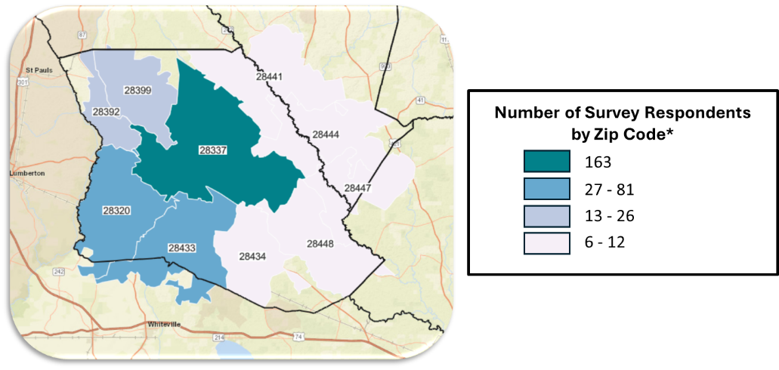
In general, survey questions focused on:
- Community health problems and concerns
- Community social/environmental problems and concerns
- Specific topics of interest to Bladen County:
  - Access to care
  - Mental health
  - Substance use disorders

The key findings from the Community Survey are detailed below:
- Alcohol/drug addiction, diabetes, and mental health were identified as the top 3 health problems affecting the community. Over one third of respondents also identified weight issues and heart disease/high blood pressure as top health problems.
- Cost, insurance, and transportation were the top three barriers to receiving health care identified by the community.
- Poverty, lack of job opportunities, and availability/access to doctor’s offices were identified as the top three most important social or environmental problems that affect the health of the community. About one in five respondents also identified limited access to healthy foods, access to insurance, and transportation issues and significant problems.

Information describing the respondents to the Community Member Survey are displayed below:
Figure 42: Respondents by Age Group
Figure 43: Respondents by Gender
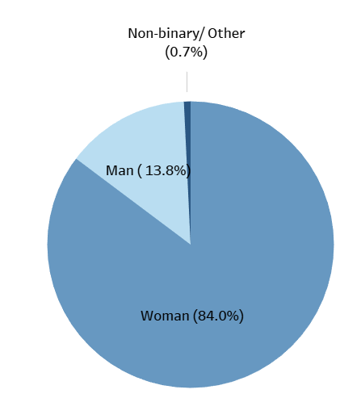
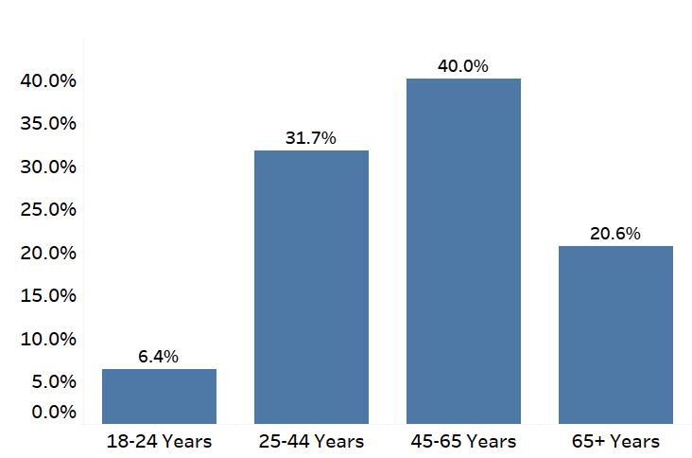

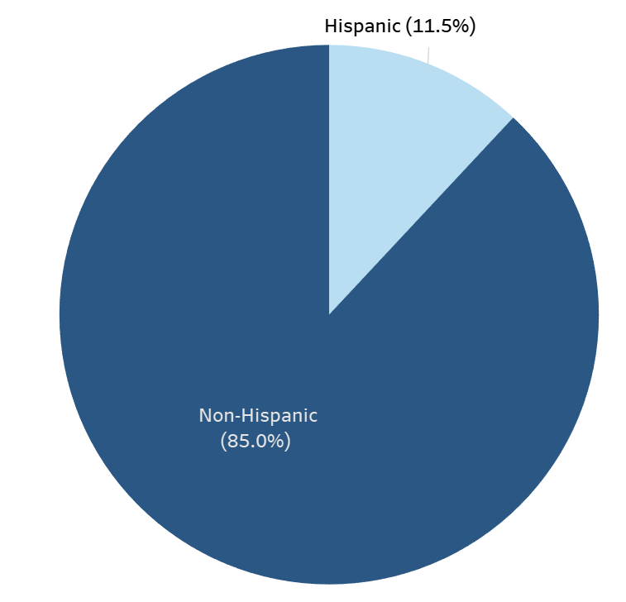
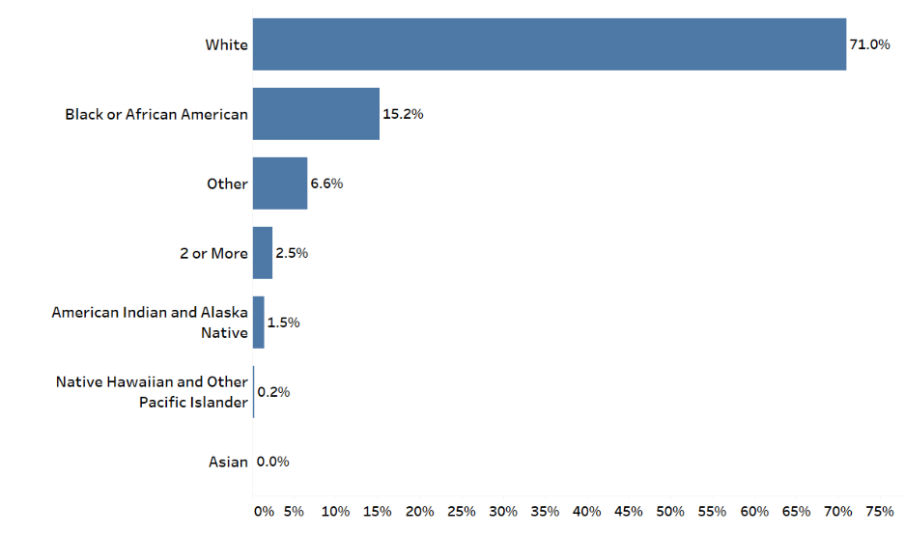
Figure 45: Respondents by Ethnicity
Figure 44: Respondents by Race

The questions administered via the Community Member Survey instrument are below. The survey instrument was also available in Spanish, and a copy of the Spanish language survey instrument is available on request.

Dear Community Member,
We invite you to participate in your county's Community Health Needs Survey.
Your responses to this optional survey are anonymous and will inform how hospitals and agencies work to improve health in your county. This is not a research survey. It will take less than 10 minutes to complete.
Instructions: You must be 18 years or older to complete this survey. Please answer all questions and return the survey as indicated.
For questions about this survey, contact Ascendient Healthcare Advisors: emilymccallum@ascendient.com
Thank you for your time and participation!

Topic: Demographics
- What is the zip code where you currently live?

- What is your age group?

□ 18-24
□ 25-44
□ 45-65
□ 65+
- Don't know/ Not sure
- Prefer not to say

- Which of the following best describes your gender? Select all that apply:

  - Man
  - Woman
  - Non-binary, genderqueer, or gender nonconforming
  - Additional gender category:
  - Prefer not to say

- How would you describe your race? Select all that apply:

  - American Indian and Alaska Native
  - Asian
  - Black or African American
  - Native Hawaiian and Other Pacific Islander
  - White
  - Other race:
  - Don't know/Not sure
  - Prefer not to say

- Are you of Hispanic or Latino origin, or is your family originally from a Spanish speaking country?

  - Yes
  - No
  - Don't know/Not sure
  - Prefer not to say

- What is the highest grade or year of school you completed?

  - Less than 9th grade
  - 9-12th grade, no diploma
  - High school graduate (or GED/equivalent)
  - Some college (no degree)
  - Associate's degree or vocational training
  - Bachelor's degree
  - Graduate or professional degree
  - Don't know/Not sure
  - Prefer not to say

- Which language is most often spoken in your home? Select one:

  - English
  - Spanish
  - Other, please specify:
  - Don't know/Not sure
  - Prefer not to say

- For employment, are you currently...Select all that apply:

- Employed full-time (40+ hours per week) | - Homemaker
- Employed part-time (under 40 hours per  week) | - Temporarily unable to work due to illness  or injury
- Retired | - Unemployed for less than one year
- Student | - Unemployed for more than one year
- Armed forces/military | - Permanently unable to work
- Self-employed | - Prefer not to answer

- Which category best describes your yearly household income before taxes? Do not give the dollar amount, just give the category. Include all income received from employment, social security, support from family, welfare, Aid to Families with Dependent Children (AFDC), bank interest, retirement accounts, rental property, investments, etc.

  - Less than $15,000
  - $15,000 - $24,999
  - $25,000 - $34,999
  - $35,000 - $49,999
  - $50,000 - $74,999
  - $75,000 - $99,999
  - $100,000 - $149,999
  - $150,000 - $199,999
  - $200,000 or more
  - Prefer not to say

Topic: Community Health Opinion Questions
- What are the three most important health problems that affect the health of your community? Please select up to three:

- Alcohol/drug addiction  - Alzheimer’s disease and other dementias  - Mental health (depression/anxiety)  - Cancer  - Diabetes/high blood sugar  - Heart disease/high blood pressure  - HIV/AIDS | - Infant death  - Lung disease/asthma/COPD  - Stroke  - Smoking/tobacco use  - Overweight/obesity  - Other (please specify):  - Prefer not to answer

- What are the three most important social or environmental problems that affect the health of your community? Please select up to three:

- Availability/access to doctor’s office  - Availability/access to insurance  - Child abuse/neglect  - Age Discrimination  - Ability Discrimination  - Gender Discrimination  - Racial Discrimination  - Domestic violence  - Housing/homelessness  - Lack of affordable childcare  - Lack of job opportunities | - Limited access to healthy foods  - Limited places to exercise  - Neighborhood safety/violence  - Limited opportunities for social connection  - Poverty  - Limited/poor educational opportunities  - Transportation problems  - Environmental injustice  - Other (please specify):  - Prefer not to answer

- What are the three most important reasons people in your community do not get health care? Please select up to three:
  - Cost – too expensive/can’t pay
  - Wait is too long
  - No health insurance
  - No doctor nearby
  - Lack of transportation
  - Insurance not accepted
  - Language barriers
  - Cultural/religious beliefs
  - Other (please specify):
  - Prefer not to answer

Topic: Access to Care
- DURING THE PAST 12 MONTHS, were you told by a health care provider or doctor’s office that they did not accept your health care coverage?

  - Yes
  - No
  - Don’t know
  - Prefer not to answer

- Where do you USUALLY go when you are sick or need advice about your health? Select all that apply:

  - Doctor’s office, clinic or health center
  - Urgent care or minute clinic
  - Hospital emergency room
  - Some other place [please specify]:
  - Don't go to one place most often
  - Don't know
  - Prefer not to answer

- There are many reasons people delay getting medical care. Have you delayed getting care for any of the following reasons in the PAST 12 MONTHS? Select all that apply:

  - Didn’t have transportation
  - You live in a rural area where distance to the health care provider is too far
  - You were nervous about seeing a health care provider
  - Couldn’t get time off work
  - Couldn’t get childcare
  - You provide care to an adult and could not leave him/her
  - Couldn’t afford the copay
  - Your deductible was too high/could not afford the deductible
  - You had to pay out of pocket for some or all of the visit/procedure
  - I did not delay care for any reason
  - Other (please specify):
  - Prefer not to answer

- DURING THE PAST 12 MONTHS, was there any time when you needed any of the following, but didn't get it because you couldn't afford it? Select all that apply:

  - Prescription medicines
  - Mental health care or counseling
  - Emergency care
  - Dental care (including checkups)
  - Eyeglasses
  - To see a regular doctor or general health provider (in primary care, general practice, internal medicine, family medicine)
  - To see a specialist
  - Follow-up care
  - None of the above
  - Prefer not to answer

- If you get sick or have an accident, how worried are you that you will be able to pay your medical bills?

  - Very worried
  - Somewhat worried
  - Not at all worried
  - Don't know
  - Prefer not to answer

- How much do you agree or disagree with the following statements about telehealth?
Telehealth means connecting virtually with a medical provider using a smartphone, tablet or computer. 1 = Strongly disagree; 2 = somewhat disagree; 3 = neither agree nor disagree; 4 = somewhat agree; 5 = strongly agree
 | 1 | 2 | 3 | 4 | 5 | Don’t know | Prefer not to  say
a. I have access to the resources I need to access  telehealth (internet, smartphone, tablet, computer, etc.) | □ | □ | □ | □ | □ | □ | □
b. I have used telehealth to access care from my doctor or other provider in the past | □ | □ | □ | □ | □ | □ | □
c. I am open to using telehealth to access medical care in the future | □ | □ | □ | □ | □ | □ | □
d. I am comfortable using a phone, tablet or computer to communicate with my doctor or other provider | □ | □ | □ | □ | □ | □ | □
e. I am comfortable using an online patient portal (i.e. MyChart, My CarolinaEast Care, myOMH, etc.) to communicate with my doctor or other provider | □ | □ | □ | □ | □ | □ | □

Topic: Mental Health
- Now thinking about your MENTAL health, which includes stress, depression, and problems with emotions, for how many days during the past 30 days was your mental health NOT
good?

  - Number of days:

- Was there a time in the past 12 months when you needed mental health care or counseling, but did not get it at that time?

  - Yes
  - No
  - Don’t know
  - Prefer not to say

- If you answered ‘Yes’ to the previous question, what was the MAIN reason you did not get mental health care or counseling?

  - Cost/No insurance coverage
  - Distance
  - Don't know where to go
  - Concerns about confidentiality
  - Inconvenient office hours
  - Lack of childcare
  - Lack of providers
  - Lack of transportation
  - Previous negative experiences/Distrust of mental health providers
  - Stigma
  - Too busy to go to an appointment
  - Too long of wait for an appointment
  - Trouble getting an appointment
  - Other (please specify):
  - None of the above
  - Don't know/Not sure
  - Prefer not to say

- Are you currently taking medication or receiving treatment, therapy, or counseling from a health professional for any type of MENTAL or EMOTIONAL HEALTH NEED?

  - Yes
  - No
  - Prefer not to say

Topic: Substance Use Disorders
- Considering all types of alcoholic beverages, how many times during the past 30 days did you have 4 (females)/ 5 (males) or more drinks on an occasion?

  - Number of drinks:

- In the past year, have you or a member of your household intentionally misused any form of prescription drugs (e.g. used without a prescription, used more than prescribed, used more often than prescribed, or used for any reason other than a doctor’s instructions)?

  - Yes
  - No
  - Don’t know/not sure
  - Prefer not to say

- To what degree has your life been negatively affected by YOUR OWN or SOMEONE ELSE's substance abuse issues, including alcohol, prescription, and other drugs? Would you say:
  - A Great Deal
  - Somewhat
  - A Little
  - Not at All
  - Don't know/Not sure
  - Prefer not to say

APPENDIX 5 | DETAILED PRIMARY DATA FINDINGS

Focus Groups

Key findings from the focus groups are summarized below.
Bladen County hosted two focus groups, which were both held at Bladen Hospital. Both groups identified several key health and social/environmental issues impacting well-being in Bladen County. Access to care was a top concern among participants, specifically citing the high cost of care, long wait times to see a provider, lack of local specialty care, and issues with insurance. Some of the physical health problems the group noted as prevalent and in need of addressing were diabetes, COPD, heart disease, and high blood pressure. Access to mental health care was also identified as a concern. Participants stated that there is a high need for quality mental health resources and facilities in the county, especially for the young people. A related challenge in Bladen County is transportation and transit. Community members are not able to access healthcare, healthy food, or job opportunities without their own vehicle.
Both focus groups also identified high cost of living, particularly housing and healthy foods, and lack of job opportunities as barriers to healthy living in Bladen County. Participants spoke on educational needs in the community, such as the need for children to be learning practical skills in school and for everyone to have better education about nutrition.
When asked what local health leaders can do to address their concerns, participants suggested bringing more specialists to the county to address the long wait times people currently face when seeking healthcare. Expanding hospital and health department services with a specific community focus was also suggested. Further, the groups noted the importance of health providers being involved in community activities to help meet Bladen County residents where they are. Lastly, advertising for available services and resources needs to be improved so community members are aware of what is available to them.

Community Member Web Survey

Charts detailing key findings from the Community Member Survey are displayed below:
Topic: Additional Demographic Information
Figure 46: What is the highest grade or year of school you completed?
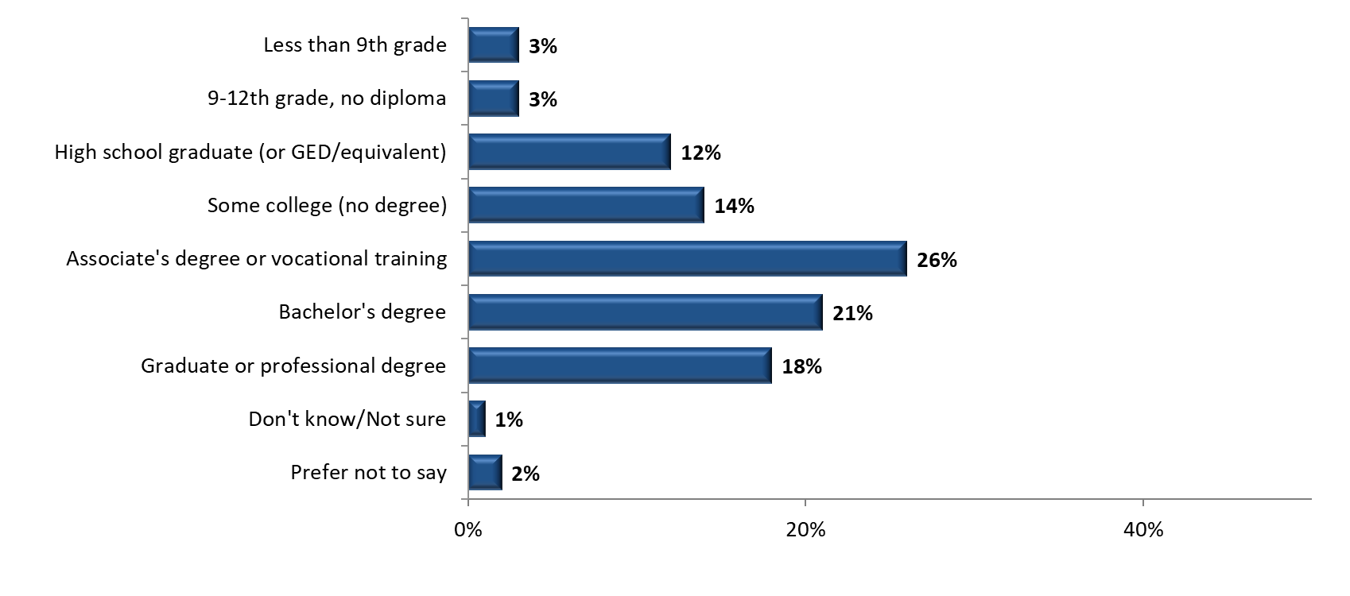
(N=407)

Figure 47: Which language is most often spoken in your home? (choose one)
(N=407)
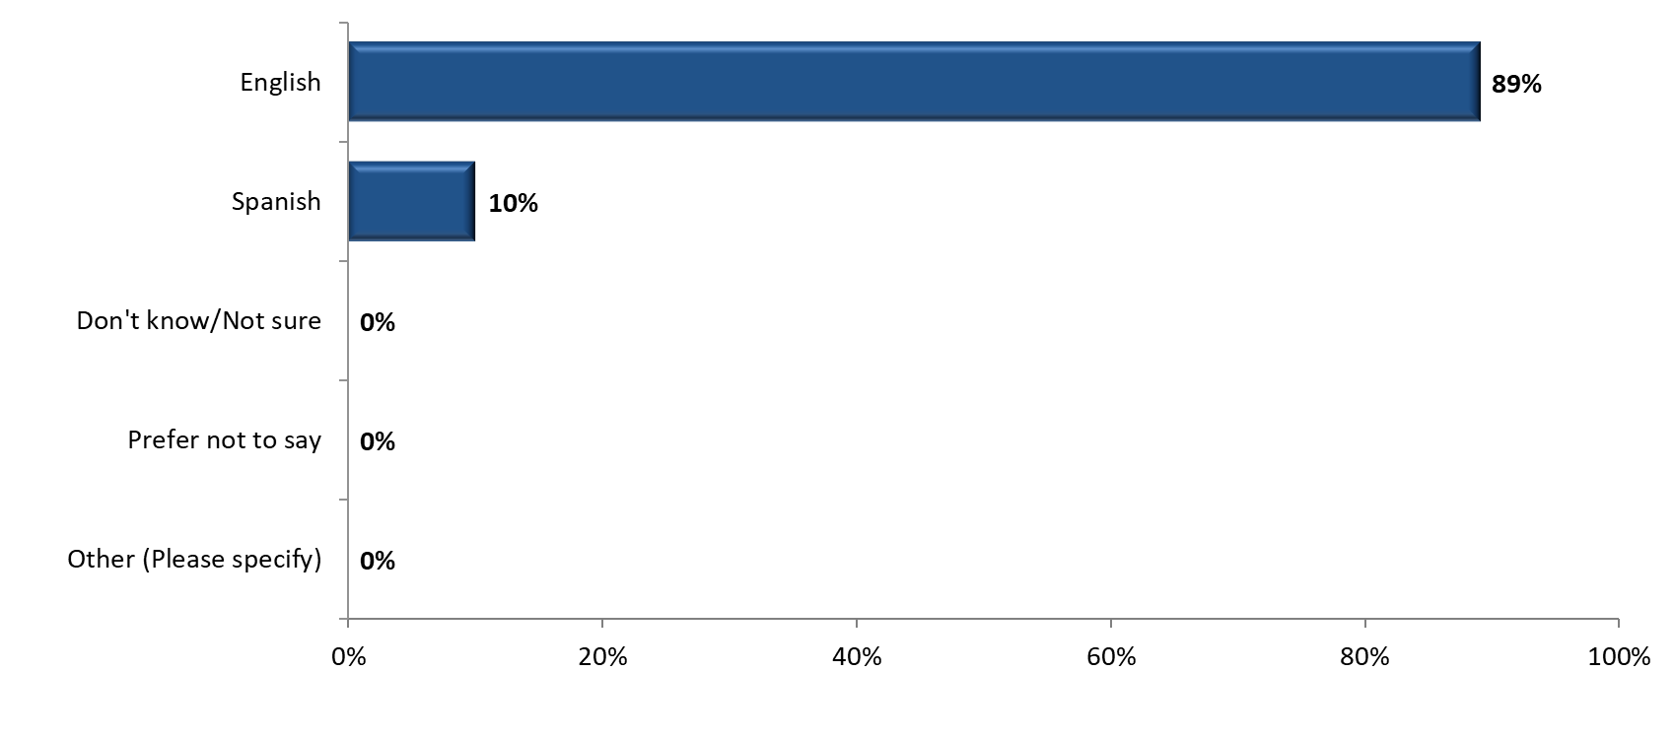

Figure 48: For employment, are you currently... (Select all that apply.)
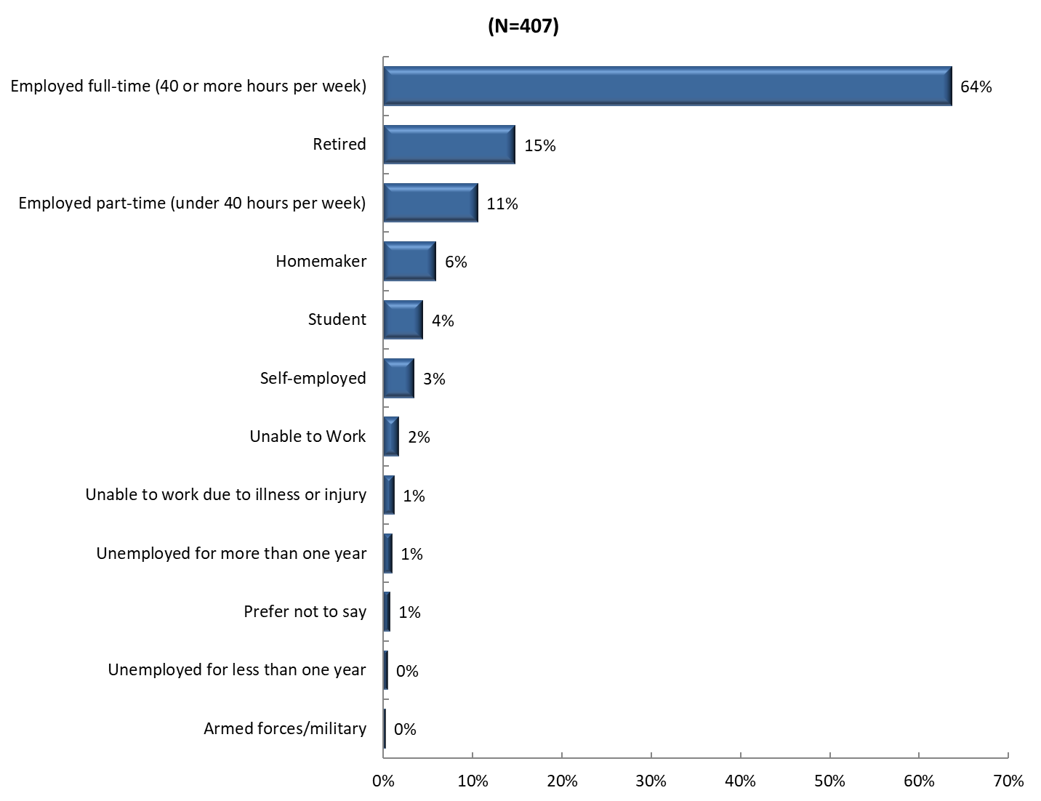

Figure 49: Which category best describes your yearly household income before taxes?
Respondents were asked to include all income received from employment, social security, support from children or other family, welfare, Aid to Families with Dependent Children (AFDC), bank interest, retirement accounts, rental property, investments, etc.
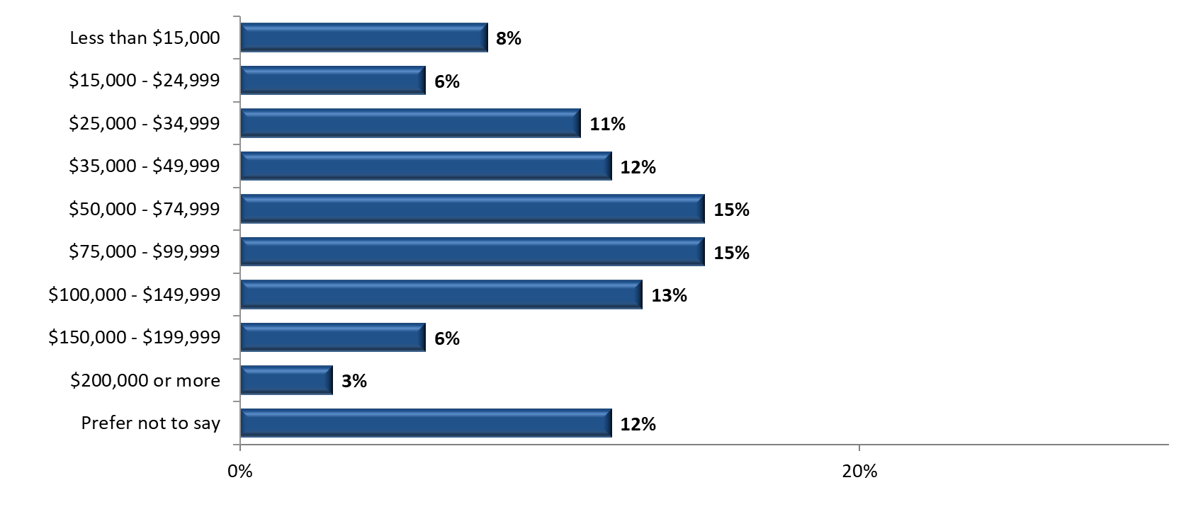
(N = 403)

Topic: Health Conditions, Barriers to Care, and Social Determinants of Health
Figure 50: What are the three most important health problems that affect the health of your community? Please select up to three.
Other (Please specify):
- “Chronic renal failure”
- “Drugs”

Figure 51: What are the three most important health problems that affect the health of your community? Please select up to three. (by age)

Figure 52: What are the three most important health problems that affect the health of your community? Please select up to three. (by gender)

Figure 53: What are the three most important health problems that affect the health of your community? Please select up to three. (by race)

Figure 54: What are the three most important health problems that affect the health of your community? Please select up to three. (by ethnicity)

Figure 55: What are the three most important reasons people in your community do not get health care when they need it? Please select up to three.

Other (please specify):

- “Availability to see Primary doctor with same/next day visit. Education on when to seek treatment and where best to seek tx”
- “Distance from quality health care”
- “Fear of the unknown”
- “Ignorance”
- “INS denial”
- “Lack of trust in medical community”
- “Lacking confidence in the medical system”
- “No specialist availability”
- “Specialty doctors are too far to drive”
- “The airport like security at the emergency room. I’d rather drive to another county than deal with that crap.”
- “The doctors at the Bladen county health department are known to miss diagnose patients, for example both of my parents have been miss diagnosed in the past, my dad was discharged with asthma when he was having a heart attack.”
- “They choose not to go”
- “TOO DAMN LAZY TO APPLY”
- “Unaware of importance”

Figure 56: What are the three most important reasons people in your community do not get health care when they need it? Please select up to three. (by age)
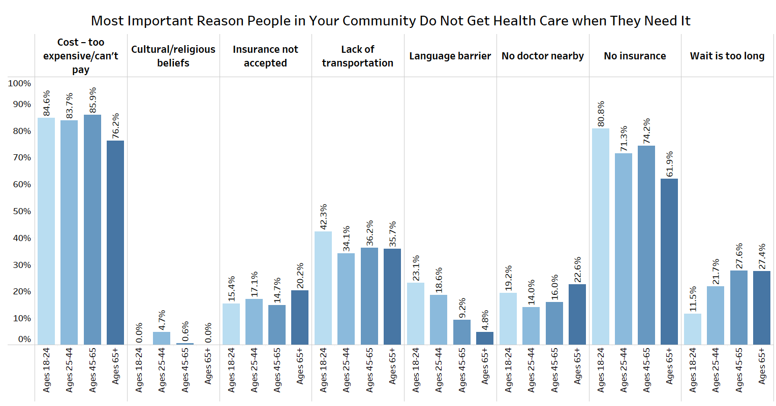

Figure 57: What are the three most important reasons people in your community do not get health care when they need it? Please select up to three. (by gender)
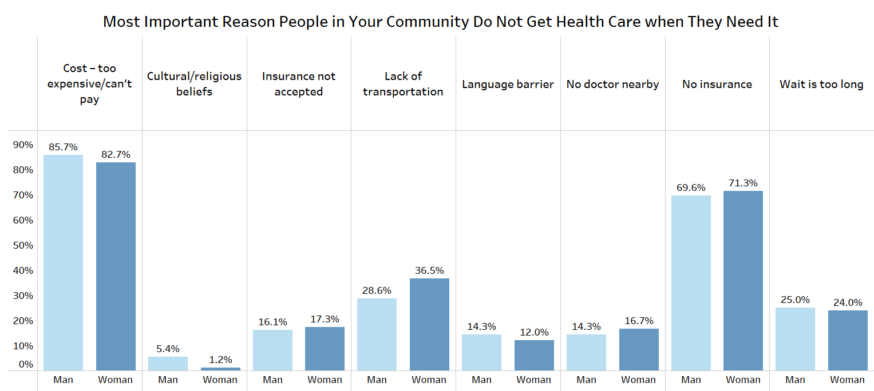
Figure 58: What are the three most important reasons people in your community do not get health care when they need it? Please select up to three. (by race)
Figure 59: What are the three most important reasons people in your community do not get health care when they need it? Please select up to three. (by ethnicity)
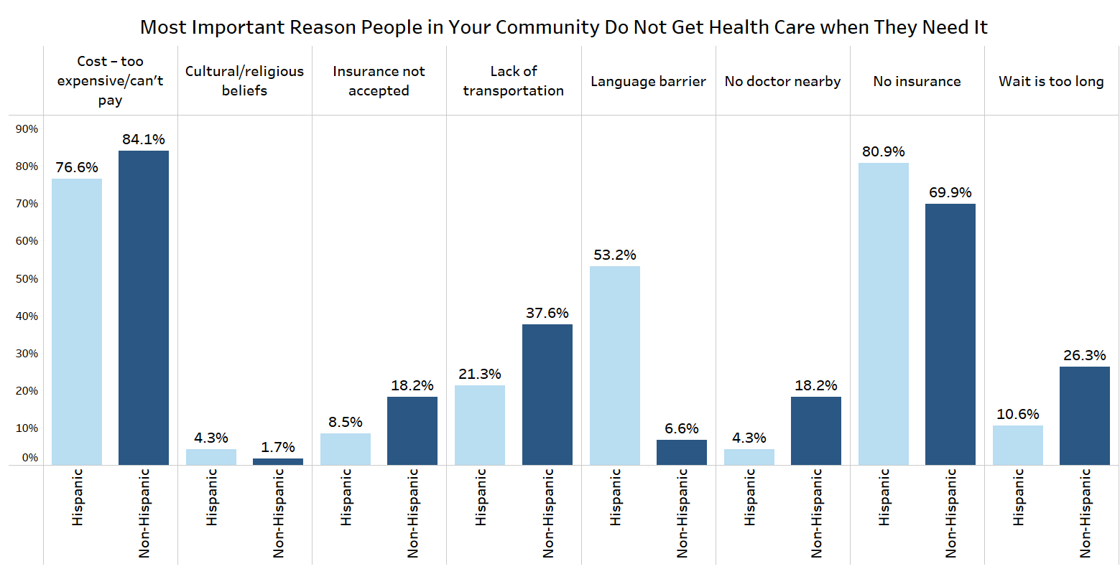
Figure 60: What are the three most important social or environmental problems that affect the health of your community? Please select up to three.
Other (please specify):
- “Available care for elderly parents when you are required to work and can't afford to pay for someone to care for my mother. She can't get Medicaid.”
- “Elder care”
- “Lack of a desire to do better”
- “Lack of resources”
- “LGBTQ discrimination”

Figure 61: What are the three most important social or environmental problems that affect the health of your community? Please select up to three. (by age)
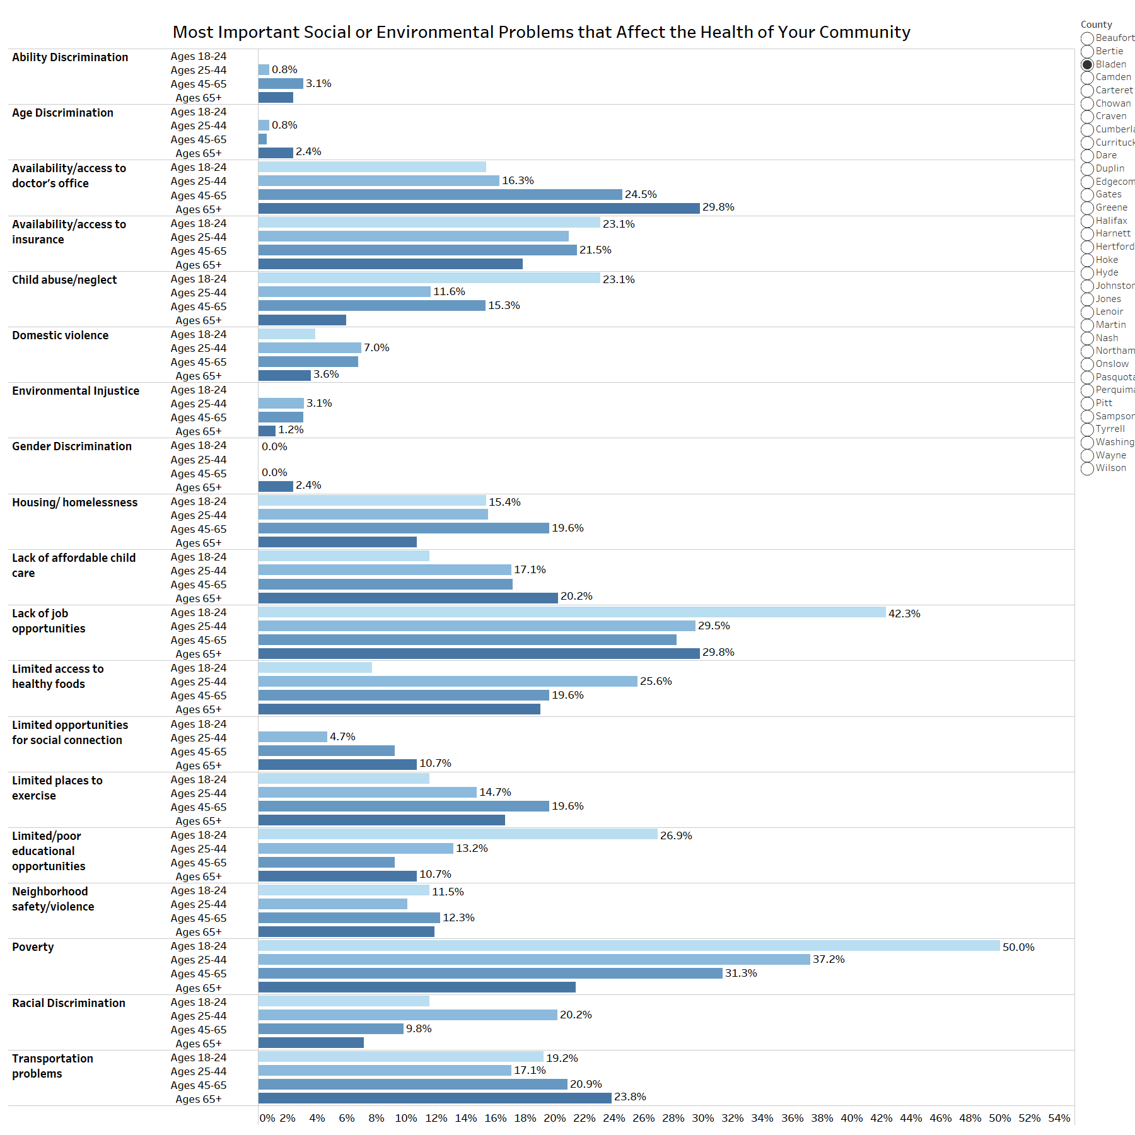

Figure 62: What are the three most important social or environmental problems that affect the health of your community? Please select up to three. (by gender)
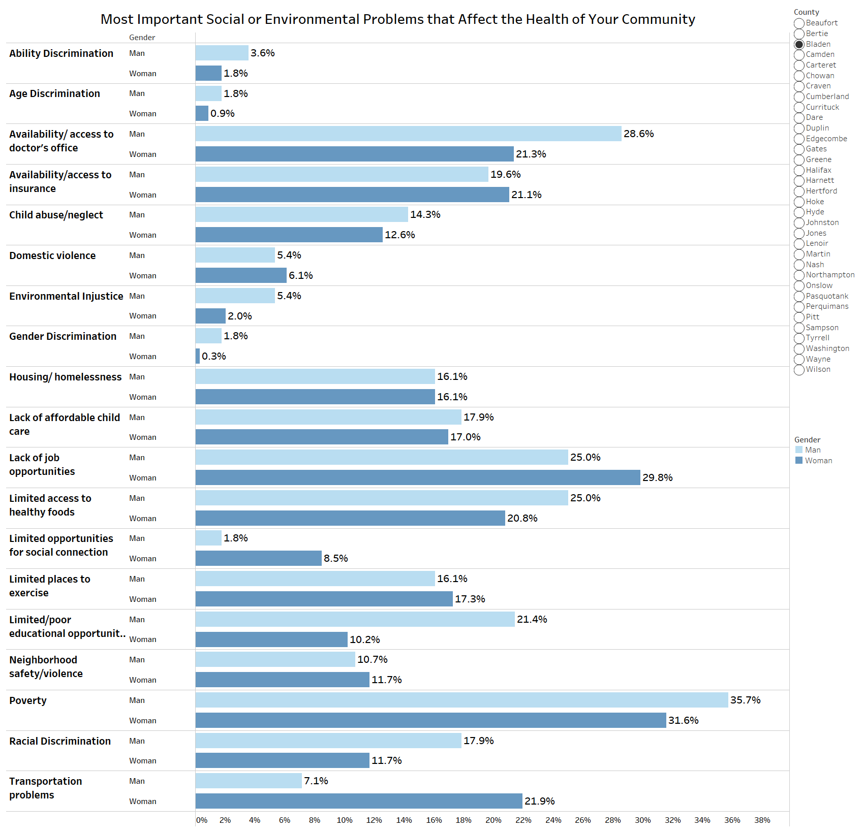

Figure 63: What are the three most important social or environmental problems that affect the health of your community? Please select up to three. (by race)
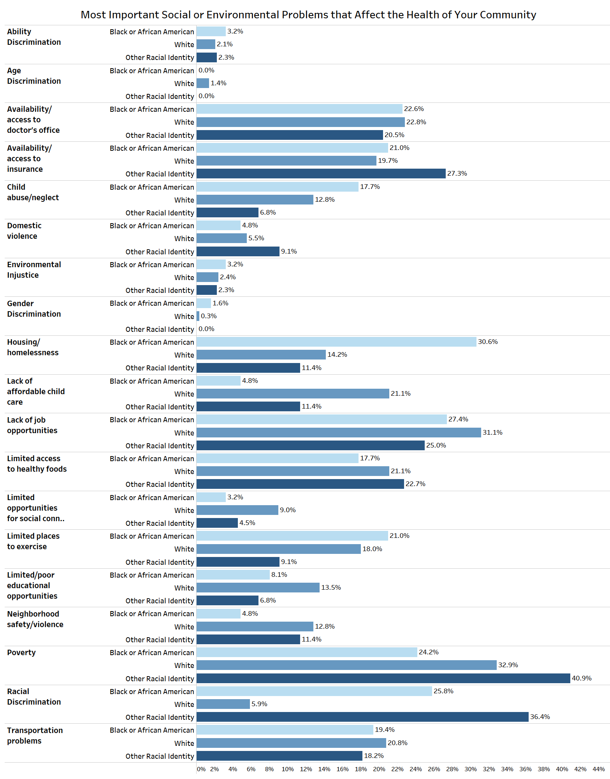
Figure 64: What are the three most important social or environmental problems that affect the health of your community? Please select up to three. (by ethnicity)
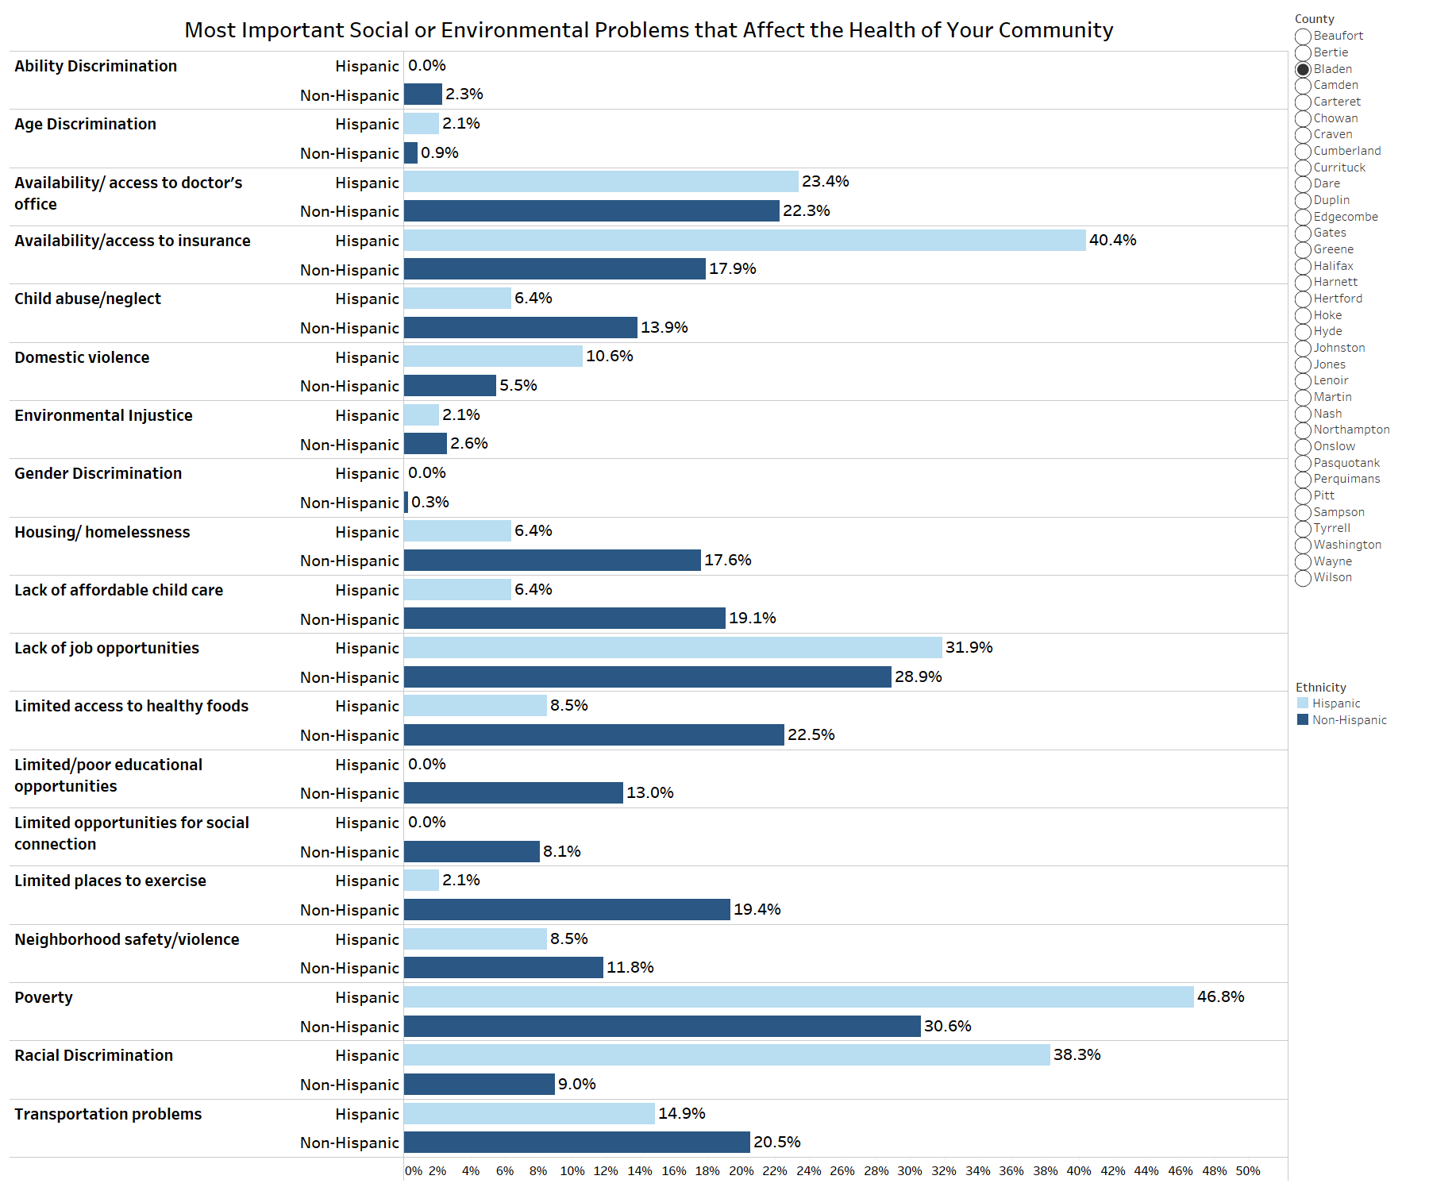

Topic: Access to Care
Figure 65: DURING THE PAST 12 MONTHS, were you told by a health care provider or doctor’s office that they did not accept your health care coverage?
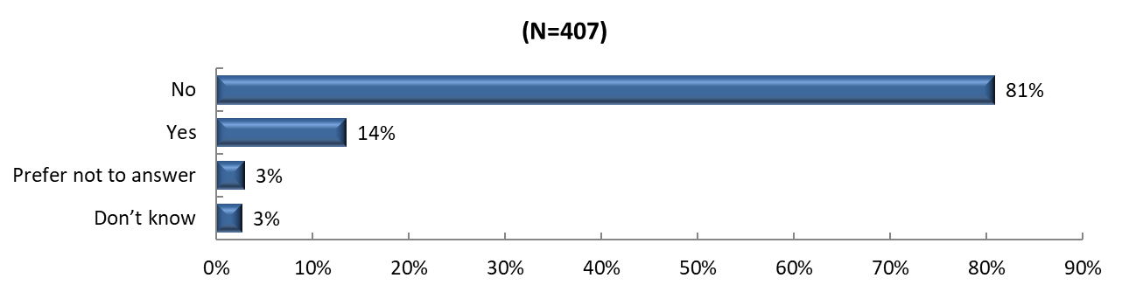
Figure 66: Where do you USUALLY go when you are sick or need advice about your health?
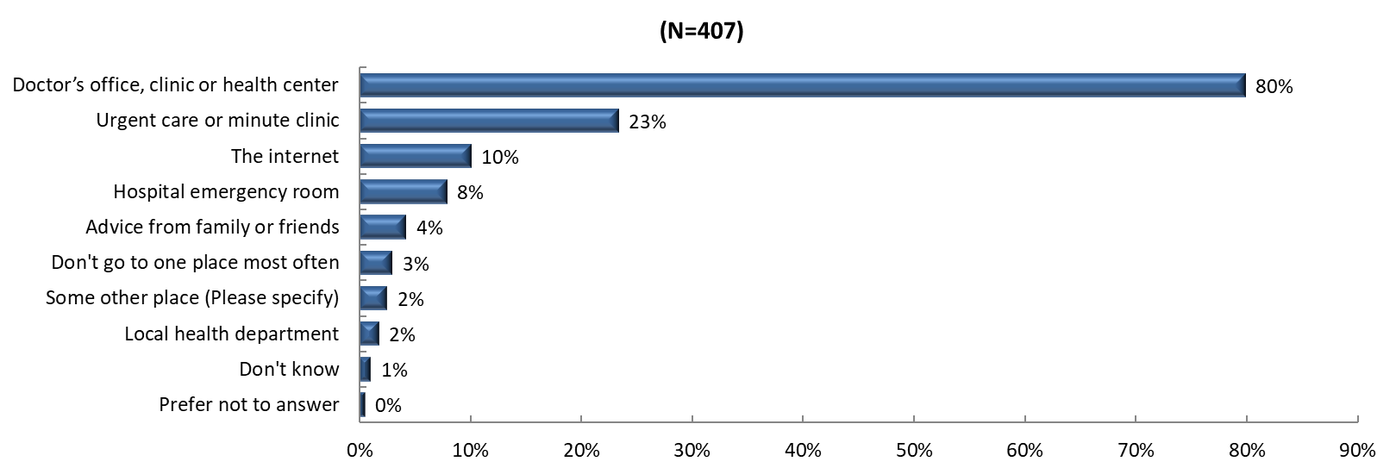
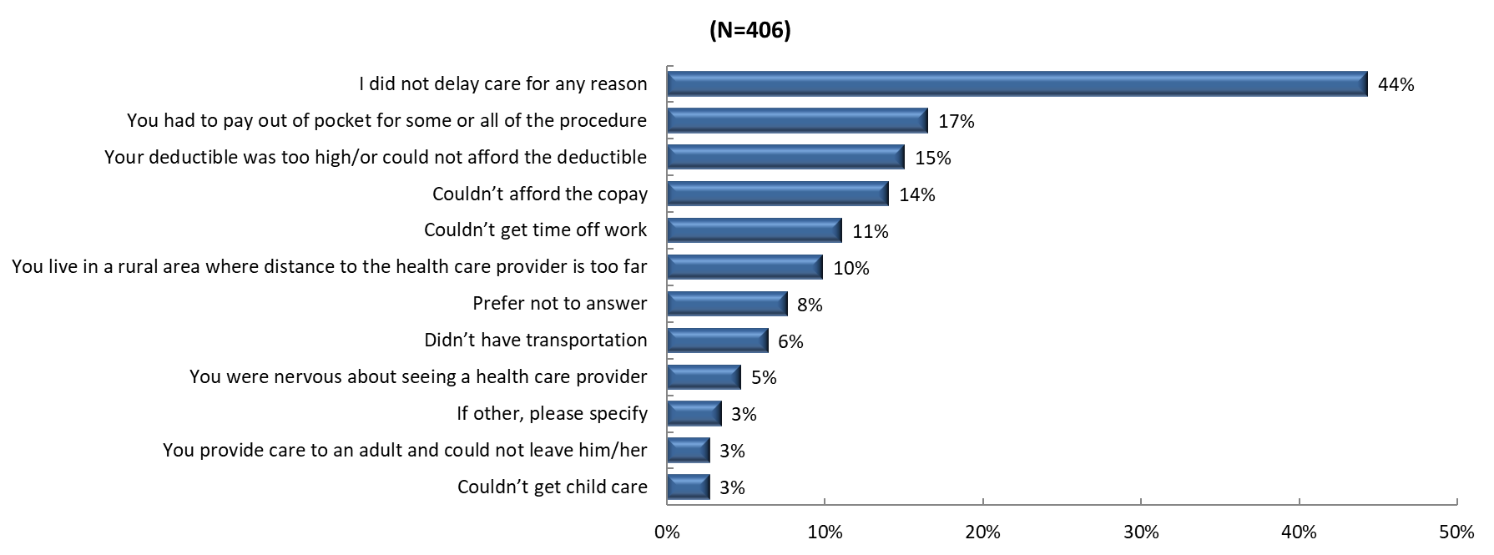
Figure 67: There are many reasons people delay getting medical care. Have you delayed getting care for any of the following reasons in the PAST 12 MONTHS?

Figure 68: DURING THE PAST 12 MONTHS, was there any time when you needed any of the following, but didn't get it because you couldn't afford it?
Figure 69: If you get sick or have an accident, how worried are you that you will be able to pay your medical bills?
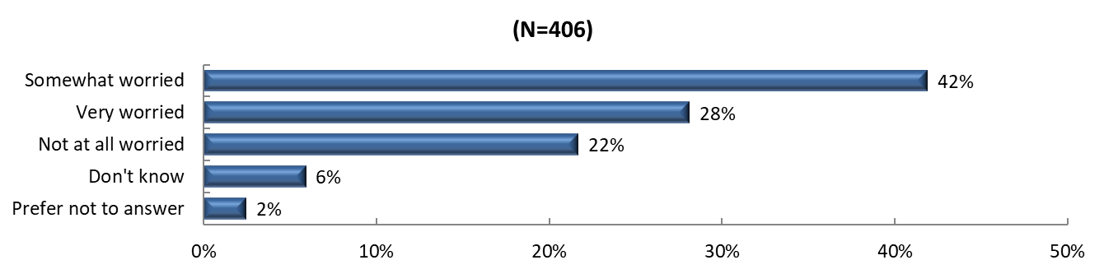

Figure 70: How much do you agree or disagree with the following statements about telehealth? Telehealth means connecting virtually with a medical provider using a smartphone, tablet or computer.
Scale from 1 to 5 with 1 being “strongly disagree” and 5 being “strongly agree”
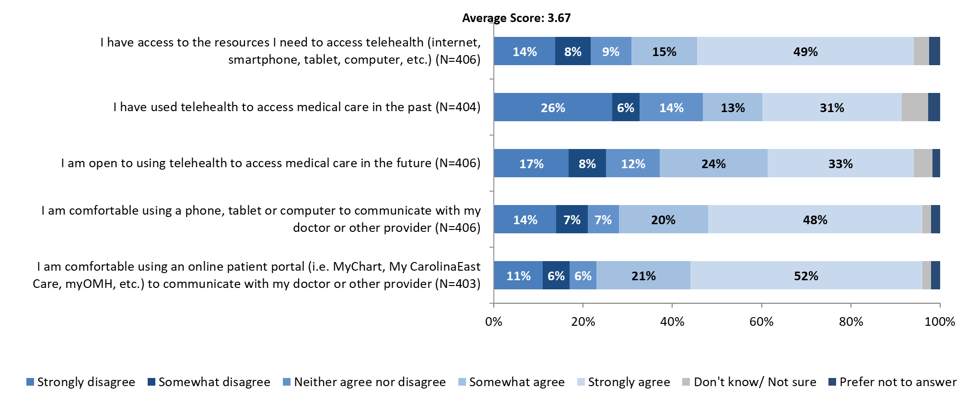
Topic: Mental Health
Figure 71: Now thinking about your MENTAL health, which includes stress, depression, and problems with emotions, for how many days during the past 30 days was your mental health NOT good?
- (N = 391)

Figure 72: Was there a time in the past 12 months when you needed mental health care or counseling, but did not get it at that time?
Please note, only participants who responded that they had experienced at least 1 poor mental health day in the previous question were asked the current follow-up question
Figure 73: What was the MAIN reason you did not get mental health care or counseling?
Please note, only participants who answered "YES" to previous question were asked the current follow-up question

Figure 74: Are you currently taking medication or receiving treatment, therapy, or counseling from a health professional for any type of MENTAL or EMOTIONAL HEALTH NEED?
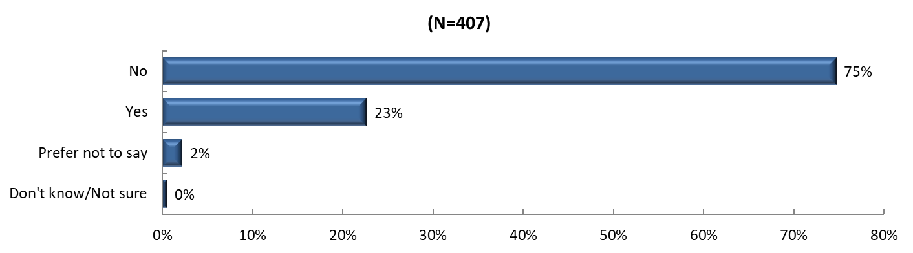

Topic: Substance Use
Figure 75: Considering all types of alcoholic beverages, how many times during the past 30 days did you have 4 (females)/ 5 (males) or more drinks on an occasion?
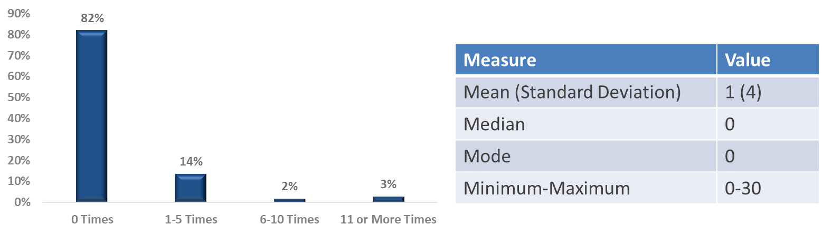

Figure 76: How often do you consume any kind of alcohol product, including beer, wine or hard liquor?
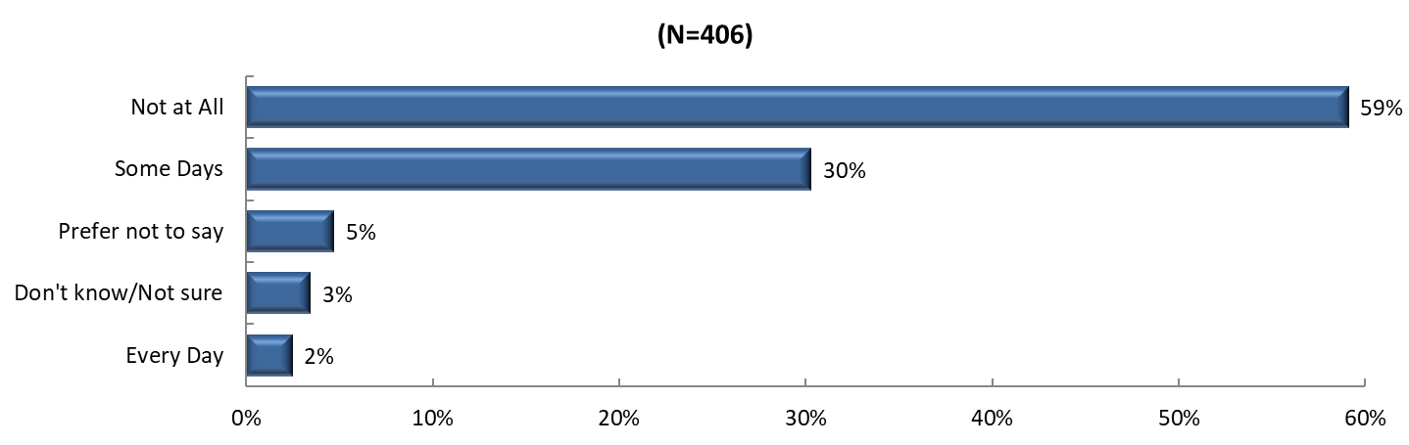
Figure 77: In the past year, have you or a member of your household misused any form of prescription drugs (e.g. used without a prescription, used more than prescribed, used more often than prescribed, or used for any reason other than a doctor’s instructions)?
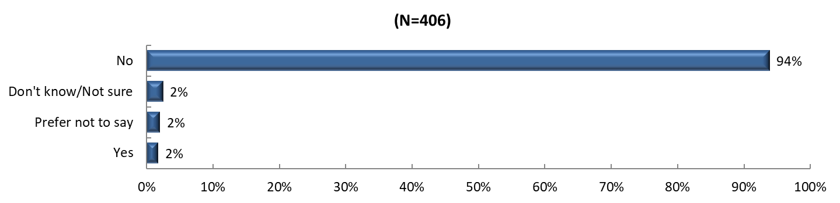
Figure 78: To what degree has your life been negatively affected by YOUR OWN or SOMEONE ELSE's substance abuse issues, including alcohol, prescription, and other drugs?
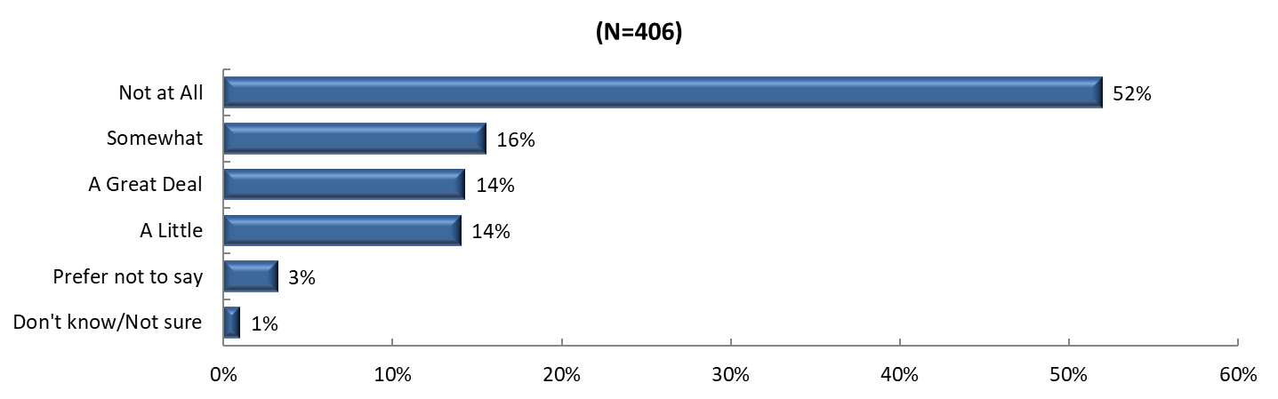

APPENDIX 6 | SUMMARY OF DATA FINDINGS ACROSS SOURCES

Primary data findings are summarized in full by the table below.

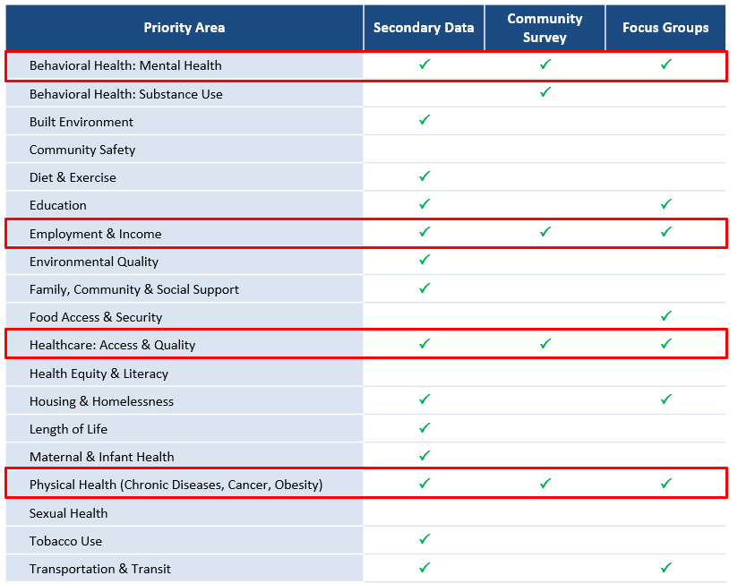

Source: NCLHDA Health Department Self-Assessment Instrument Interpretation Document 2024.
Source: Community Health Needs Assessment for Charitable Hospital Organizations – Section 501®(3) (2023). Internal Revenue Service. Retrieved February 13th, 2024 from https://www.irs.gov/charities-non-profits/community-health-needs-assessment-for-charitable-hospital-organizations-section-501r3.
Note: All graphics in this image were licensed from Adobe Stock.
Source: University of Wisconsin Population Health Institute (2024). County Health Rankings & Roadmaps. www.countyhealthrankings.org.
Source: CDC (2022). Social Determinants of Health at CDC. Accessed March 7th, 2024 via https://www.cdc.gov/about/sdoh/index.html
Source: Kaiser Family Foundation (2024). Disparities in Health and Health Care: 5 Key Questions and Answers. Accessed December 30, 2024 via https://www.kff.org/racial-equity-and-health-policy/issue-brief/disparities-in-health-and-health-care-5-key-question-and-answers/
Source: Esri. Throughout this report, maps and demographic estimates (unless otherwise noted) were developed using ArcGIS® software by Esri. ArcGIS® and ArcMap™ are the intellectual property of Esri and are used herein under license. Copyright © Esri. All rights reserved. For more information about Esri® software, please visit www.esri.com
Source: U.S. Census Bureau. "Selected Social Characteristics in the United States." American Community Survey, ACS 5-Year and 1-Year Estimates Data Profiles, Table DP02, 2022, https://data.census.gov. Accessed on April 1, 2024.
Disability status is classified in the ACS according to yes/no responses to questions about six types of disability concepts. For children under 5 years old, hearing and vision difficulty are used to determine disability status. For children between the ages of 5 and 14, disability status is determined from hearing, vision, cognitive, ambulatory, and self-care difficulties. For people aged 15 years and older, they are considered to have a disability if they have difficulty with any one of the six difficulty types.
Source: Healthy People 2030 (2023). Poverty. Accessed March 7th, 2024 via: https://health.gov/healthypeople/priority-areas/social-determinants-health/literature-summaries/poverty
The Supplemental Nutrition Assistance Program (SNAP) provides nutrition assistance to eligible, low-income individuals and households. It is the largest Federal nutrition assistance program. Source: USDA Supplemental Assistance Program fact sheet.
Source (for County and North Carolina): U.S. Census Bureau. "Educational Attainment for the Population 25 Years and Over.” American Community Survey, ACS 5-Year Estimates Detailed Tables, Table B15003, 2020, https://data.census.gov/table/ACSDT5Y2020.B15003?q=b15003&g=040XX00US37,37$0500000&moe=false. Accessed on April 1, 2024.
Source (for United States): U.S. Census Bureau. “Educational Attainment in the United States: 2022.” Table 1, All Races. https://www.census.gov/data/tables/2022/demo/educational-attainment/cps-detailed-tables.html.
Source (for County and North Carolina): U.S. Census Bureau. "Educational Attainment for the Population 25 Years and Over.” American Community Survey, ACS 5-Year Estimates Detailed Tables, Table B15003, 2020, https://data.census.gov/table/ACSDT5Y2020.B15003?q=b15003&g=040XX00US37,37$0500000&moe=false. Accessed on April 1, 2024.
Source (for United States): U.S. Census Bureau. “Educational Attainment in the United States: 2022.” Table 1, All Races. https://www.census.gov/data/tables/2022/demo/educational-attainment/cps-detailed-tables.html.
US Totals combine GED with High School Diploma
Source (for County and North Carolina): U.S. Census Bureau. "Employment Status." American Community Survey, ACS 5-Year Estimates Subject Tables, Table S2301, 2022, https://data.census.gov/table/ACSST5Y2022.S2301?q=S2301&g=040XX00US37,37$0500000&moe=false. Accessed on April 1, 2024.
Source (for United States): Federal Reserve Bank of Saint Louis. Federal Reserve Economic Data - FRED (March 2024). https://fred.stlouisfed.org/
Source: U.S. Census Bureau. "Selected Characteristics of Health Insurance Coverage in the United States." American Community Survey, ACS 5-Year Estimates Subject Tables, Table S2701, 2022, https://data.census.gov/table/ACSST5Y2022.S2701?q=s2701&g=010XX00US_040XX00US37,37$0500000&moe=false. Accessed on April 1, 2024.
CDC/ATSDR Social Vulnerability Index (SVI). Retrieved from https://www.atsdr.cdc.gov/placeandhealth/svi/index.html.
U.S. Environmental Protection Agency (2024). Retrieved from https://www.epa.gov/environmentaljustice
Source: American Medical Association (2022). What is behavioral health? Retrieved September 13th, 2023, from https://www.ama-assn.org/delivering-care/public-health/what-behavioral-health.
Source: CDC. (2024). About mental health. Retrieved October 1, 2024, from: https://www.cdc.gov/mentalhealth/learn/index.htm
Source: National Institute of Mental Health (2023). Mental Illness. Retrieved September 13th, 2023, from https://www.nimh.nih.gov/health/statistics/mental-illness.
Source: CDC. (2024). Mental health. Retrieved October 1, 2024, from https://www.cdc.gov/mentalhealth/learn/index.htm
RHI Hub. (2023). Rural mental health. Retrieved October 1, 2024 from: https://www.ruralhealthinfo.org/topics/mental-health
Source: NAMI (2023). Mental Health in North Carolina. Retrieved October 10, 2024, from https://www.nami.org/wp-content/uploads/2023/07/NorthCarolinaStateFactSheet.pdf
Source: American Psychiatric Association (2024). Addiction and Substance Use Disorders. Retrieved January 16, 2024, from https://www.psychiatry.org/patients-families/addiction-substance-use-disorders.
Source: SAMHSA (2024). Highlights from the 2023 National Survey on Drug Use and Health. Retrieved October 10th, 2024 from https://www.samhsa.gov/data/sites/default/files/reports/rpt42731/2022-nsduh-main-highlights.pdf.
Source: National Center for Drug Abuse Statistics (2023). Drug Abuse Statistics. Retrieved January 8th, 2024, from https://drugabusestatistics.org/.
Source: Cleveland Clinic. (2024). Substance Use Disorder (SUD). Retrieved October 1, 2024, from https://my.clevelandclinic.org/health/diseases/16652-drug-addiction-substance-use-disorder-sud
Source: KFF. (2023). Saunders, H., Rudowitz, R. (2023). Will the availability of Over-The-Counter Narcan increase access? Retrieved October 1, 2024 from https://www.kff.org/policy-watch/will-availability-of-over-the-counter-narcan-increase-access/
Source: NCDHHS. (2022). Overdose epidemic. Retrieved October 3, 2024 from: https://www.ncdhhs.gov/about/department-initiatives/overdose-epidemic#:~:text=Combating%20North%20Carolina's%20Opioid%20Crisis,is%20devastating%20families%20and%20communities.
Source: Panchal, N., Saunders H., Rudowitz, R. and Cox, C. (2023). The Implications of COVID-19 for Mental Health and Substance Use. Kaiser Family Foundation. Retrieved from https://www.kff.org/mental-health/issue-brief/the-implications-of-covid-19-for-mental-health-and-substance-use.
Source: U.S. Department of Health and Human Services Office of Disease Prevention and Health Promotion (2023). Healthy People 2030: Health Care Access and Quality. Retrieved September 9th, 2024 from https://health.gov/healthypeople/objectives-and-data/browse-objectives/health-care-access-and-quality.
Source: Phillips, K.A., Marshall, D.A., Adler, L., Figueroa, J., Haeder, S.F., Hamad, R., Hernandez, I., Moucheraud, C., Nikpay, S. (2023). Ten health policy challenges for the next ten years. Health Affairs Scholar. Retrieved from: https://academic.oup.com/healthaffairsscholar/article/1/1/qxad010/7203673.
Source: Association of American Medical Colleges (AAMC) (2024). The complexities of physician supply and demand: Projections from 2021 to 2036. Retrieved from: https://www.aamc.org/media/75236/download?attachment .
Source: Association of American Medical Colleges (AAMC) (2024). State of US Nursing Report 2024. Retrieved, from https://www.incrediblehealth.com/wp-content/uploads/2024/03/2024-Incredible-Health-State-of-US-Nursing-Report.pdf .
Source: AAMC (2021). North Carolina physician workforce profile. Retrieved September 9, 2024, from: https://www.aamc.org/media/58286/download.
Source: Joszt, L. (2018). 5 Vulnerable Populations in Healthcare. American Journal of Managed Care. Retrieved September 9, 2024 from https://www.ajmc.com/view/5-vulnerable-populations-in-healthcare.
Source: Espinoza, J. and Derrington, S. (2021). How Should Clinicians Respond to Language Barriers That Exacerbate Health Inequity? AMA Journal of Ethics. Retrieved from: https://journalofethics.ama-assn.org/article/how-should-clinicians-respond-language-barriers-exacerbate-health-inequity/2021-02.
Source: Centers for Disease Control and Prevention. (2023). Taking care of your body. Retrieved October 3, 2024 from: https://www.cdc.gov/howrightnow/taking-care/index.html
Source: U.S. Department of Veterans Affairs. (2023). Healthy living overview. Retrieved October 10th, 2024 from https://www.prevention.va.gov/Healthy_Living/index.asp
Source: CDC (n.d.) Health behaviors in rural America. Retrieved October 3, 2024 from https://www.cdc.gov/rural-health/php/public-health-strategy/public-health-considerations-for-health-behaviors-in-rural-america.html#:~:text=People%20living%20in%20rural%20areas,and%20getting%20regular%20health%20screenings.
Source: Eat Smart Move More North Carolina. (2017). The roles of nutrition and physical activity in Chronic Disease in North Carolina. Retrieved
Clear Impact (2022). Results-Based Accountability™: A Framework to Help Communities Get From Talk to Action. Retrieved from: https://clearimpact.com/wp-content/uploads/2022/02/Clear-Impact-Results-Based-Accountability-Brochure-2022.pdf. Note: Clear Impact has exclusive and worldwide rights to use Results-Based Accountability™ (RBA), including all of proprietary and intellectual property rights represented by RBA. RBA intellectual property is free for use (with attribution) by government and nonprofit or voluntary sector organizations, as well as small consulting firms representing the interests of these organizations.
The U.S. Census Bureau defines “Hispanic or Latino” as “a person of Cuban, Mexican, Puerto Rican, South or Central American, or other Spanish culture or origin regardless of race.”
Survey results captured here reflect major findings from the Community Health Opinion Survey questions. Red boxes indicate categories identified as high need consistently across data sources.

